**Let’s make a Chinese drum!**

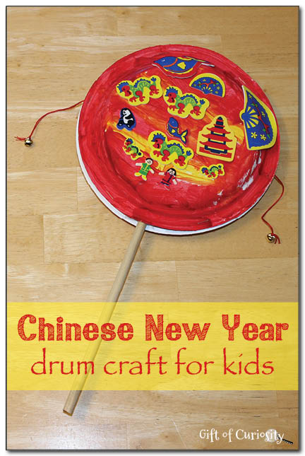

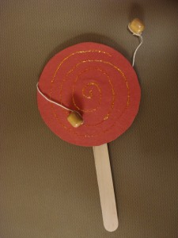When people celebrate the Chinese New Year, they make a lot of loud noise to keep the evil spirits away. If you want to make your drum really loud, you can use an old CD and beads on string! Or if you want to make gentle sound, you can decorate two paper plates and stick them together and attach the beads to the side.