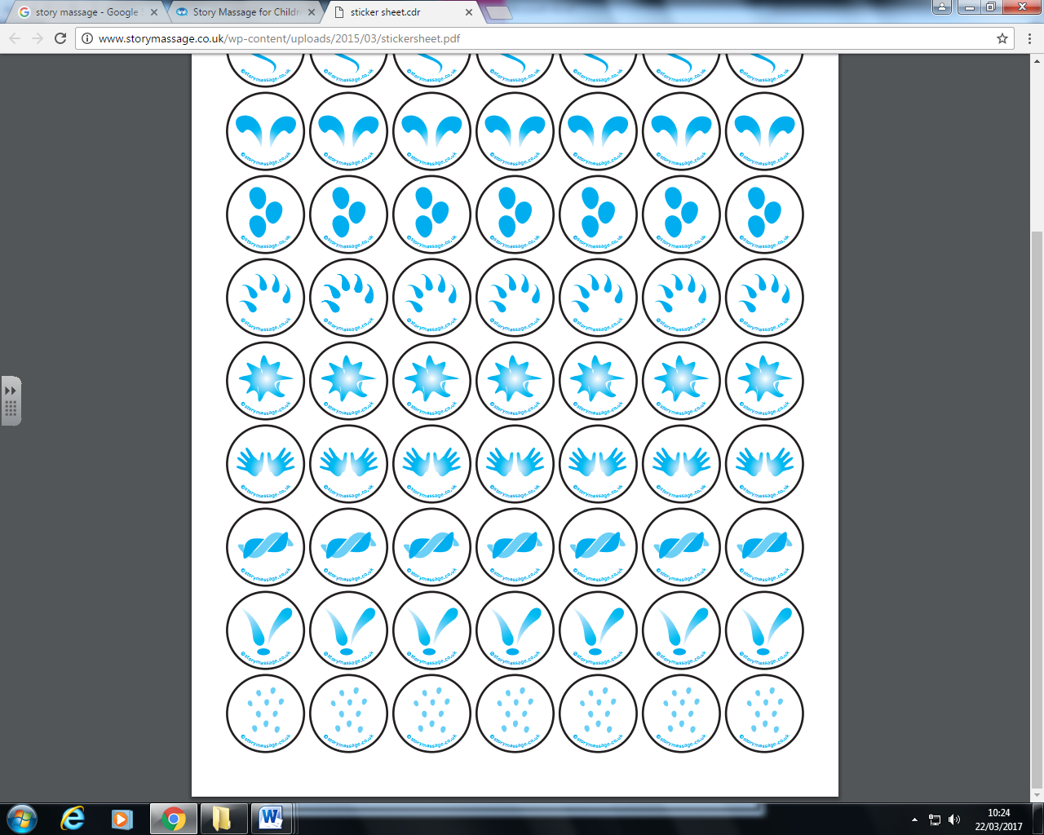

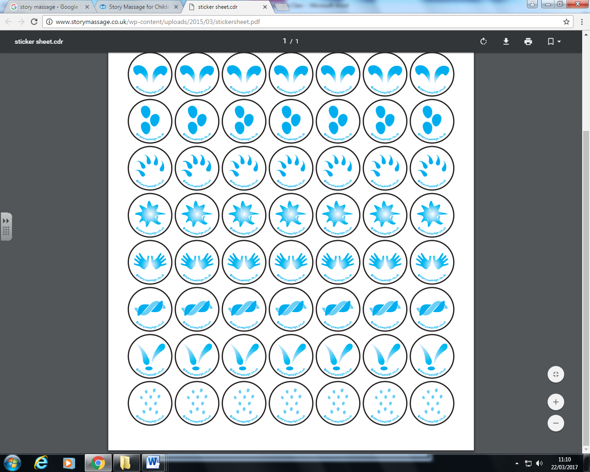

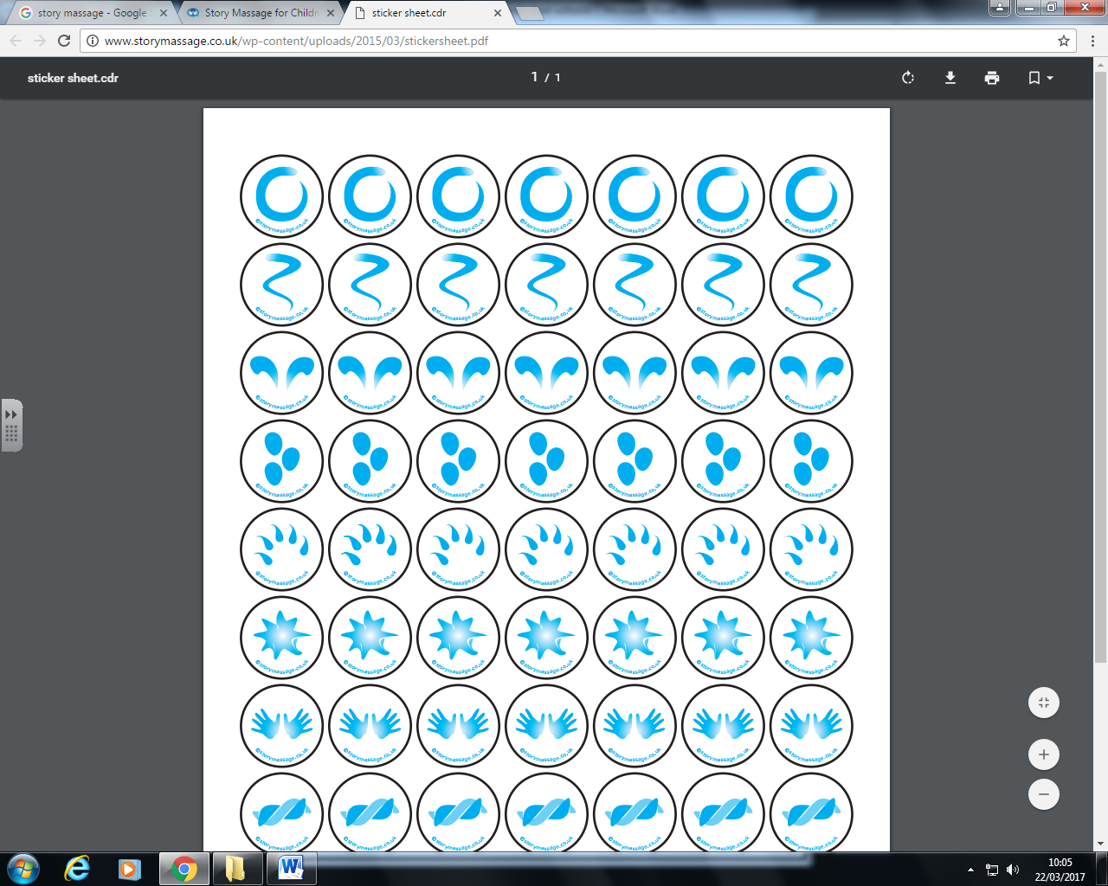



And couldn’t get up in the morning

He bumped his head and went to bed

The old man is snoring

It’s raining, its pouring ,

**Raining it’s pouring**