beetle | ladybird | snail | slug | 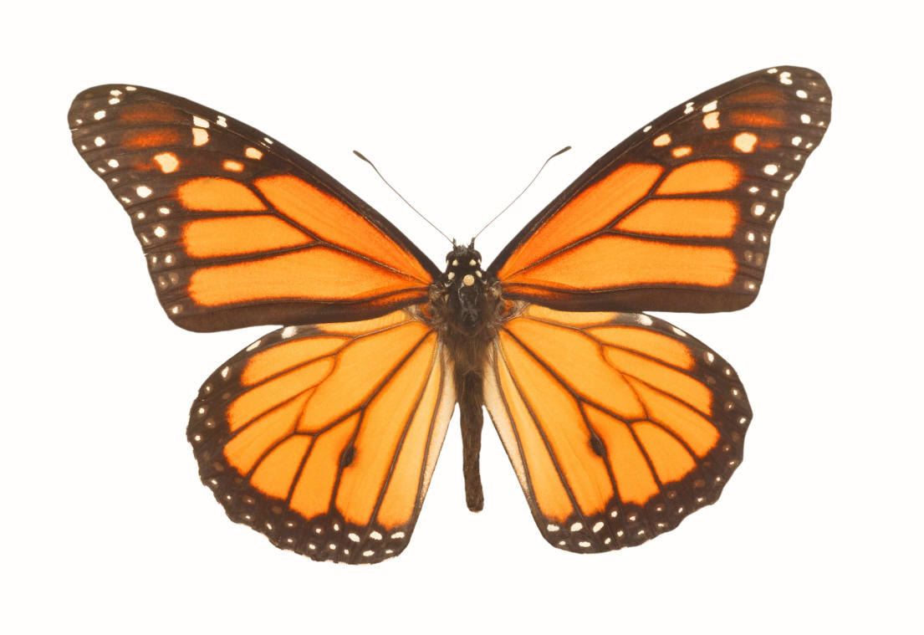  butterfly
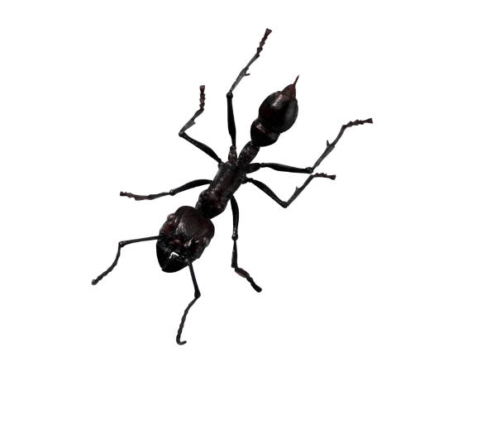  ant |   fly | 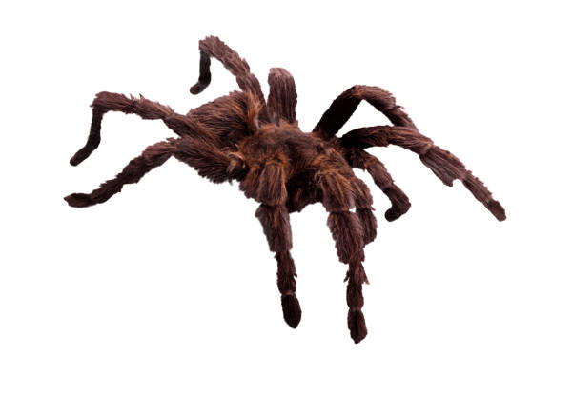  spider | worm  centipede
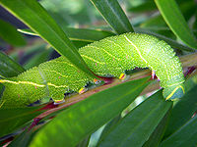  caterpillar | 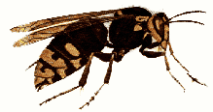  wasp | 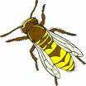  bee | 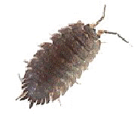  woodlouse | 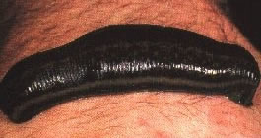  leech
Minibeast Hunt Tick List

Have a look in your garden to see if you can spy any of these minibeasts hiding under a rock or behind a log. Tick the box for the minibeasts you have found together!

