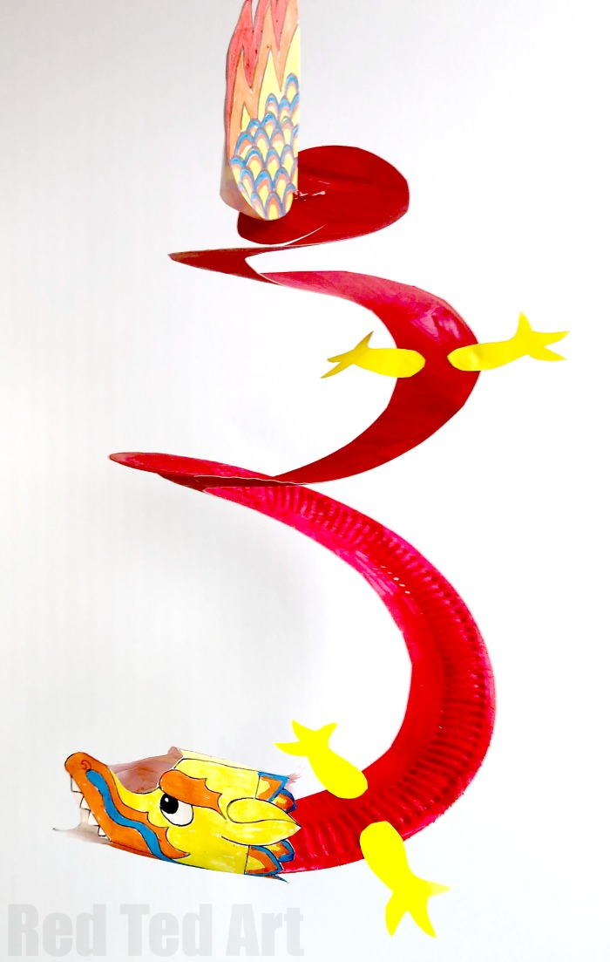Paper Plate Dragon Twirler

**Materials needed**

One paper plate per Dragon Twirler

Red paint (or any colour you like, great colours for Chinese New Year are red, yellow, green and blues.

Scissor

Glue

String & stapler for hanging

Pens for colouring

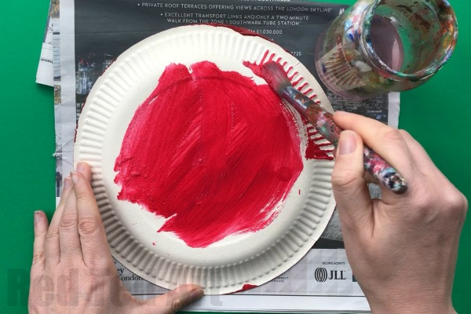Brushes for painting

**How to make a Paper Plate Dragon Twirler step by step instructions**

Paint your paper plate a lovely Dragon Red. Off course your dragon can be any colour – green, yellow, or maybe a mixture of colours to represent the scales.

Let it dry and paint the reverse side.

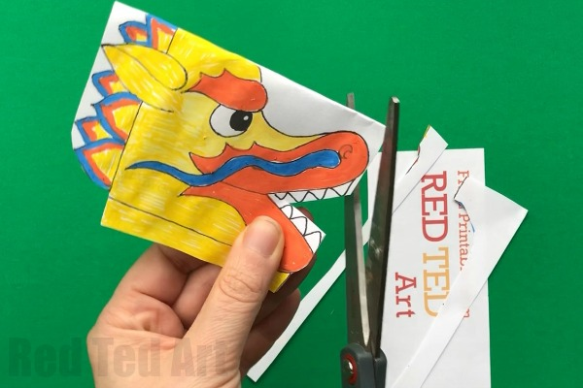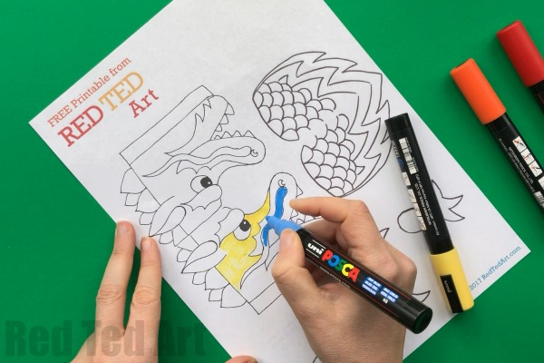

Whilst waiting for the paper plate to dry, you can start colouring your Paper Plate, you can have a 3D Dragon head, tail and some feet for you to print and colour.

Colour in whatever way you wish – use crayons, pens, watercolours! Whatever takes your fancy

Once your paper plate is dry, get your scissors and cute a spiral into your Paper Plate to make the Dragon Whirligig. It should look a bit like a snail.

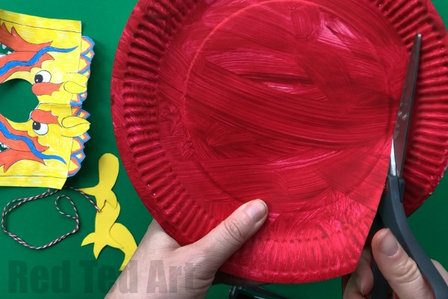

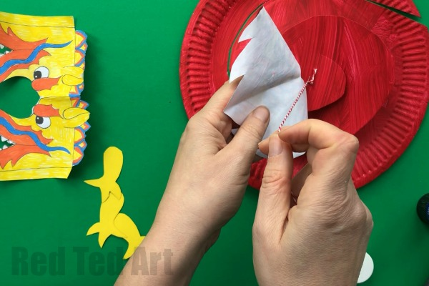

Take a piece of string and tie a knot one end. Then staple it into place.

Next you glue your dragon’s paper tail to the top of your dragon– make the string stick between the two dragon tail halves.

Now “assemble” your head. You will need to glue the bottom of your dragon face together.

Then add a little glue to the top of the nose and glue that too.

Now glue the paper dragon’s head to the bottom of your whirligig…. you can add tissue paper for FIRE if you wish.

Finally add your legs.

