HOW TO MAKE A HUNGRY CATERPILLAR WITH EGG CARTON

Things you need to make Hungry Caterpillar

- Egg carton
- Pipe cleaner
- Googly eyes
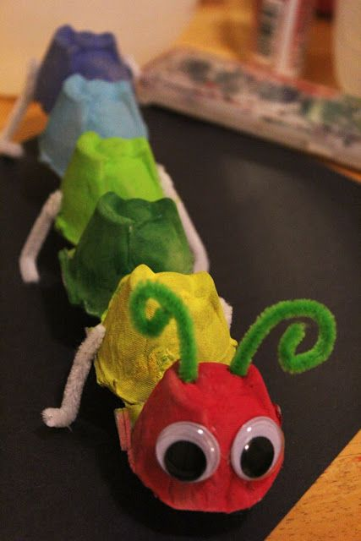
- Glue
- Paint

Separate six the cups from the egg container and paint it green or any colour you like.

Stick the cups using glue to each other as shown in the picture.

Stick two googly eyes on the front cup.

Stick two pipe cleaners as feelers and six pipe cleaners as legs on the sides of the cups.

Now your amazing Hungry caterpillar is ready to eat your dinner. 😊

