Owl Cupcakes

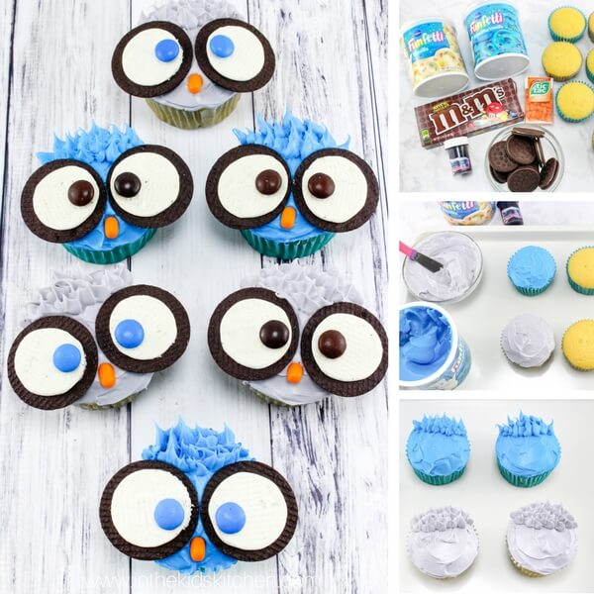

You will need…

* 2 cups flour
* 1/2 teaspoon salt
* 2 teaspoons baking powder
* 1/2 cup butter
* 3/4 cup white sugar
* 2 eggs
* 1 cup milk
* 1 teaspoon vanilla

Owl Decoration ingredients

* 1 Container Blue Frosting
* 1 Container White Frosting
* 1 pkg. Oreos
* 1 pkg. M&M’s Candy
* 1 pkg. Tic Tacs, orange
* Black Gel Food Colouring

Tools used

* Muffin tray
* Stand mixer
* Frosting decorating bags

How to make…

1. Preheat oven to 180°c and line a cupcake tray with your chosen liners.
2. In a medium bowl, whisk together the flour, baking powder and salt. Set aside.
3. Place the butter in a separate bowl and beat for 30 seconds before slowly adding in the white sugar.
4. Once the butter and white sugar mixture is light and fully beaten, beat in the vanilla and eggs.
5. Add half of the dry ingredients, mix completely, then add half of the milk. Repeat.

How to decorate…

1. Fill the muffin liners halfway full and bake 12-15 minutes and cool in the pan before removing to a cooling rack.
2. Mix a few drops of the black food colouring into about 95g of white frosting to make a light grey colour.
3. 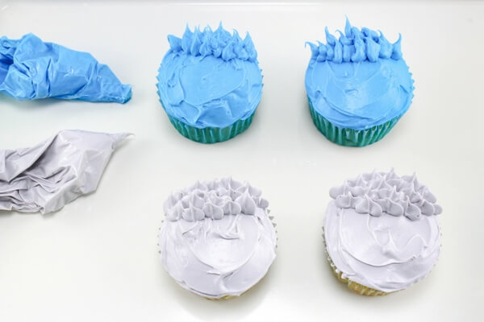Frost half the cupcakes with the blue frosting and the other half with the grey frosting.
4. Use a piping tip and a small plastic bag to pipe some feathers on the top half of the cupcakes.
5. Open cookies gently so the white filling stays on one side of the cookie. Set aside the halves with no filling, you will only use the filled sides.
6. Place two cookies on each cupcake to look like big owl eyes. Place an M&M on each cookie to represent the eyeballs.
7. Put a Tic Tac on each cupcake right underneath the cookie eyes, so it looks like a beak.

