**Floor Exercise Fitness**

**Winter fitness and Physical Development.**

Firstly, you will start by finding a comfortable spot on the floor. These exercises are better if you can lay your child on the floor, but can be done whilst the child is in his/her chair with full support.

Use this lesson to help with the physical development and stretch the body joints that maybe tight.

Follow the link below for the music and actions. Also find a list of ideas below for each exercise.

<https://youtu.be/34gaDOwFY28>

1. Arm Stretches - Raise the child’s arms above their head, you can either do one arm at a time or both arms, depending on the child’s ability of movement.
2. Side stretches – Move your child if possible, gently moving you child side to side from the waist upwards, this will help to stretch the side and stomach muscles.
3. Knees up – get both of your child’s knee and raise them up and down towards their chest, only stretch the legs to the child’s ability of movement.
4. 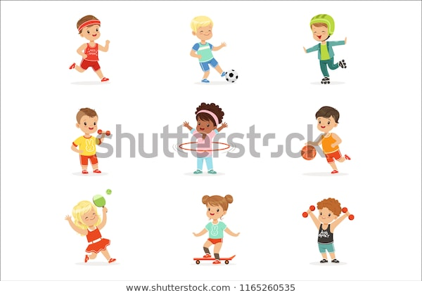Reindeer kicks- keep both legs straight and move the feet around is circles and wiggle them gently up and down.
5. Legs lift (side) – gently move your child’s leg outwards and slowly, do both legs one at a time. Stretch those inside muscles of the legs.
6. Legs Lift (Front)- back to lift the legs upwards toward the chest. This time do one leg at a time, left leg first then move to the right leg.
7. Sits up – If you can sit your child up, you can do this by giving the child your full support by sitting behind them. Why the child is sat up see if he/she can balance with or without support.
8. Relax- Use this time to reflect.

**Observations**

Let’s look at what worked and what didn’t work.

* Did your child show any likes/dislikes?
* Was your child comfortable in a certain position?
* Did he/she show response of being happy? Sad? Not sure? Pulling faces? Smiling?