**Counting 1-5**

Sit down with your child to watch the video below by clicking on the link.

<https://www.youtube.com/watch?v=uvo5DSTElxE>

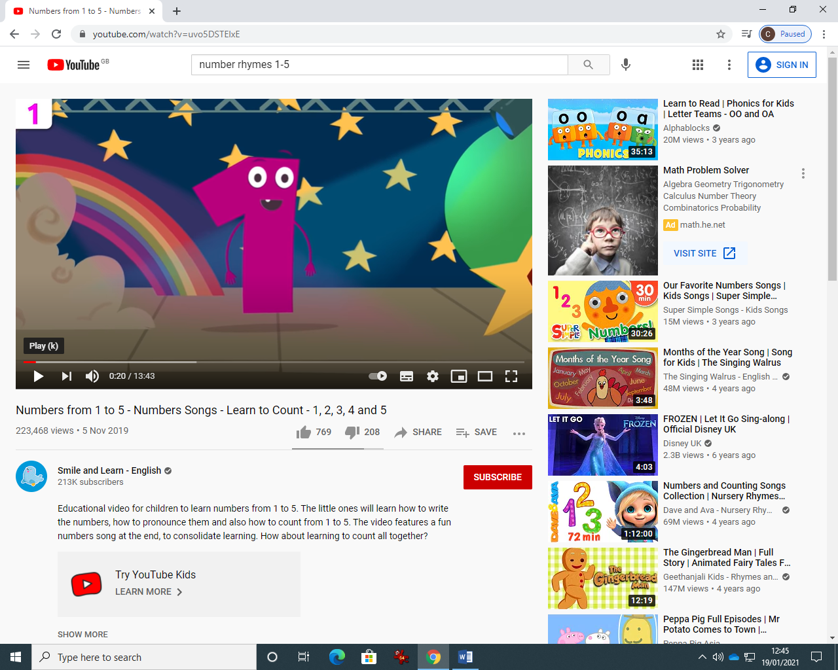

In the first part of the video the number will introduce himself.

This is followed by the number saying his name over and over and showing how it is written. Encourage your child to try and vocalise and make the sound of the number.

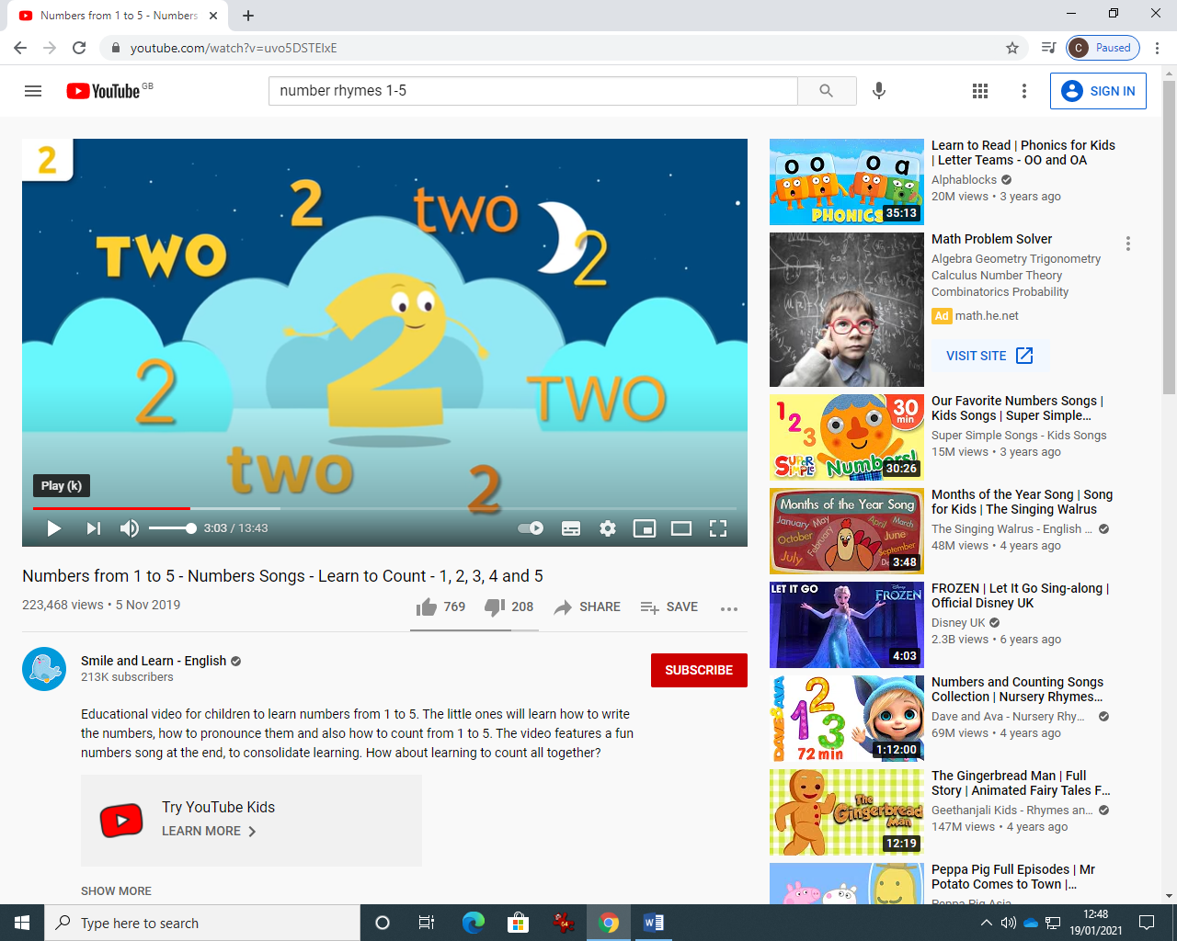

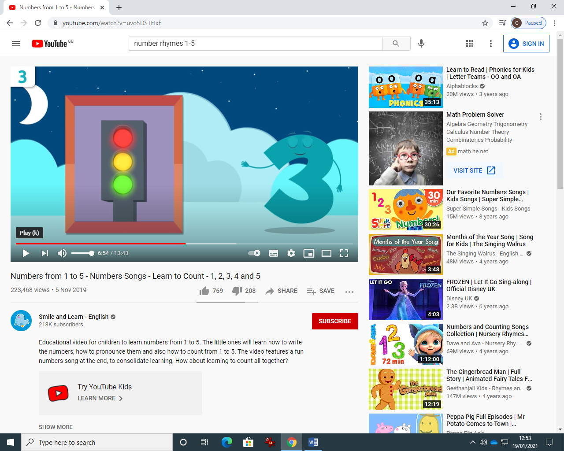

The number will then count objects that match him, like 3 traffic lights for number 3.

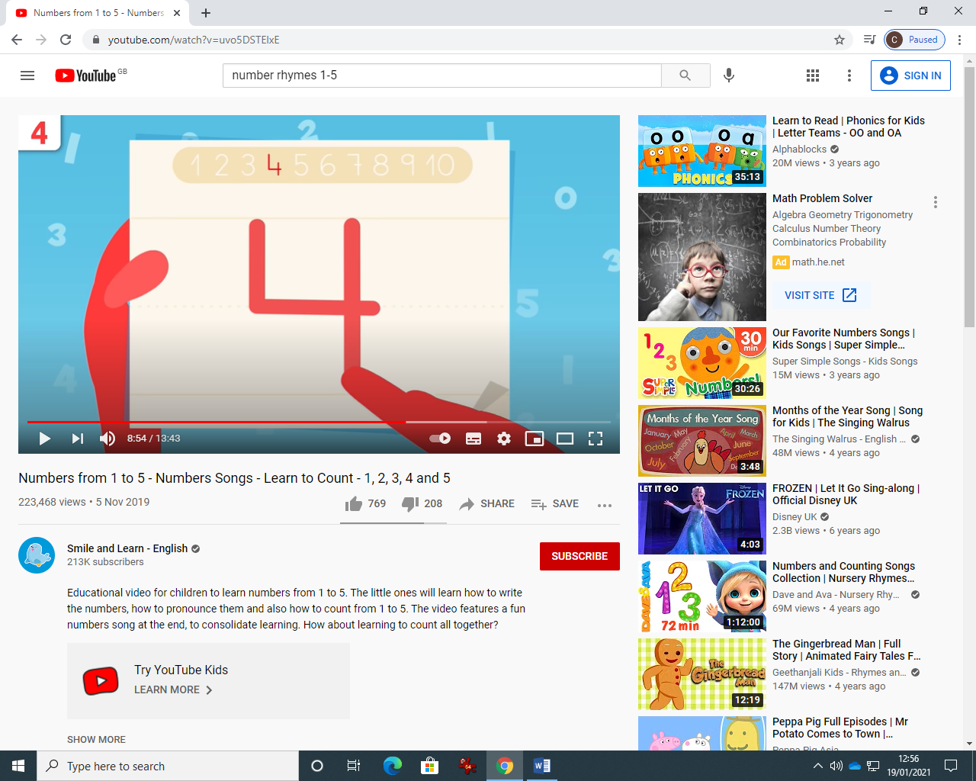

The number then will show you how to draw him and make the shape of him. You can help your child draw the shape of the numeral in the air, holding their hand with 1 finger pointing. You can help them trace the numeral in sand or shaving foam or on paper with support.

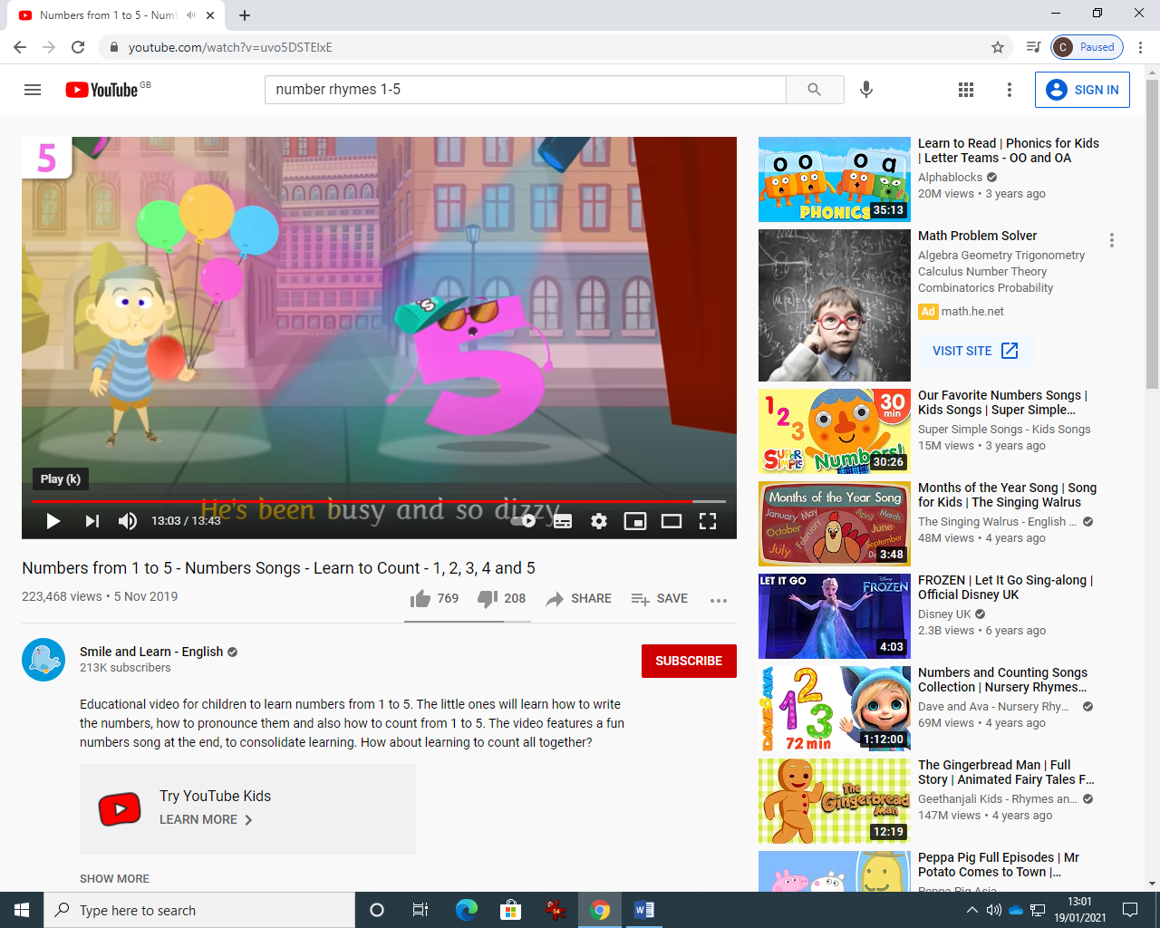

Finally, you can join in the song and dance for each number.

Have fun !

For an extension activity you could ask your child to point/eye point to the correct numeral when you hold up two e.g. 1 and 4 and ask them to look at number 4.

You could print two of each numeral and help them match, physically or by eye pointing.