Pringle tube reindeer

**[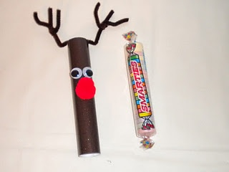](http://jeanscraftycorner.blogspot.com/2011/12/reindeer-candy-tube.html)**

**What you need (resources in bag):**

Pringle tube

Glittery card

Googly eyes

Glue

Clear tape

Pipe cleaners

**How to make it:**

**Step 1**: Paint the pringle tube brown.

**Step 2**: Stick the red glittery card onto the tube for Rudolph’s nose.

**Step 3**: Stick the googly eyes onto the tube using glue.

**Step 4**: Attach the pipe cleaners to the top of the tube using tape for Rudolph’s antlers.