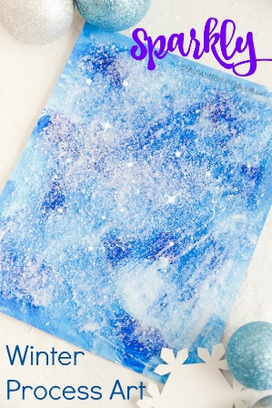**Winter Process Art**

**You will need:**

Card

Blue paint – selection of different blues

White paint

Glitter

Paint brush

**How to make:**

1. Encourage your child to use their hands or a paint brush to paint the background of their card using a mixture of different coloured blue paints and white paint.
2. Once the paint has dried, help your child to cover with glue and then sprinkle glitter all over their picture.