**Bubble wrap winter tree**

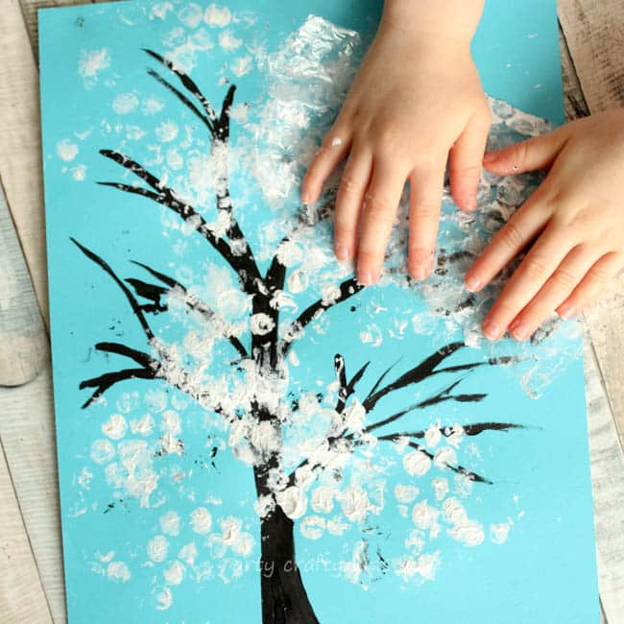

**You will need:**

* Blue card
* White paint
* Paint tray
* Black pen
* Bubble wrap

**How to make:**

* Draw a tree outline onto blue card, using a thick black or brown pen
* Cut bubble wrap into a smallish square. Encourage your child to explore the feel of the bubble wrap and help them to pop the bubble wrap bubbles.
* Place white paint into a paint tray (or a container). Help your child to dip the bubble wrap into the paint.
* Help your child to press the paint covered bubble wrap onto the card, over the tree outline, to make prints and create a winter tree!