***Story Massage Strokes***

|  |  |
| --- | --- |
| ***The circle***  With your palm flat, make a circle |  |
| ***The semi-circle***  With your palm flat, make half a circle |  |
| ***The wave***  With your palm flat, draw a vertical wavy line |  |
| ***The sideways wave***  With your palm flat, draw a horizontal wavy line |  |
| ***The fan***  With both palms flat, start with hands at the centre together and move ***up*** and out (away from each other) to create a fan shape |  |
| ***The downward fan***  With both palms flat, start with hands at the centre together and move ***down*** and out (away from each other) to create a fan shape |  |
| ***The calm***  Place both palms onto area and just hold. Provide enough pressure to encourage calm. |  |
| ***The walk***  Palms flat, place one after each other and ‘walk’ up or down the area. |  |
| ***The drum***  Hands make a fist and gently knead area. |  |
| ***The claw***  Fingers make a claw shape and use fingertips to gently move over the area. |  |
| ***The squeeze***  Use both hands (between fingers and thumb) to gently ‘squeeze’ the area and hold. |  |
| ***The bounce***  Use one hand at a time to gently ‘squeeze’ and pick up the area and then release upwards. |  |
| ***The sprinkle***  Use your fingertips alternately to tap over area like rain. |  |

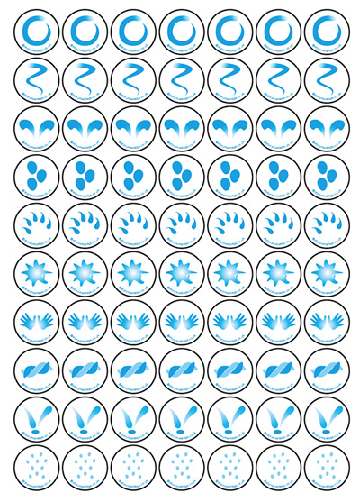Story massage symbols

