**Green and red rice**

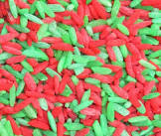

**You will need**

Uncooked rice

Red paint

Green paint

Tray or bowl

**How to make:**

* Pour half a bag of dried rice into one bowl and then the other half of the rice into another bowl.
* Mix one bowl of rice with red paint and a little bit of water
* Mix the other bowl of rice with green rice and a little bit of water.
* You can either leave in the bowl to dry or tip onto greaseproof paper to dry.
* Once the rice has dried, mix the coloured rice together and encourage your child to explore!