 ***Milk carton birdhouse***

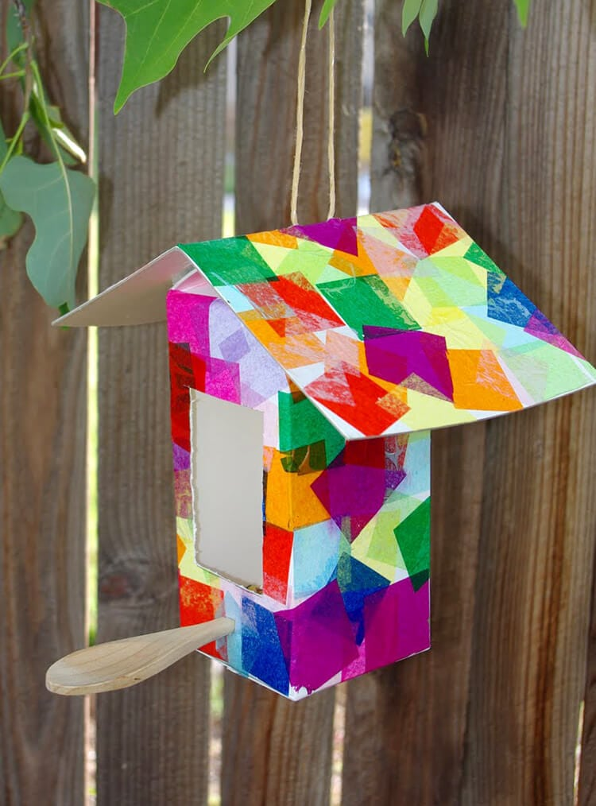**What you need:**

* Clean and dry Recycled Milk or Juice Carton
* White Paint
* Recycled Cardboard
* [PVA Glue](https://amzn.to/2s8E619)
* [Paintbrush](https://amzn.to/2rYfYQA)
* [Tissue Paper Squares](https://amzn.to/2tjHLZk) in assorted Colours
* String
* [Wooden Spoon](https://amzn.to/2tjKTVd)
* [Knife](https://amzn.to/2sq83Ns) (if needed, parental use only)

**Method :**

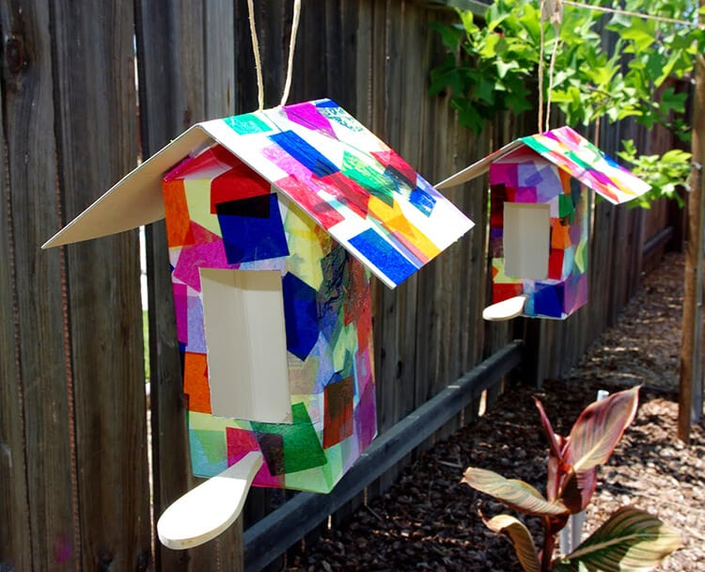Paint the milk carton with white paint and stick coloured tissue paper to the outside with PVA glue. Decorate in the same way the cardboard for the roof. After this has dried, cut out a rectangle shape for the entrance and make two holes under the entrance to attatch the wooden spoon for birds to stand ! Make a small hole on top of the roof to hang it on the tree brunch using the string. Now you have made a cosy house for your garden birds