Paper plate Christmas tree

[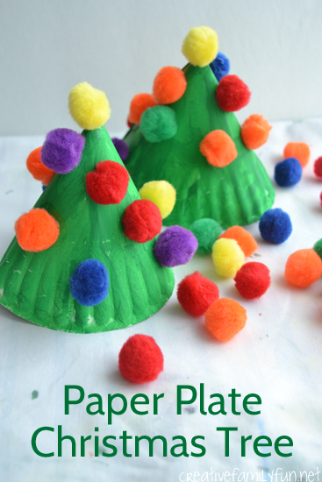](http://1.bp.blogspot.com/-HTsLwYPEhzY/VIITDYQX-QI/AAAAAAAAMFY/xI-1xQZOEzE/s1600/paperplatechristmastree1creativefamilyfun.png)

**What you need:**

Paper plate

Green paint

Pom poms

Glue

Clear tape

**How you make it:**

**[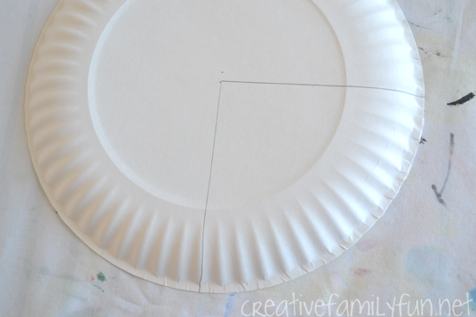](http://1.bp.blogspot.com/-nEHa5fGIPzQ/VIITDcmktNI/AAAAAAAAMFQ/75PyBn55U5A/s1600/paperplatechristmastree3creativefamilyfun.png)Step 1:** Cut a corner out of the paper plate.

**Step 2:** Paint the paper plate green.

**Step 3**: Roll the plate into a cone shape and attach it together using tape.

**Step 4**: Use the glue to attach the pom poms onto the tree.