Springtime TacPac!
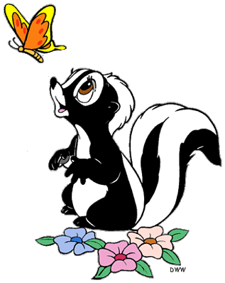
- Here Comes Peter Cottontail –
https://www.youtube.com/watch?v=q7UXYvRRZFc
Do a massage bouncing motion over the child’s arms and legs.
- Little April Shower (Bambi) –
https://www.youtube.com/watch?v=BPjgz_sWQTA
Use a water spray to spray over child.
- Let’s Sing a Little Spring Song (Bambi) –
https://www.youtube.com/watch?v=3QSNlj1Kv9w
Use a torch to allow children to track light.
- Ba-Ba Black Sheep –
https://www.youtube.com/watch?v=MR5XSOdjKMA
Use a handful cotton wool and let your child feel the cotton wool, stroke over arms and legs.
- Relaxation time –
https://www.youtube.com/watch?v=5wkAO5o7uoE
Use baby oil or moisturising lotion to give your child a hand massage and relax.
Tell your child the tacpac has finished and thank them for working with you.

