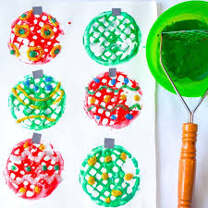**Potato Masher Bauble Printing**

**You will need:**

Selection of coloured paints

Potato masher

Card

**How to make:**

1. Encourage your child to choose the coloured paints that they would like to use.
2. Help your child to dip their potato masher into the paint and then make a print onto the card.
3. Repeat as many times as you like!