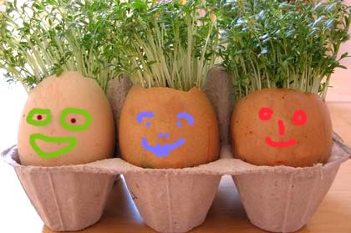

**Mustard and Cress Men**

Save a few boiled egg shells, pierce the base with a needle (for drainage) and place them into an old egg box, or egg cups for support.

Tear up kitchen paper or use cotton wool which makes a good medium for growing, filling each egg shell to three quarters level and then sprinkling some seeds on top - one shell use mustard seeds, one of cress, one of chives and so on.

Top off the seeds with some more paper or cotton wool and just add water – keeping it on the draining board initially until the first drainage flow has stopped.

Now place them on the windowsill ensuring they don’t have too much day-long sun to bake in, then just wait to see some green sprouts appear – which could be the next morning, or 48 hours max.