**“What’s the Time Grandma Wolf?” by Dosbarth Eirlys**

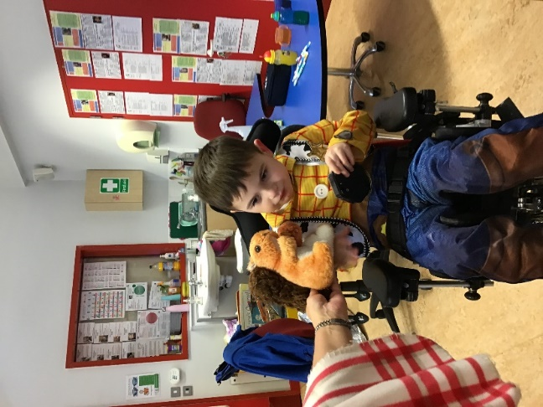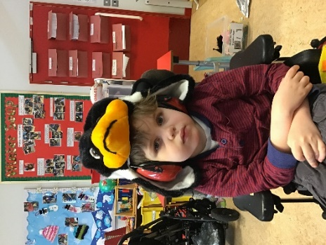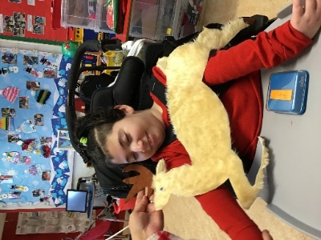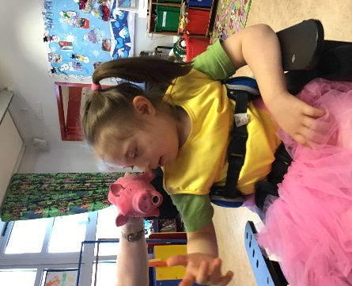**Starring:**

**Harley as Squirrel**

**George as Crow**

**Elissah as Fawn who’shy**

**Sofia as Piglet**

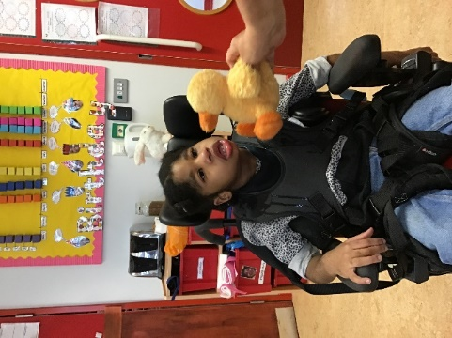

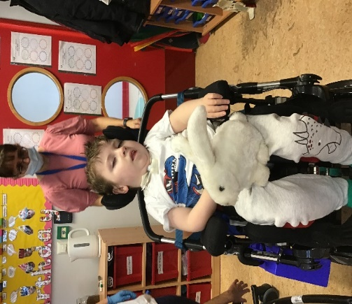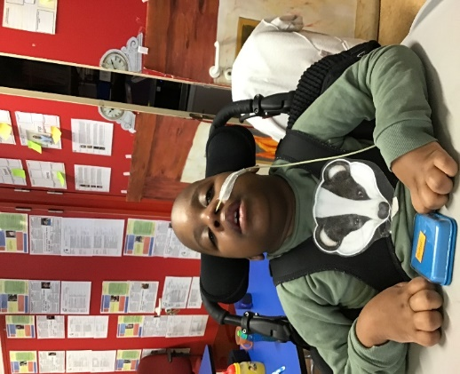

**Amina as Duckling**

**Alfie as Rabbit**

**Daniel as Badger**

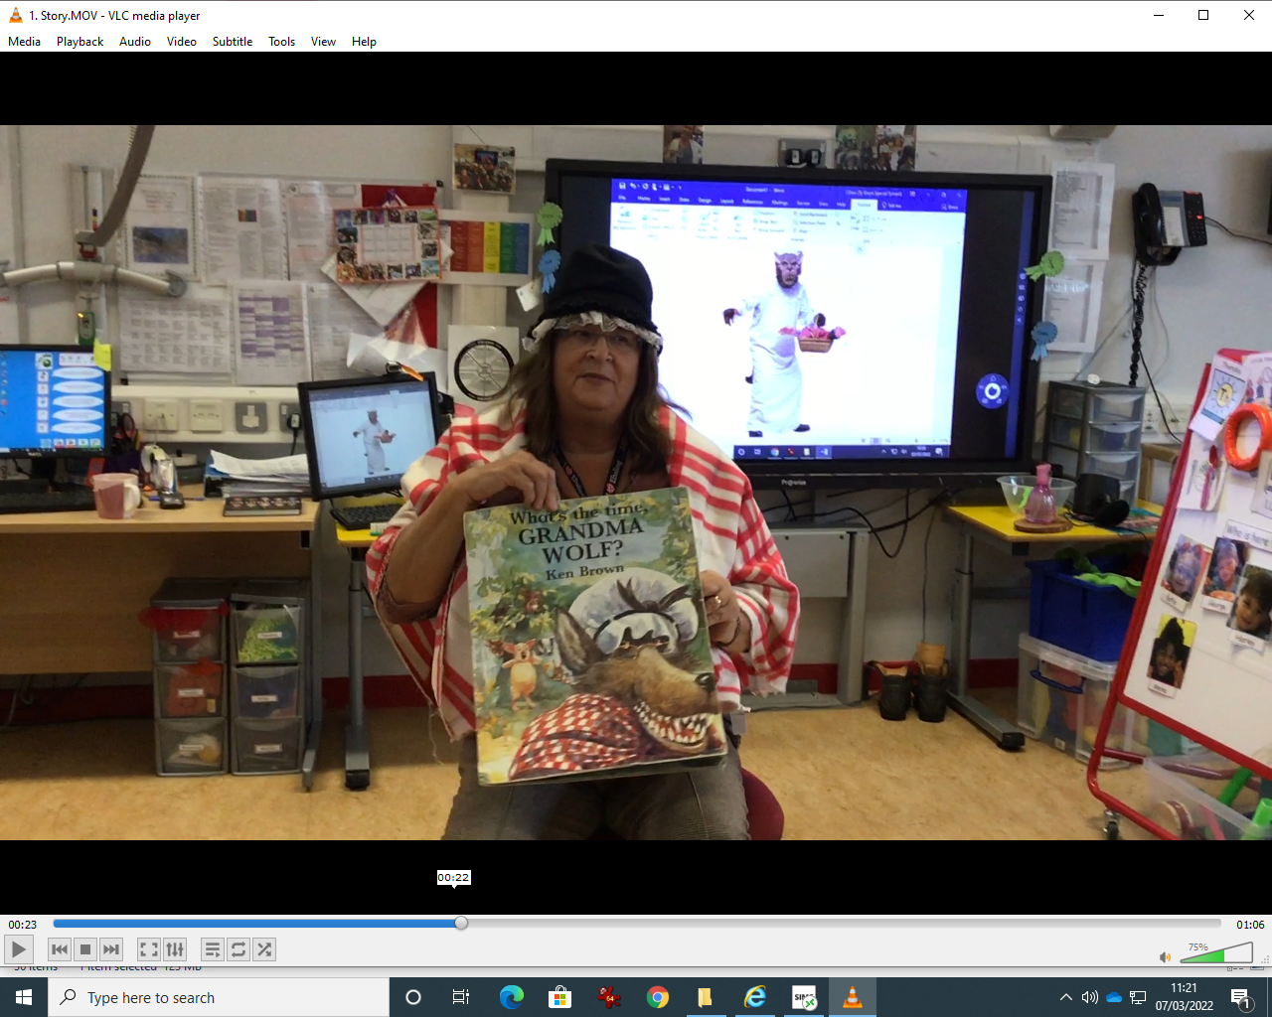

**And Jackie as Grandma Wolf**

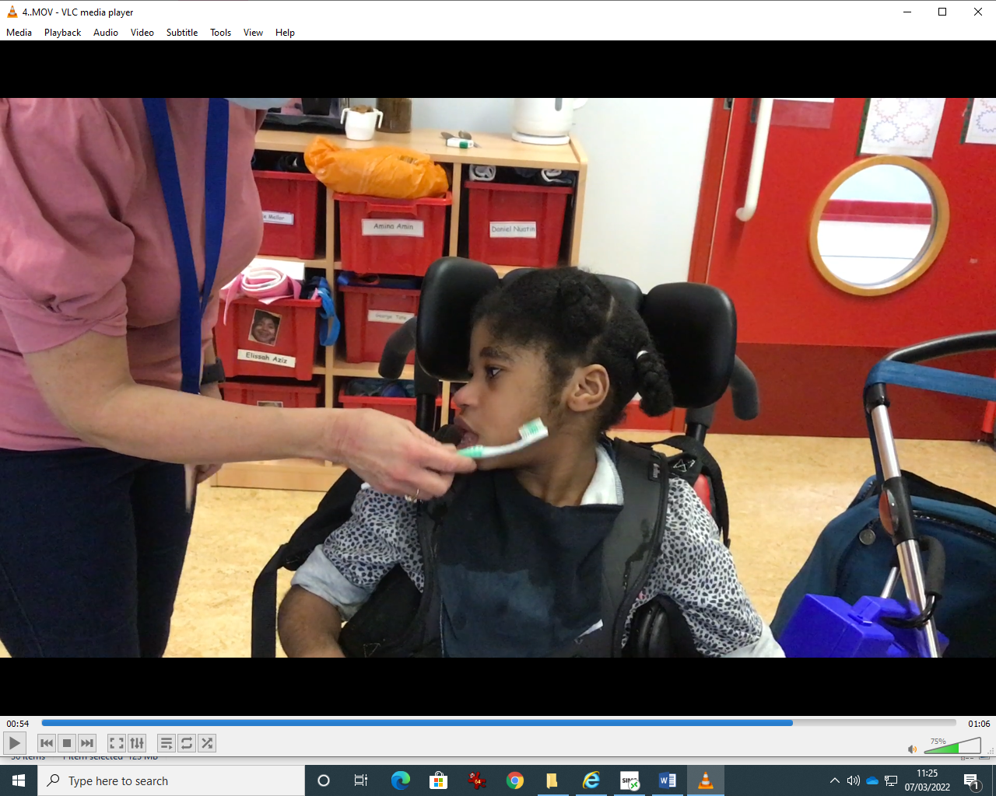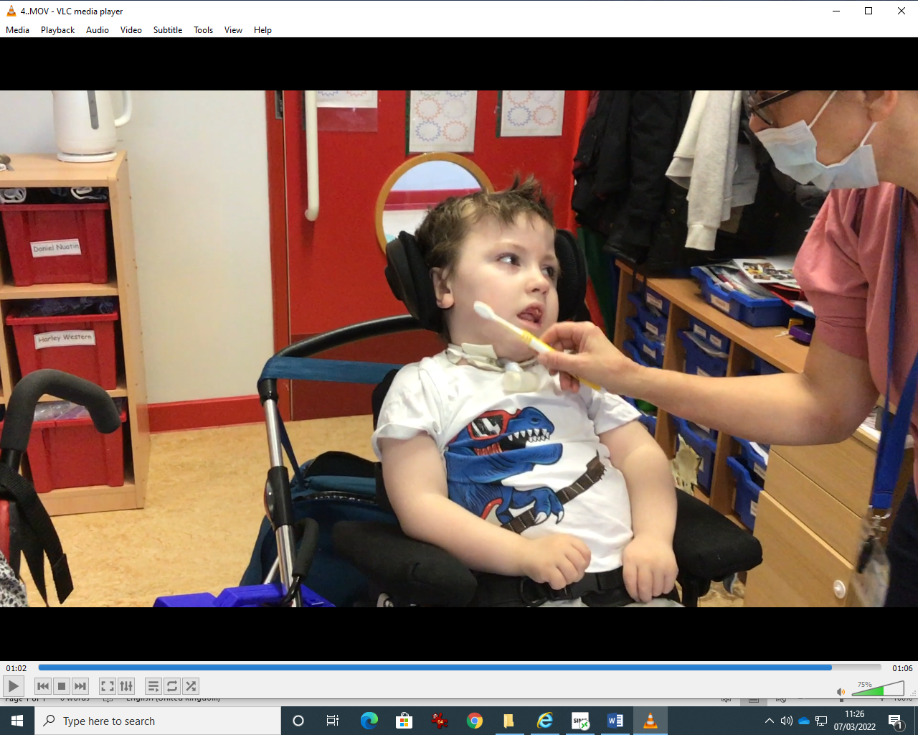First it was time they cleaned their teeth,

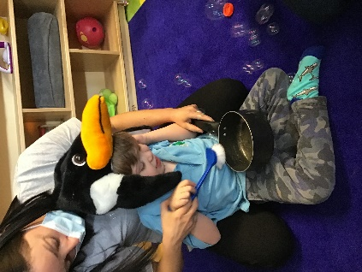

Then time to scrub the stewpot,

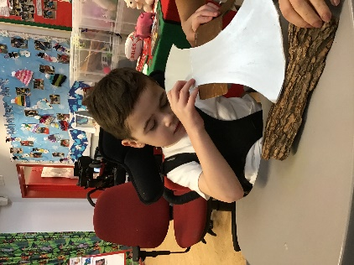

Next it was time to chop the wood,

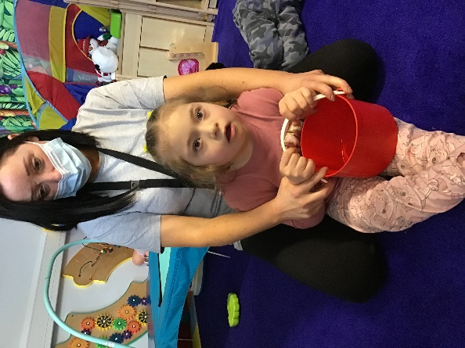

Then the water needed fetching,

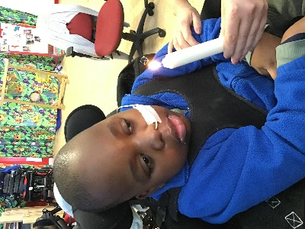

Next it was time to light the fire,

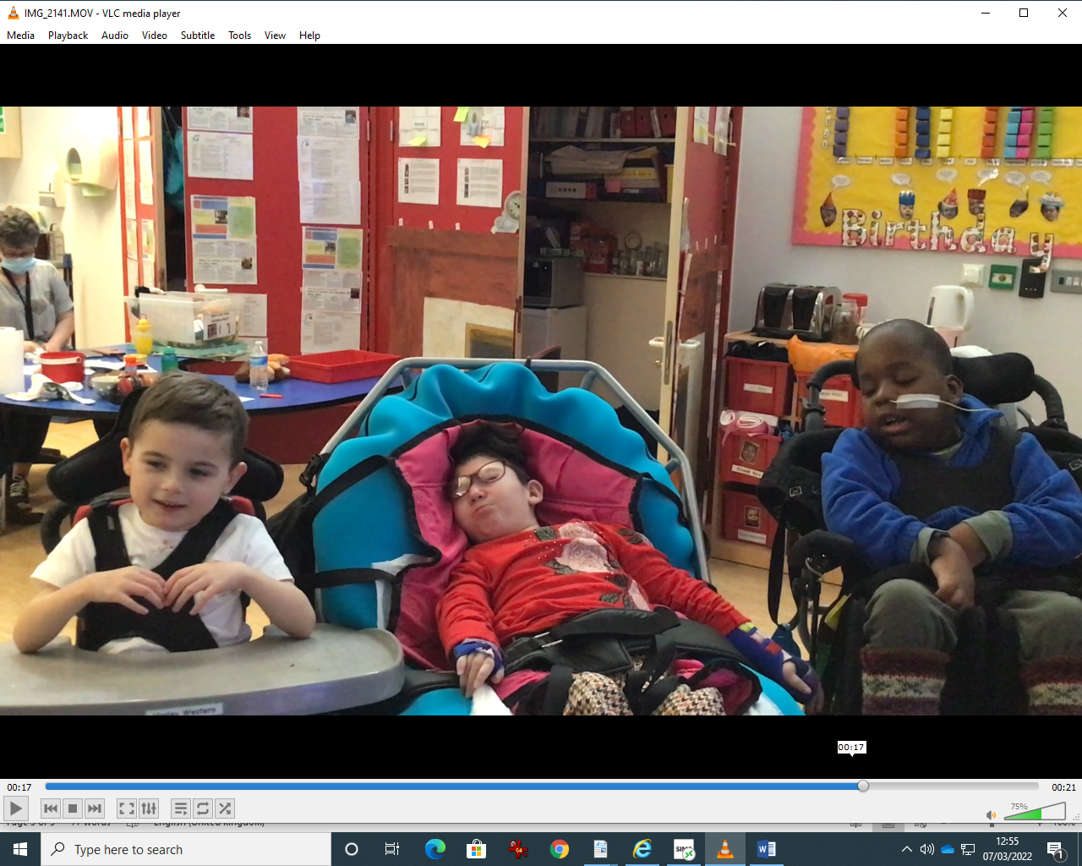 Then it was **Dinner Time!**

The pupils jumped when Grandma Wolf shouted!