**Sea themed sensory play**

Here are some simple sensory play ideas that link in with part of our story, The Everywhere Bear. Most of the items needed can be found around the house or bought cheaply in a discount store.

***Sea Sensory Bag***

* Blue shower gel
* Clear re-sealable bag (good quality!)
* Small plastic sea creatures or fish
* Shells
* Duct tape

Add all of the items to a bag and seal with duct tape. Children love to poke and prod the bag and see the creatures move about. A mess free activity too!

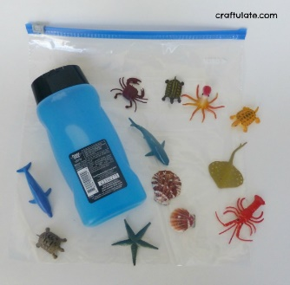 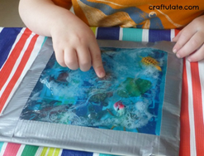 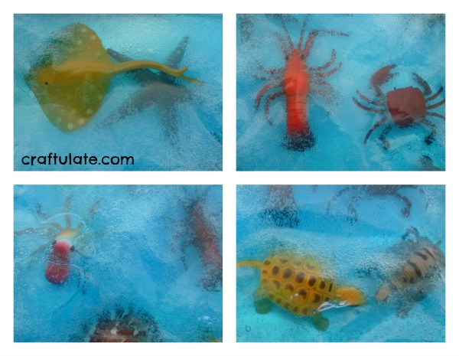

***Ocean in a Bottle***

* Water
* Cooking oil
* Blue food colouring

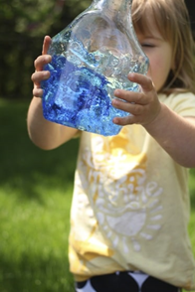**TIP:** a mouthwash bottle is perfect, as it has a childproof lid which prevents children from opening it when playing with it.

1. Fill approximately 1/3 of your bottle with water.
2. Add several drops of food colouring.
3. Have your child shake the bottle to disperse the food colouring and watch the waves appear!

***Soapy Sea Foam***

* Washing up liquid
* Green food colouring
* Bowl
* Electric Whisk

Add lots of washing up liquid to a small amount of water and a few drops of food colouring. Whisk up with the electric whisk and watch the foam appear! You could even add a sea minerals type shower gel to give a fresh sea fragrance to the foam.

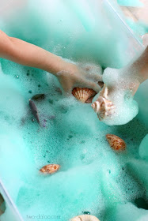

***Seafood Squidge***

* Dried Spaghetti
* Tuna or any tinned fish

Cook a pan of spaghetti pasta, once cooked, drain and add a little oil and green food colour so it looks like a seaweed type mixture.

Tip onto a tray and mix in tuna or tinned fish.

Allow your child to explore the fishy seafood squidge! Its edible too, just a bit stinky!

***Small World Edible Fish Play***

* Blue Jelly
* Swedish fish sweets

Make a bowl of jelly (use lemon or pineapple jelly and use blue food colouring if you can’t find a blue jelly).

Swedish fish are jelly sweets that can be bought online or in a shop called Tiger. Once jelly has set allow your child to mix it all up and scrunch it between their fingers. The fish sweets can be added to the jelly to encourage fine motor skills.

