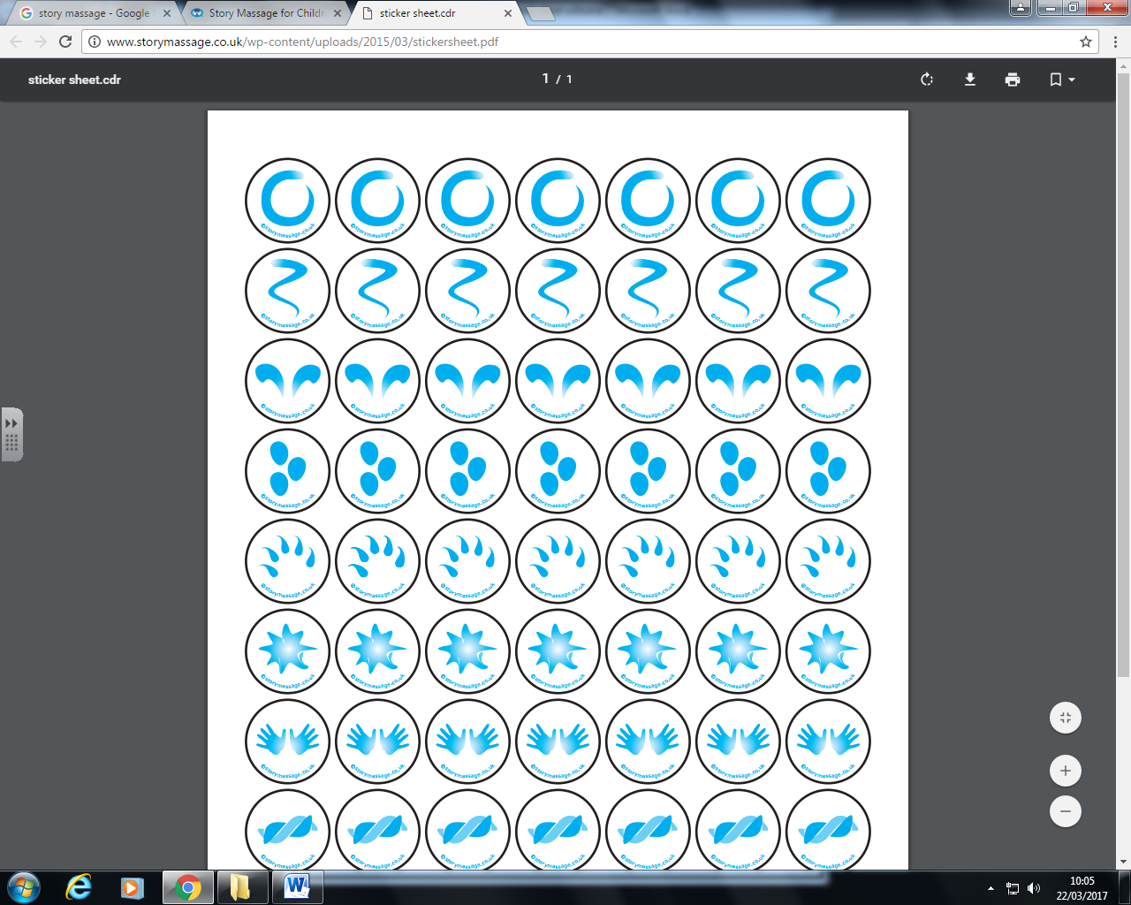



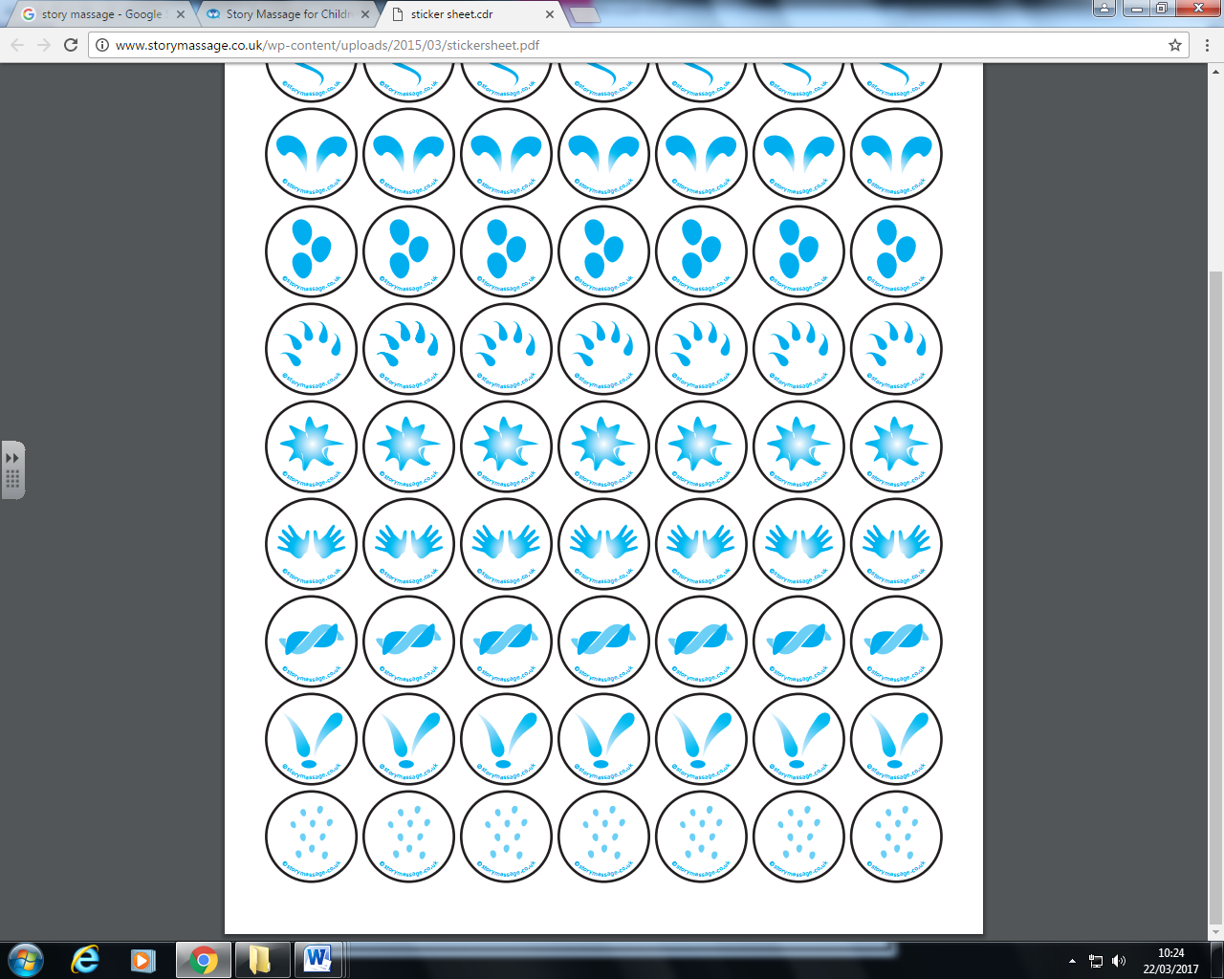



Repeat and count down

Then there were four green speckled frogs..

One jumped into the pool where it was nice and cool

Sat on a speckled log, eating some most delicious grub…yum yum

Five little speckled frogs

**Speckled frogs**