**Feather clothes peg birds**

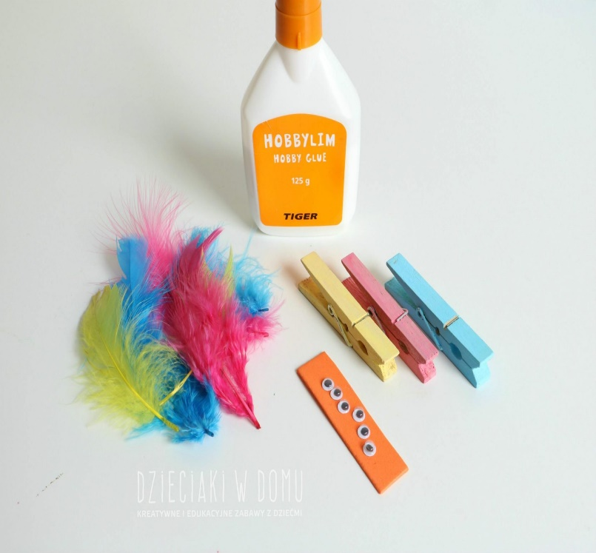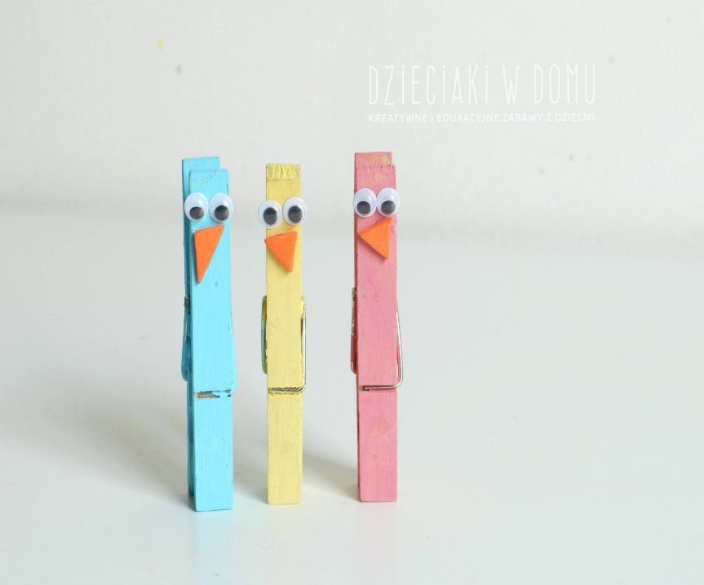**You will need:**

* Wooden pegs
* Colourful feathers
* Googlie eyes
* Orange felt
* Scissors
* Glue
* Paint
* Brushes

**Method:**

Paint the pegs first like you see in the pictures. After drying, glue on the eyes and beaks cut from orange felt, and then the feathers like shown in the pictures.

If you want to attach these peg birds to branches, remember to stick the head elements to the appropriate side of the peg, this can be clearly seen in the pictures. You can use spring branches, which is showed in the picture no 4.

