**What is your animal birth year in the Chinese calendar?**

**What is the Chinese Zodiac?**

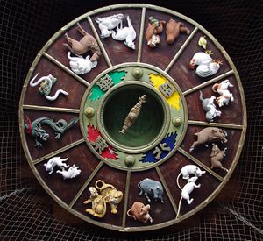The Chinese zodiac is a cycle of 12 animals. Each animal represents one year. People are associated with the zodiac animal for the year that they are born. The 12 animals in order are: Rat, Ox & Cow, Tiger, Rabbit, Dragon, Snake, Horse, Goat, Monkey, Rooster & Chicken, Dog, and Pig. Zodiac animals can also represent hours of the day and directions. Although it is called the Chinese zodiac, this system is also used in several other countries in Asia such as Korea, Japan, and Vietnam.

**Let’s find out which animal is the year that you are born?**

**Squeak!**

If you are born in 2008…

You are a year of Rat!

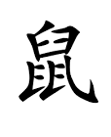

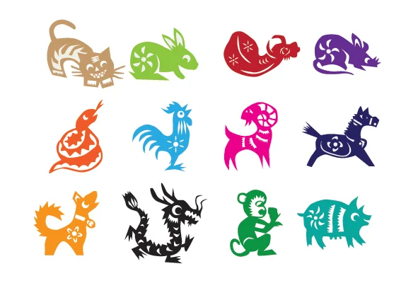

And your personality is honest, freedom, hard working, charming.

Roar!

If you are born in 2010…

You are a year of Tiger!

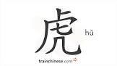

And your personality is strong and generous.

If you are born in 2011…

**Hop Hop!**

You are a year of Rabbit!

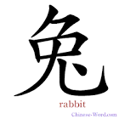

And your personality is kind, sensitive, elegant, artistic.

If you are born in 2012…

Roar!

You are a year of Dragon!



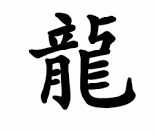

And your personality is strong, proud, direct, eccentric.

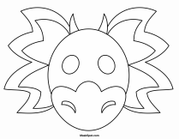Use the printable templates to decorate your own year of animal mask! Dragon Mask

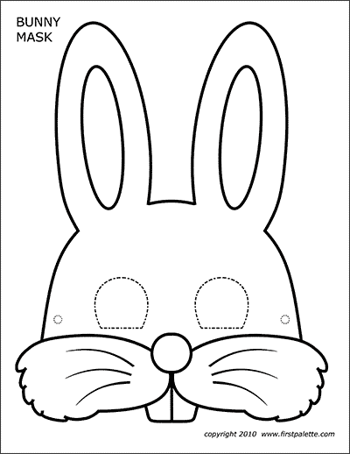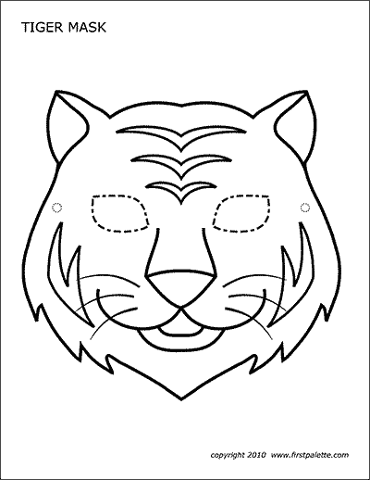Tiger Mask

