Shapes with Peppa Pig!
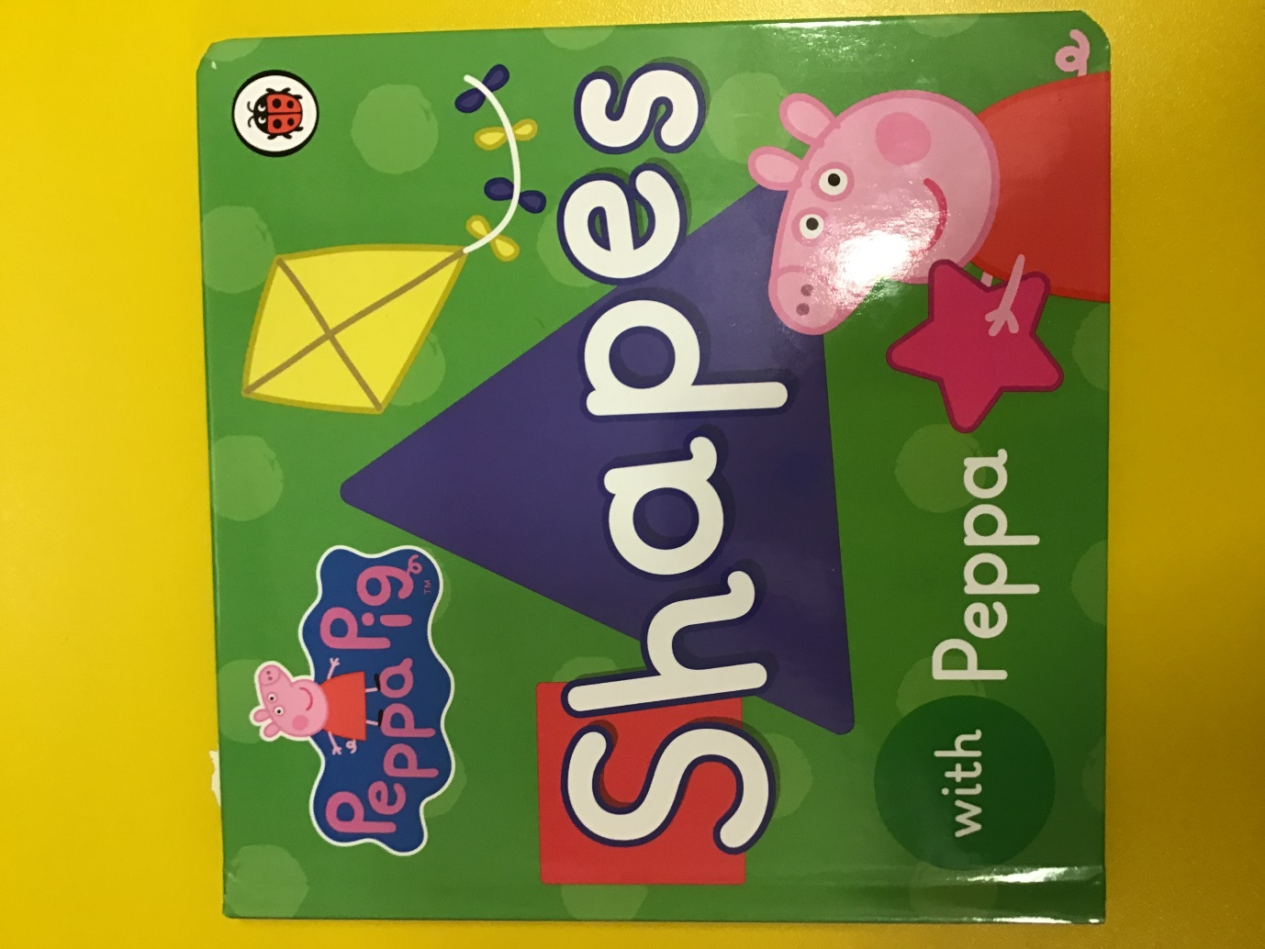

Whilst looking through the story use Mathematical language with your child such as the triangle has 3 sides 1,2,3. Help them explore the object with help saying, “Can you feel the shape? It is round.”
Play The Shape Song 2 on youtube to begin the activity: https://www.youtube.com/watch?v=WTeqUejf3D0

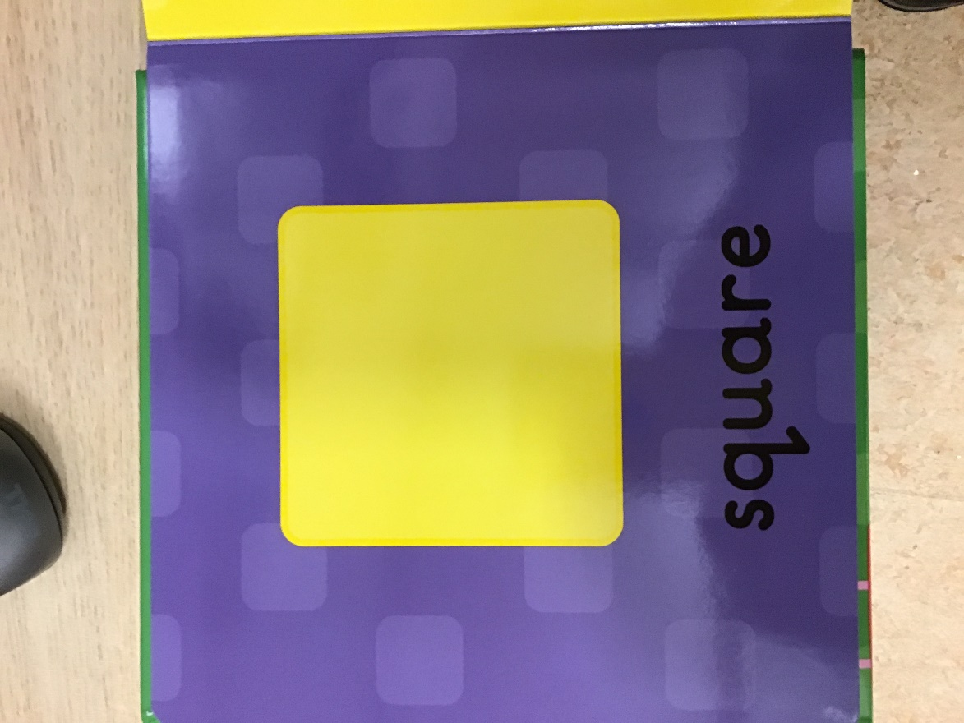

This is a square. It has 4 sides. Let’s count 1,2,3,4.
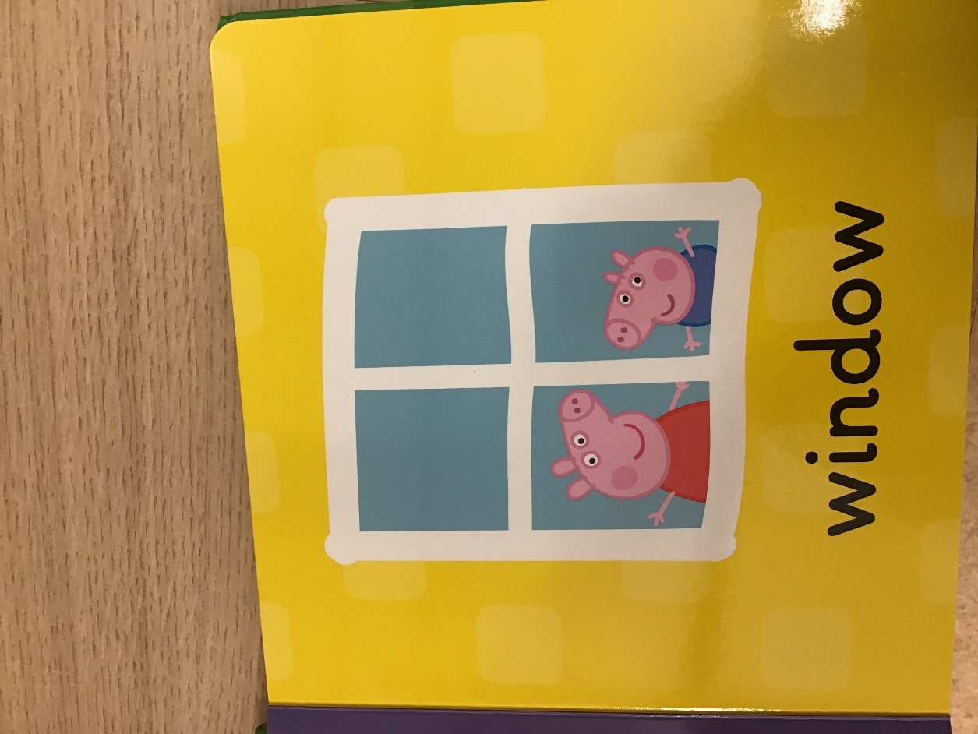

The window is square. Peppa and George are looking out of the square window.
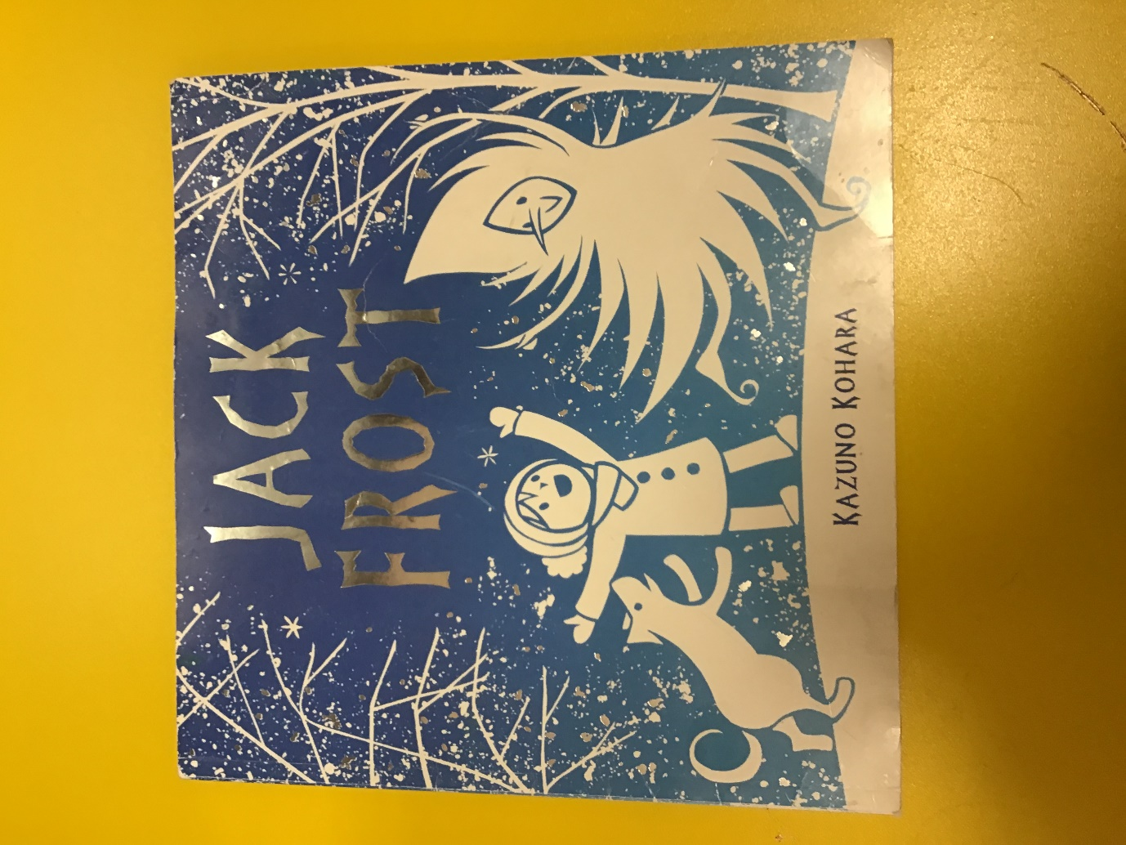
My book is square.

So is the present.
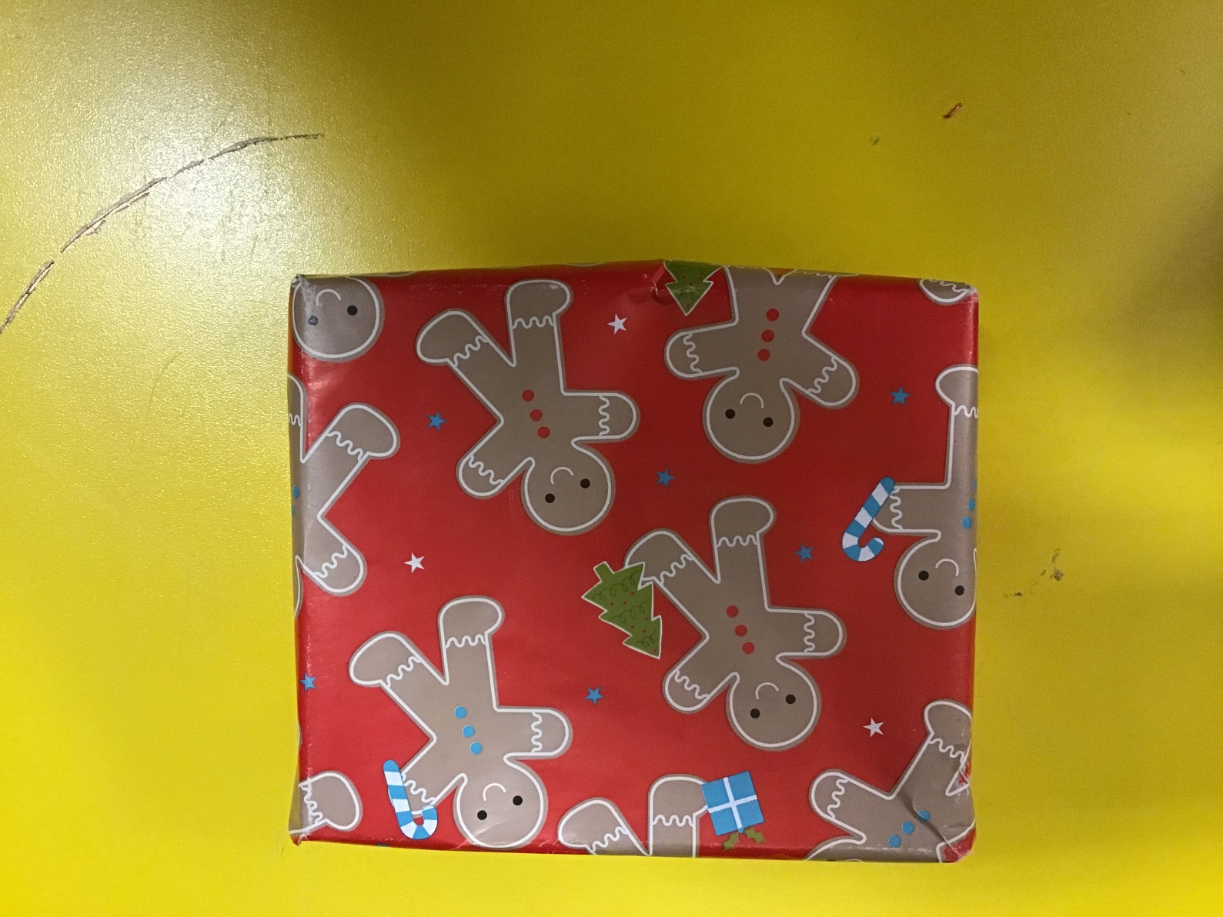
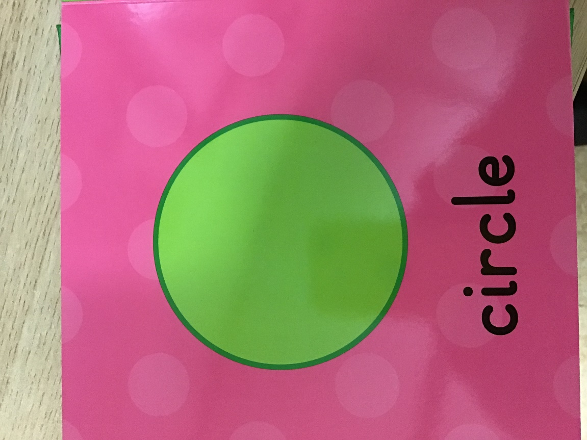

This is a circle. It only has 1 side.
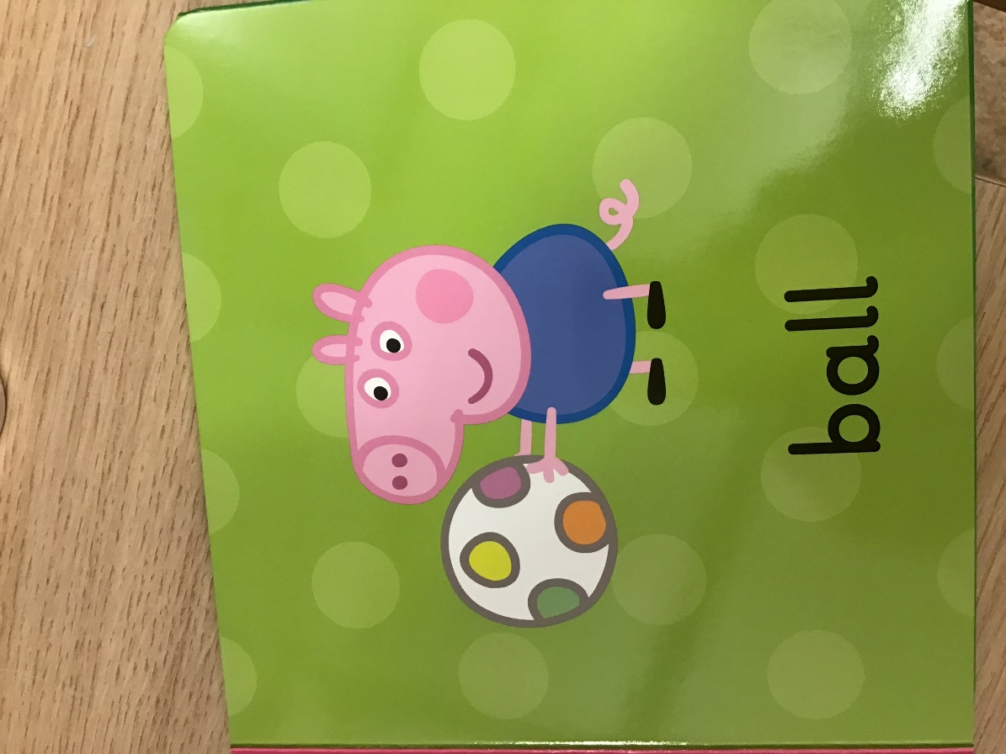

A circle is round. George has a round ball. Can you make a circle in the air with help?
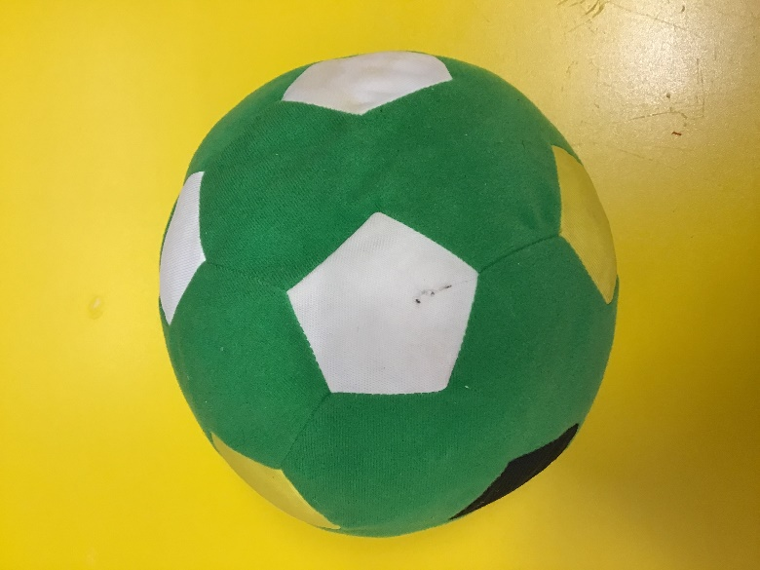
I also have a round ball.

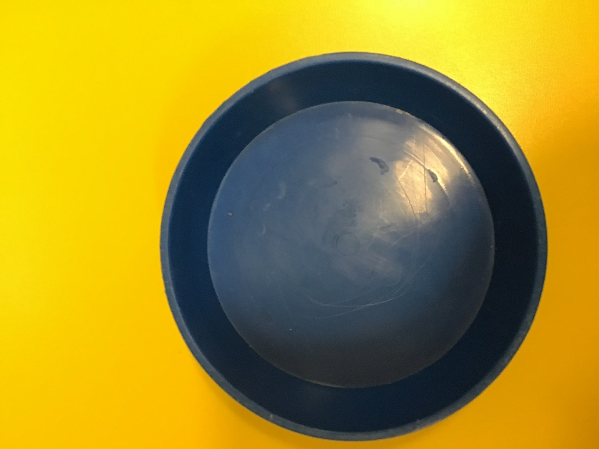

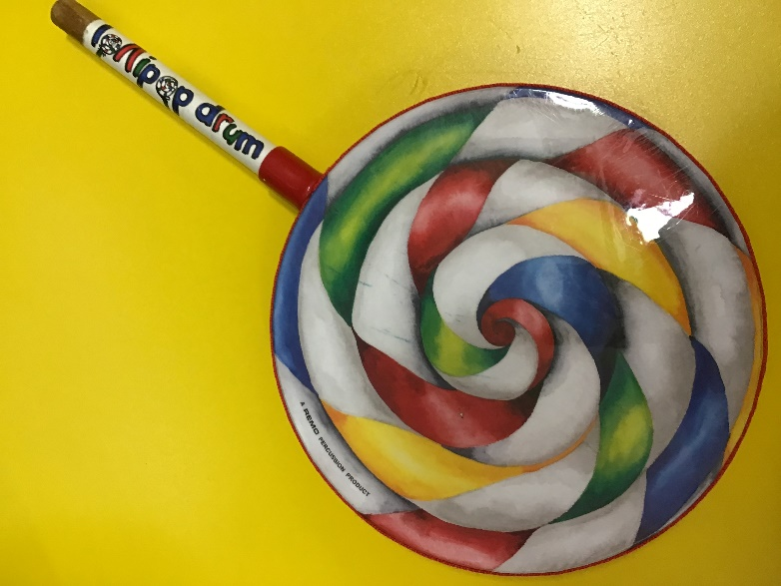
The bowl is a circle.

So is the lollipop drum.

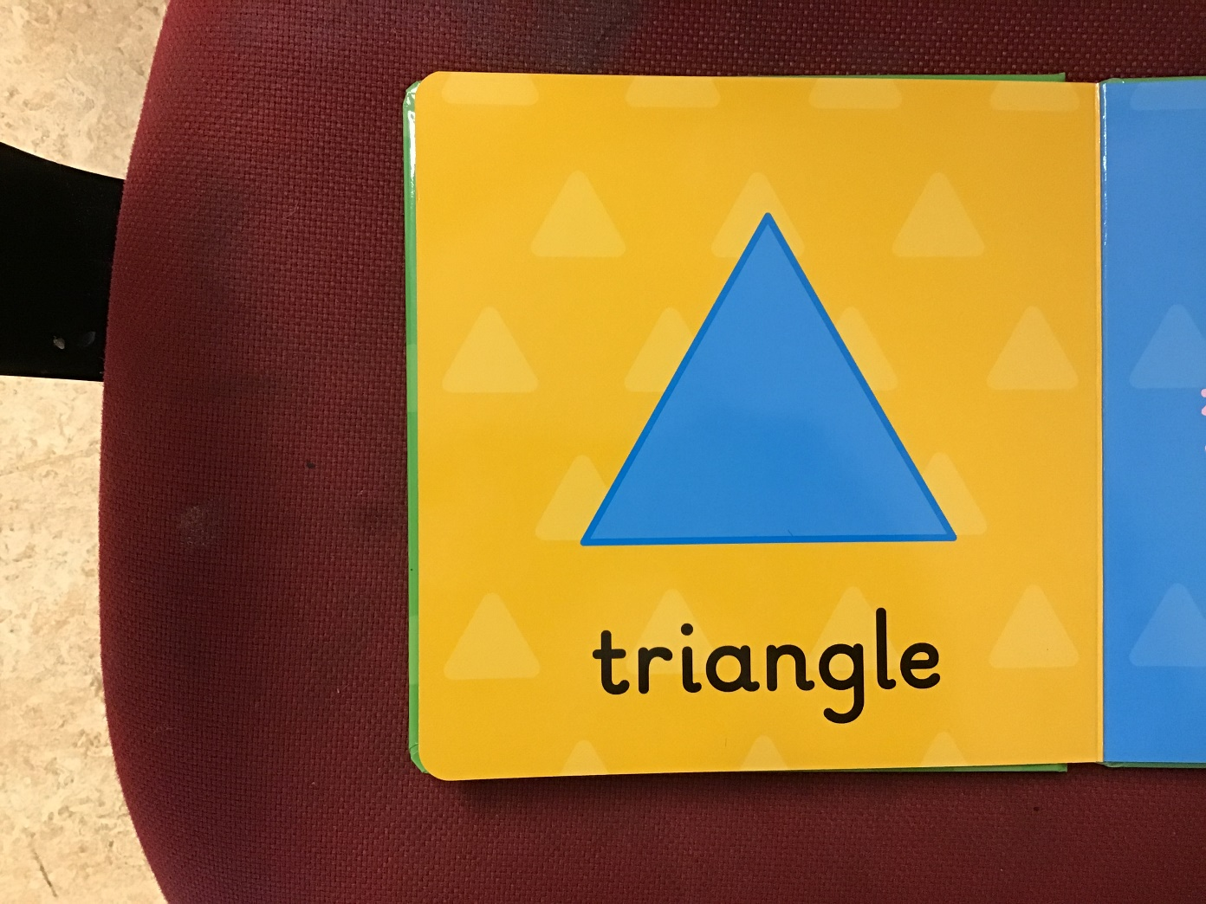

This is a triangle. It has 3 sides. Let’s count 1,2,3.
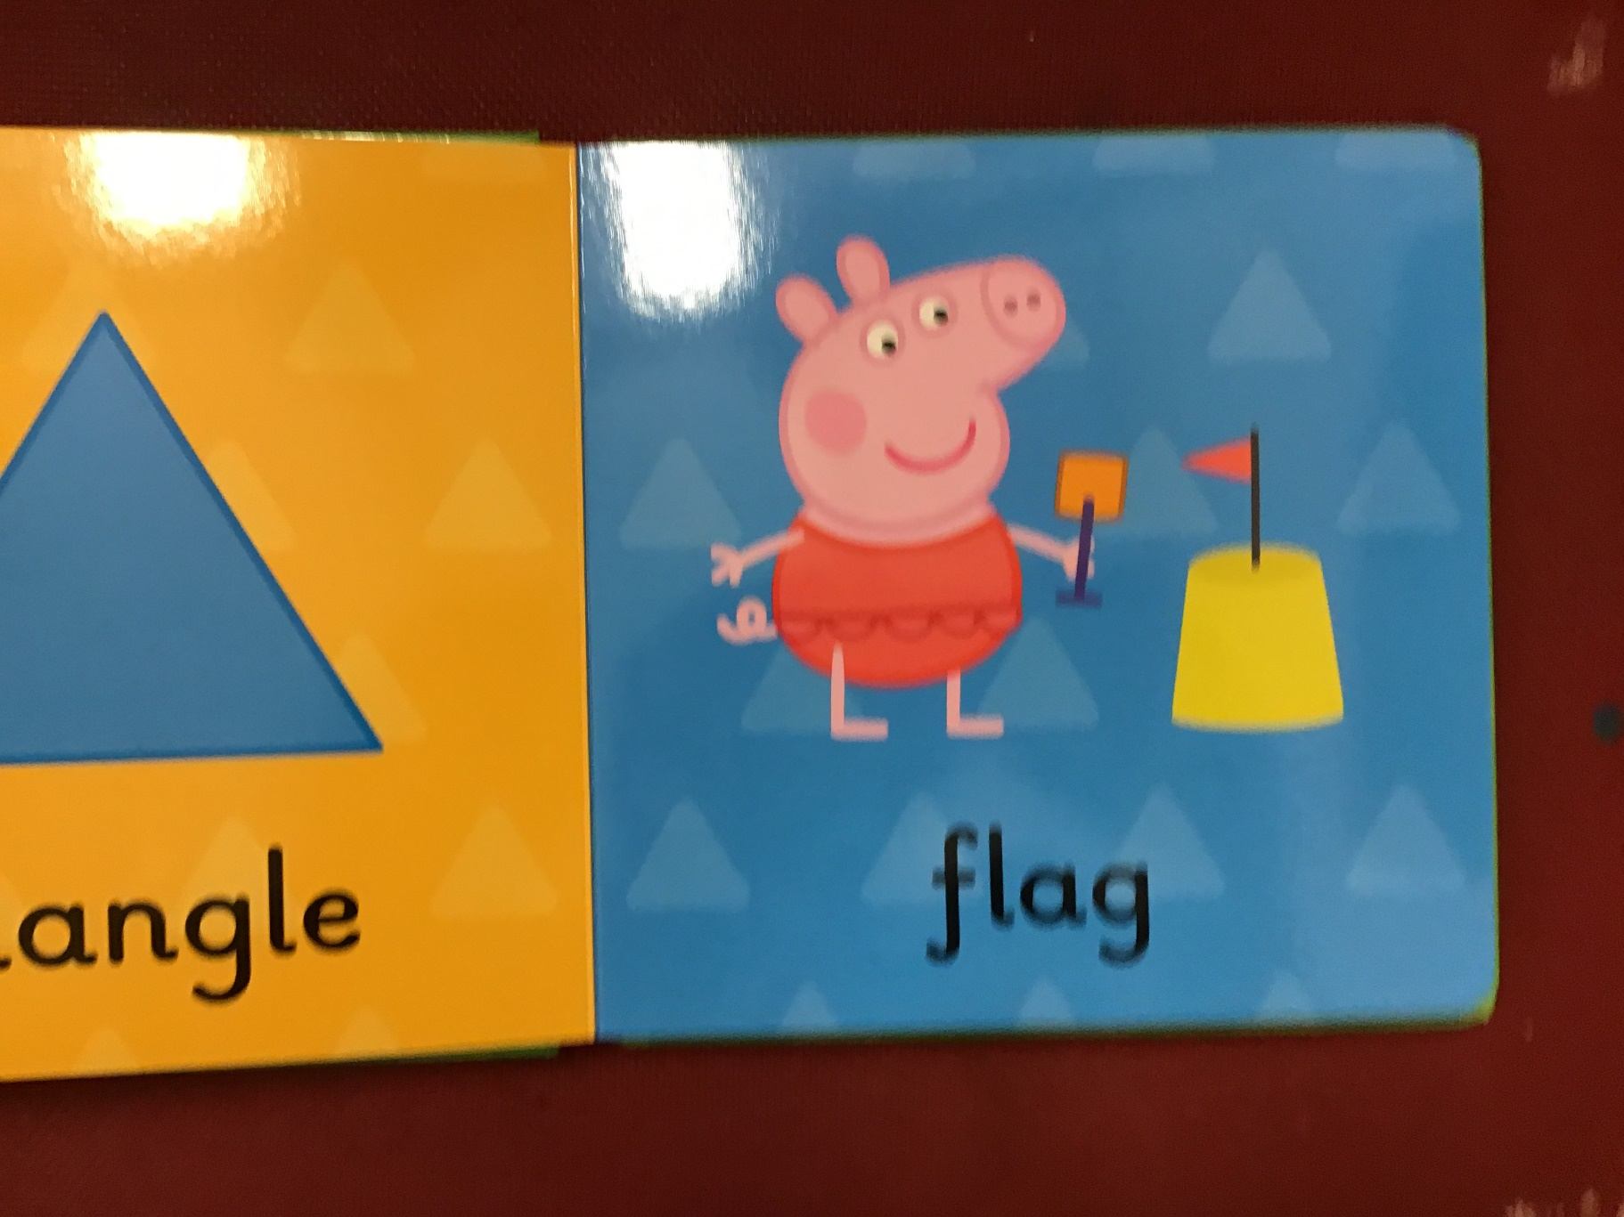

The flag on Peppa’s sandcastle is a triangle.
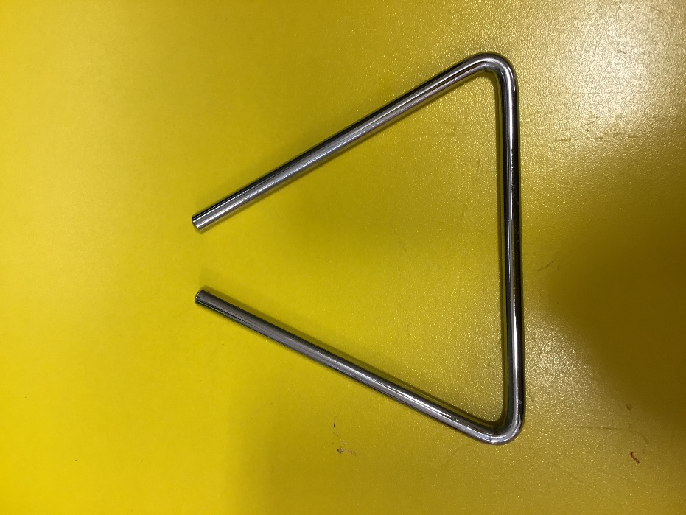
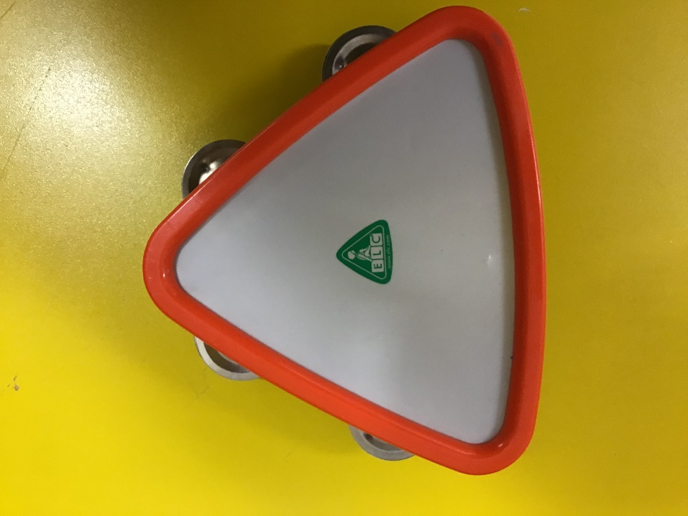

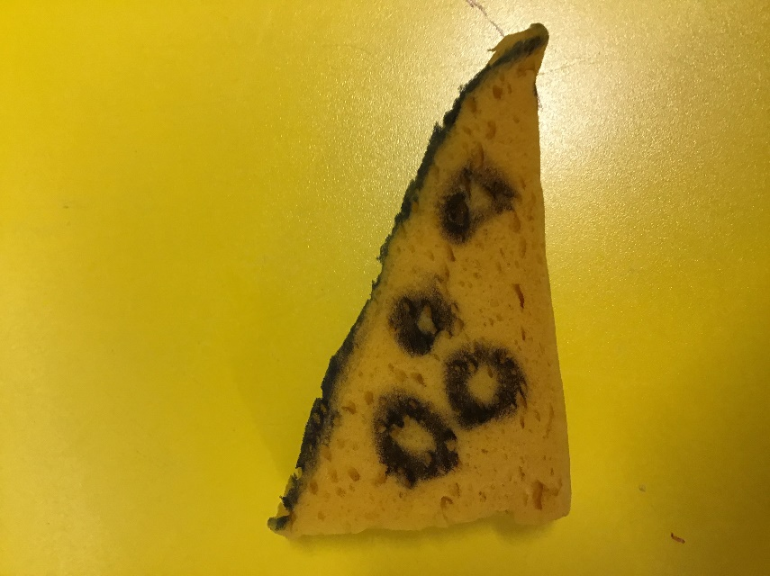
These musical instruments are triangles.

The mouse’s cheese in our story is a triangle.
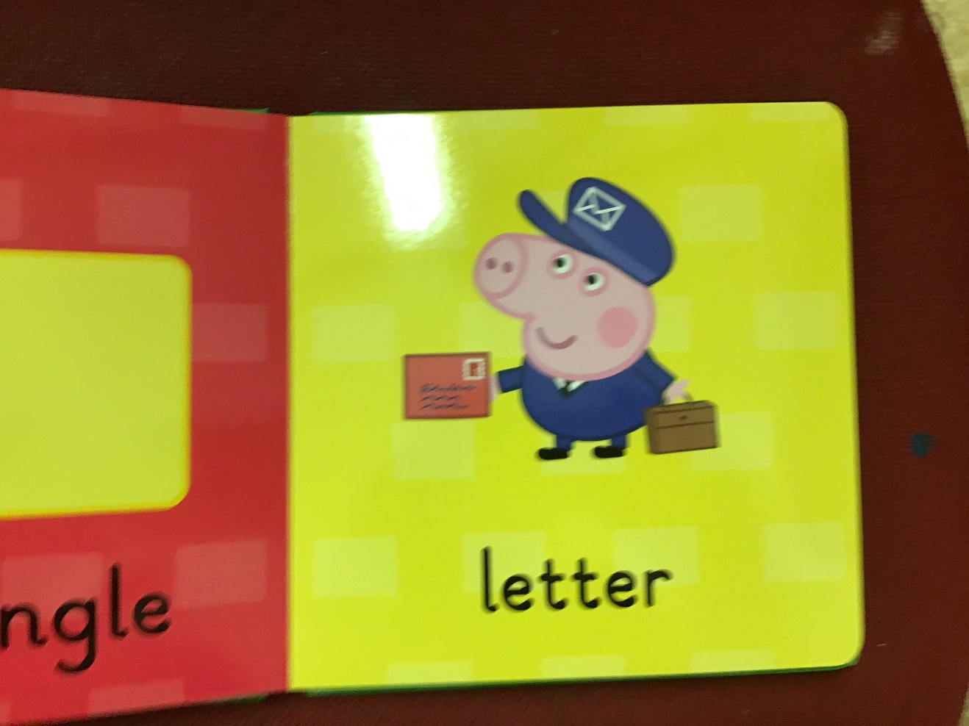
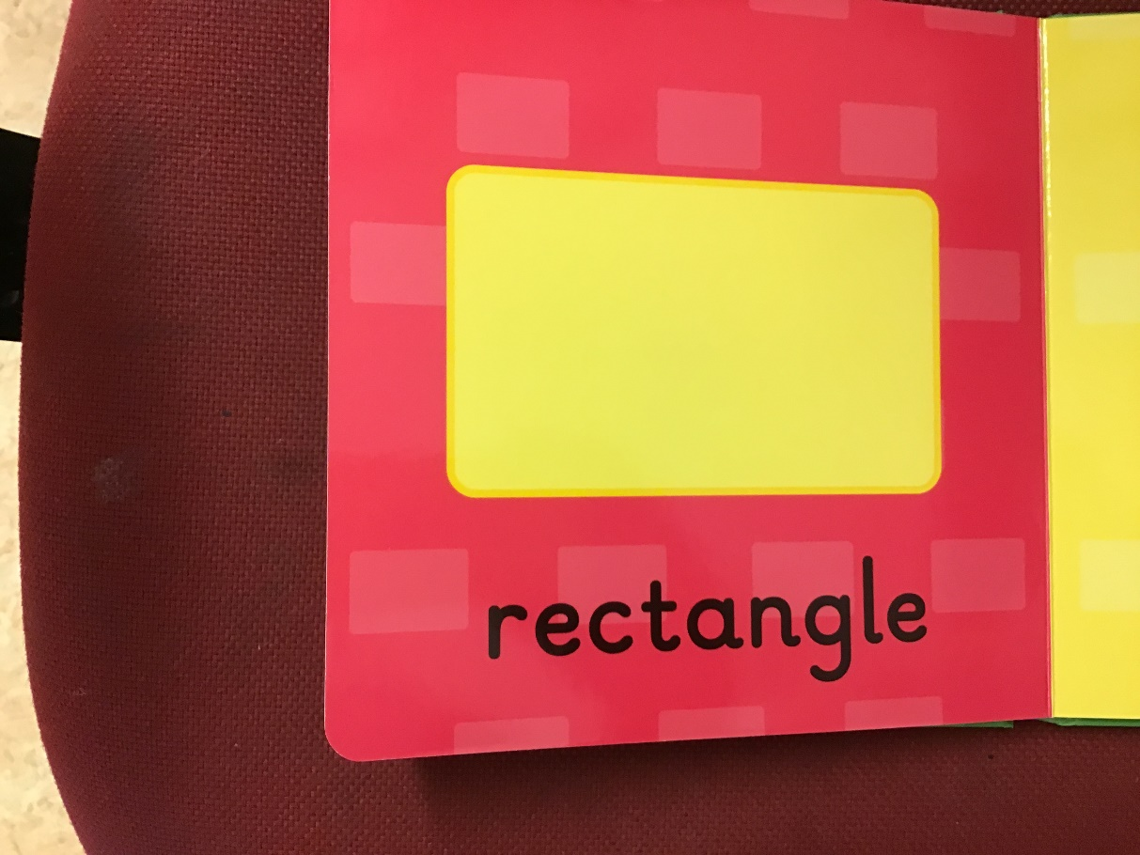
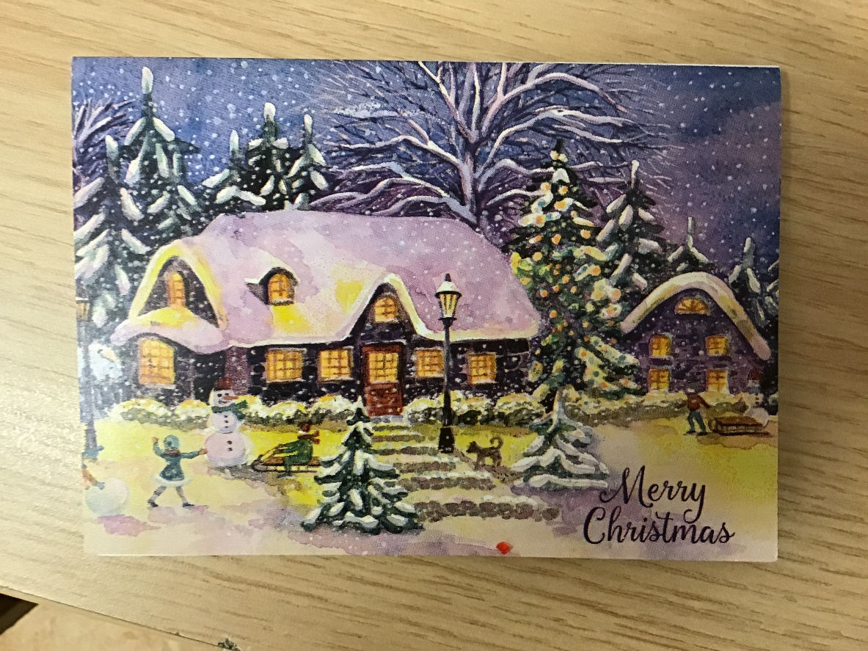
This is a rectangle. It has 4 sides, 1,2,3,4 but 2 are longer than the other 2. The letters the postman brings are rectangles.

My Christmas card was a rectangle.
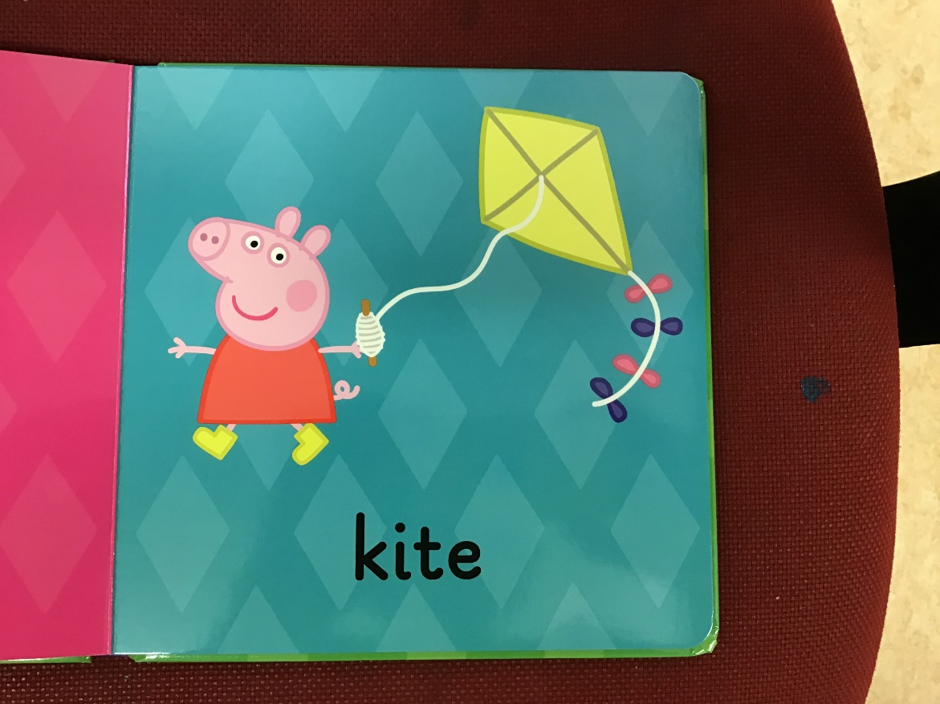
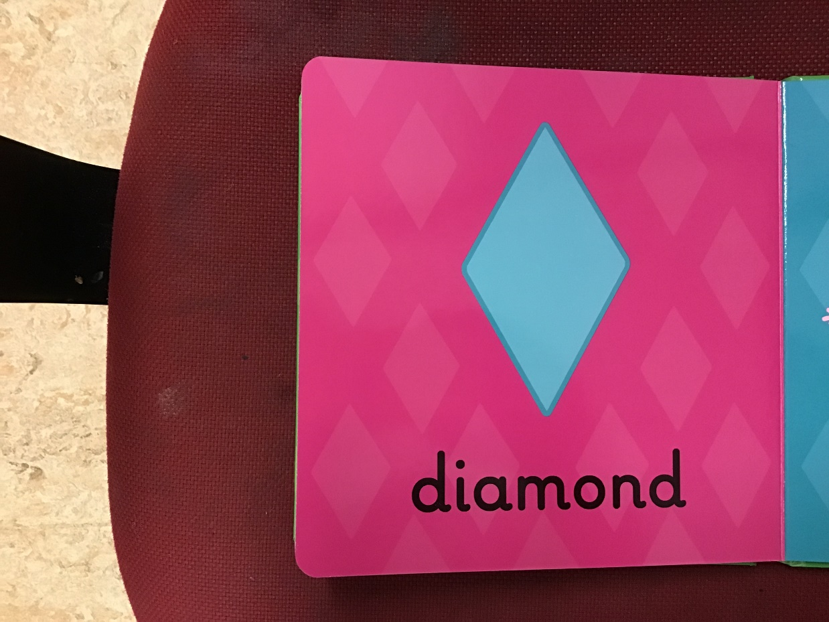

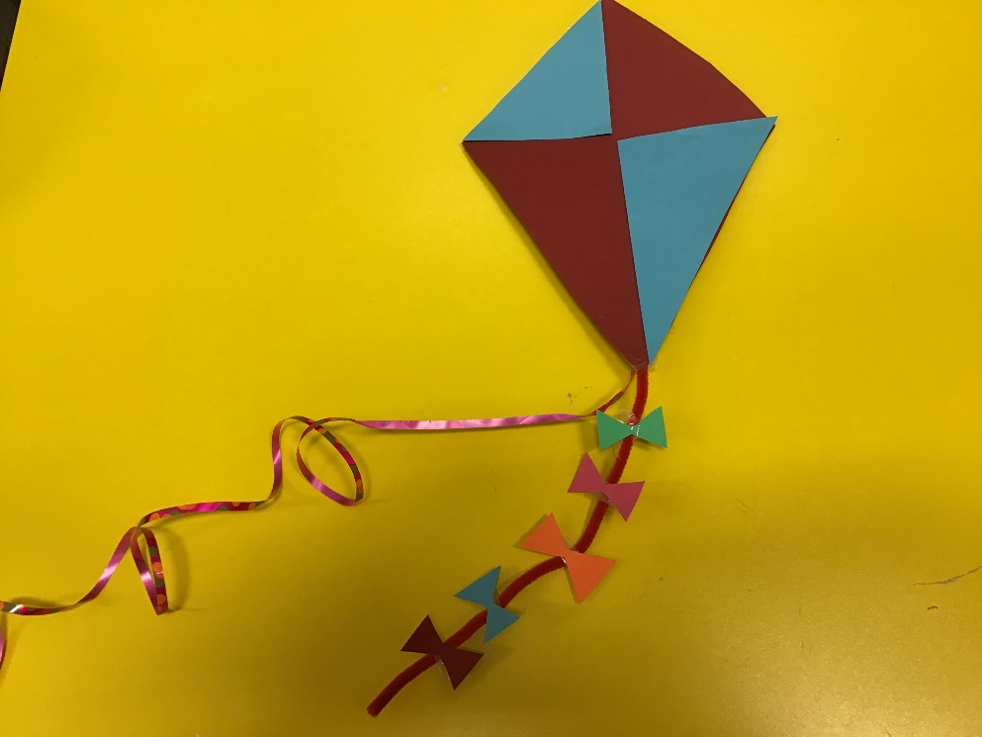
This shape is a diamond. It has 4 sides 1,2,3,4. Peppa has a kite that is a diamond.

Do you like the kite I made from a diamond shape? It is made up of 4 triangles. 2 are red and 2 are blue.
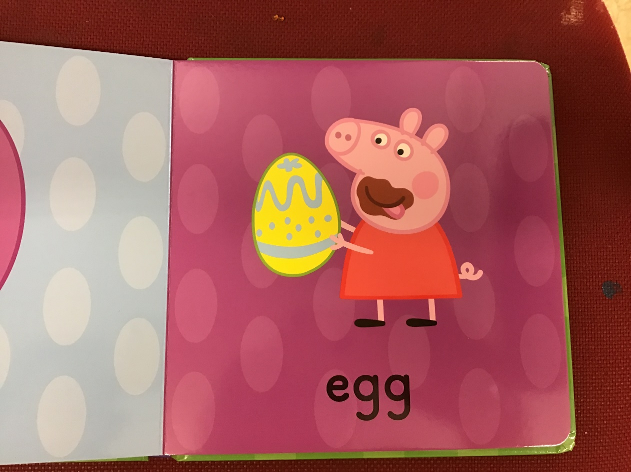
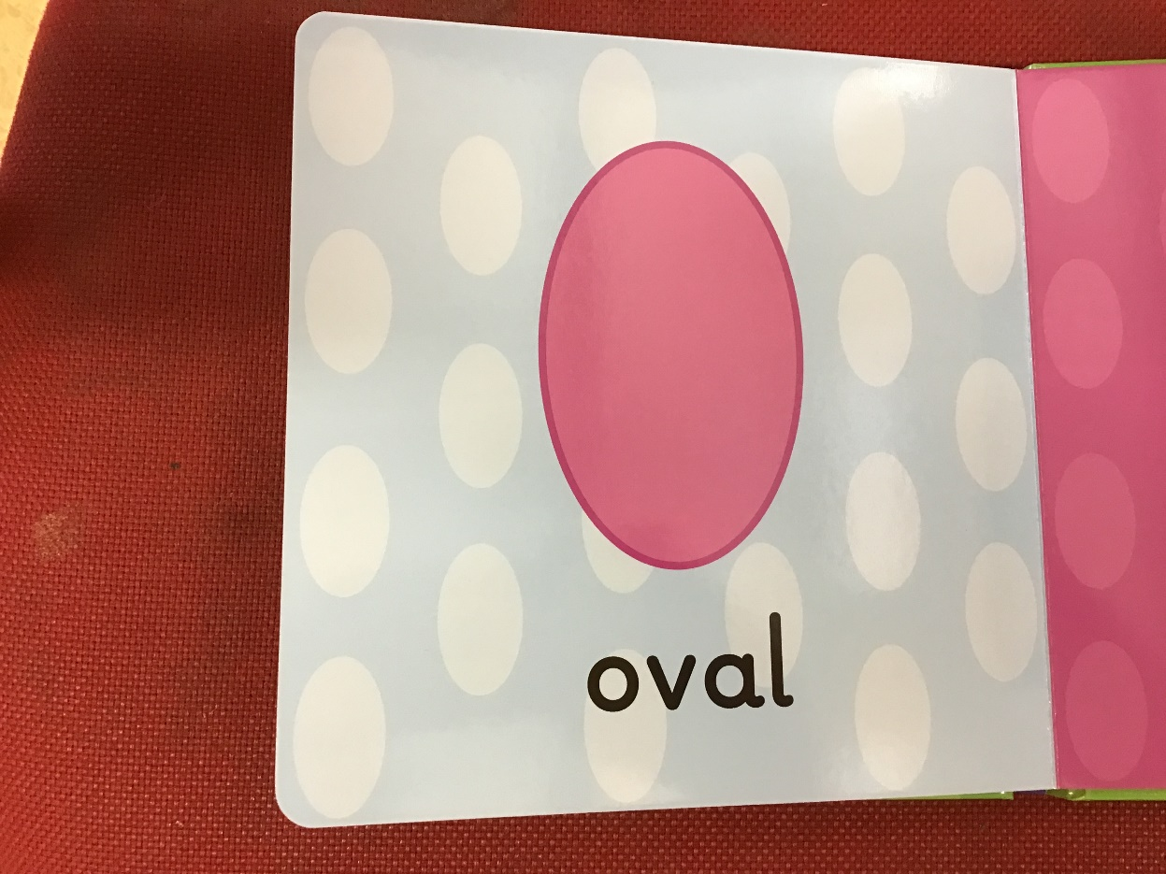

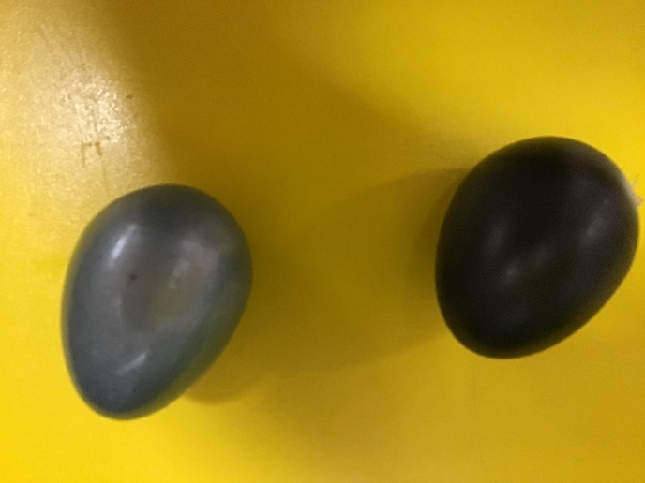
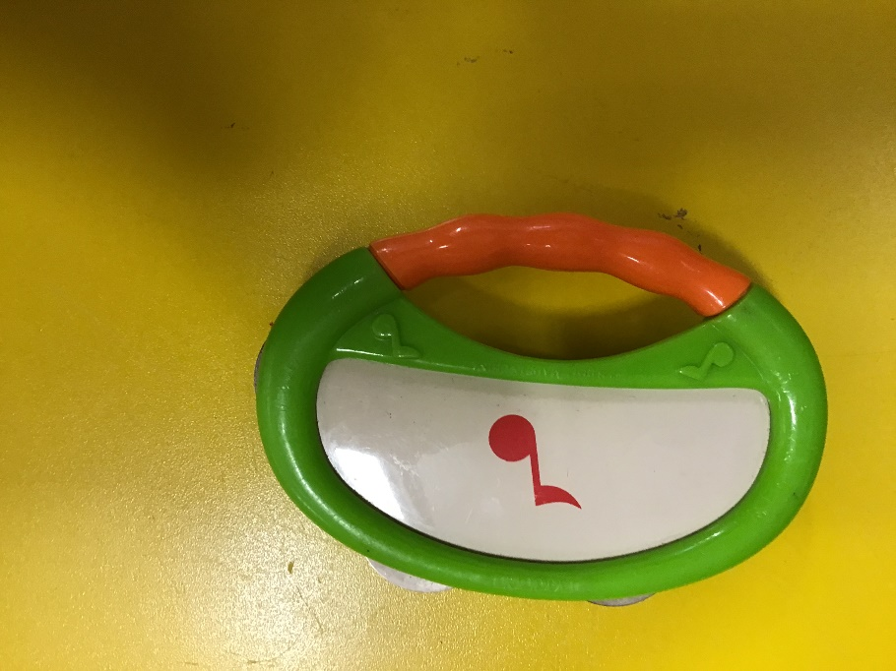
This shape is an oval. Like a circle it has 1 side. Peppa is enjoying her oval shaped chocolate egg!

Sound eggs

Tambourine
These musical instruments are ovals.
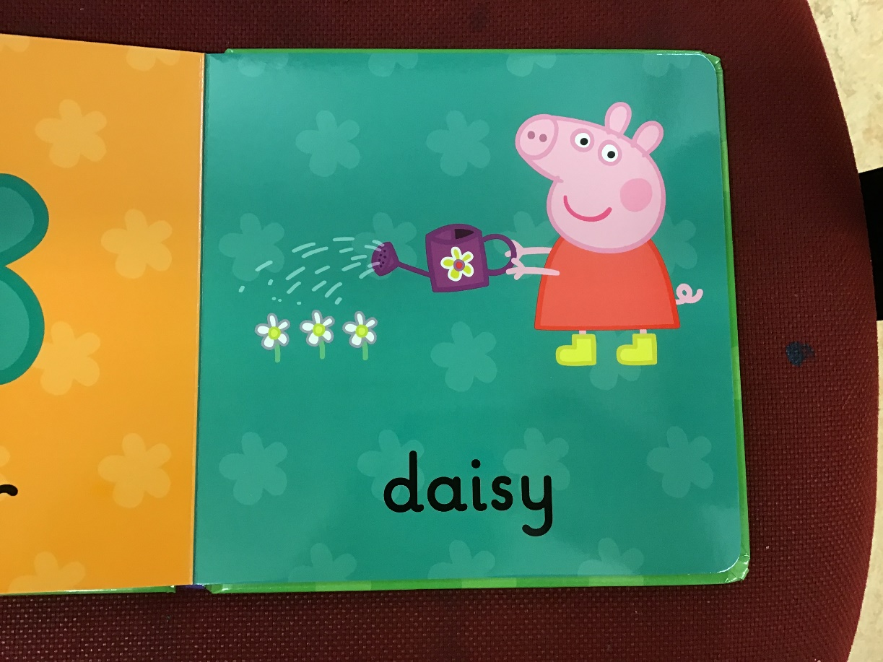
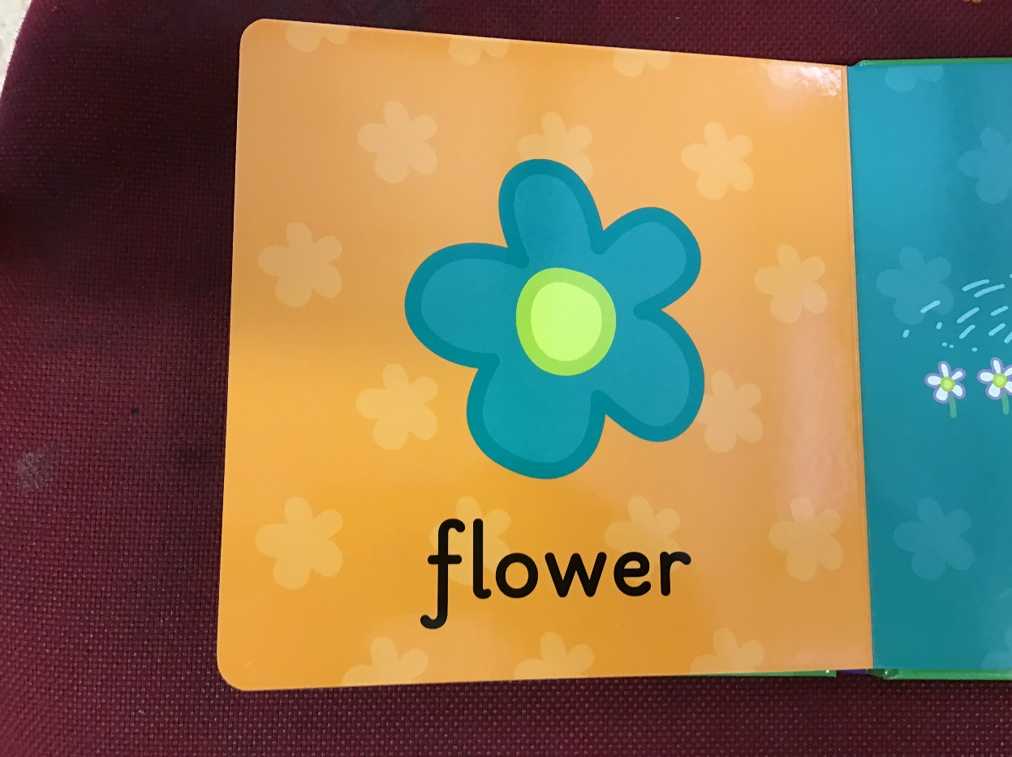

This is a flower shape. It is one of many. Flowers are all different shapes. It is the shape of the daisies that Peppa is watering.
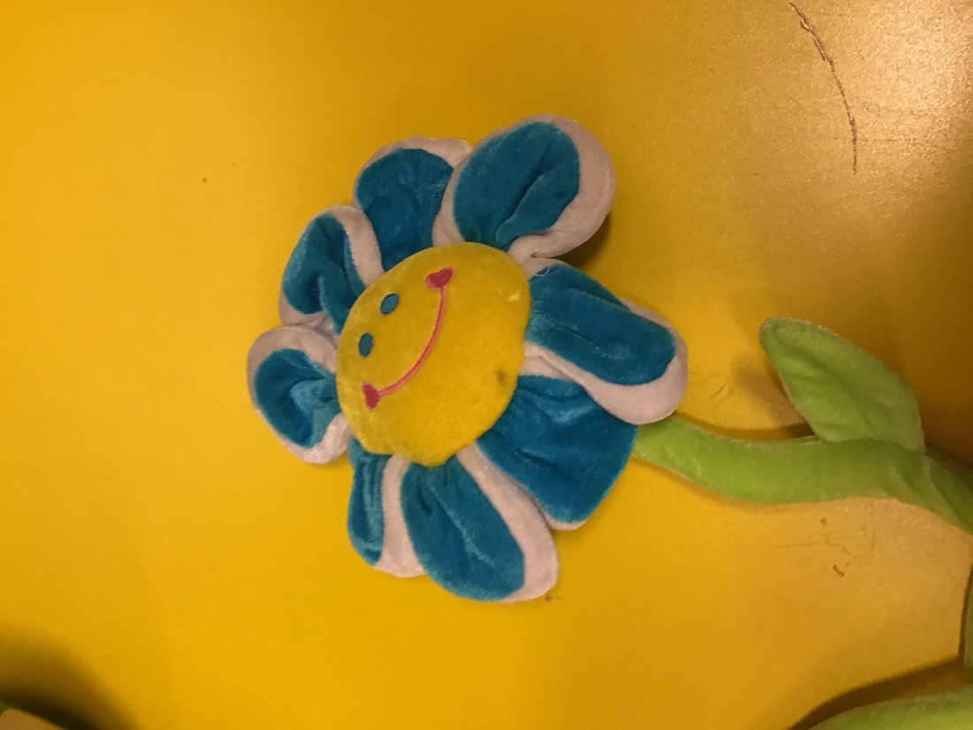

We use this soft, toy flower in our ‘Language through Song’ activity.

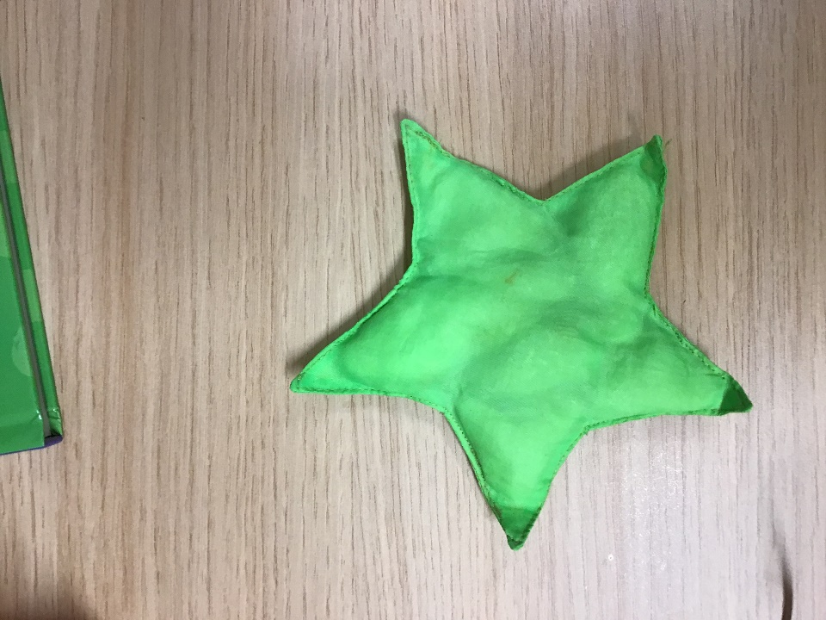
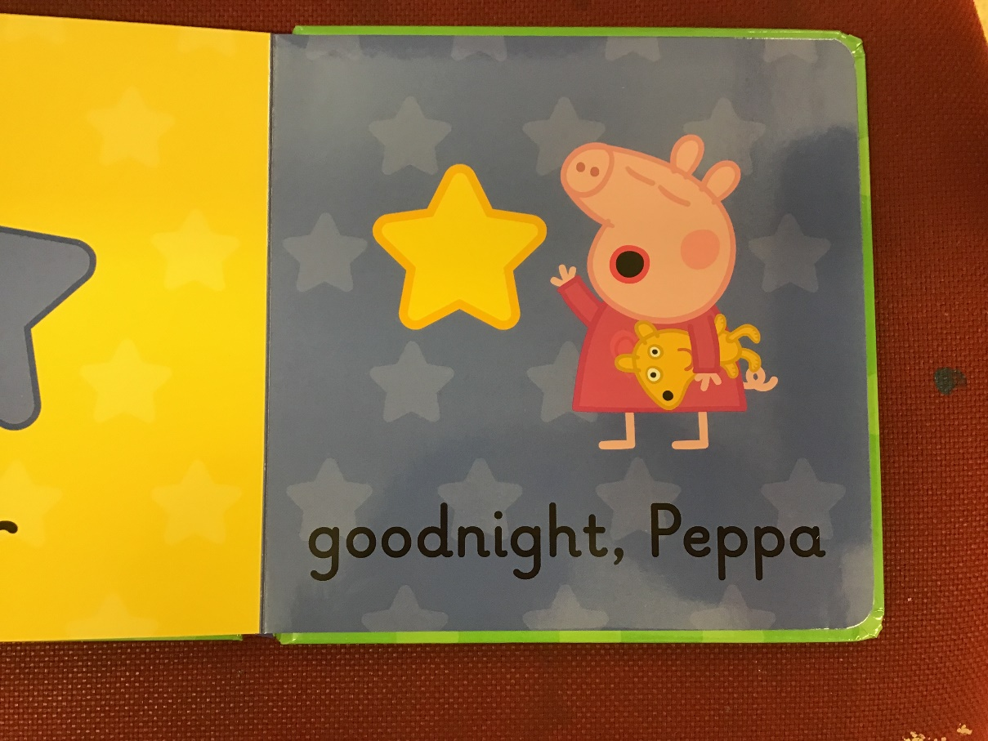
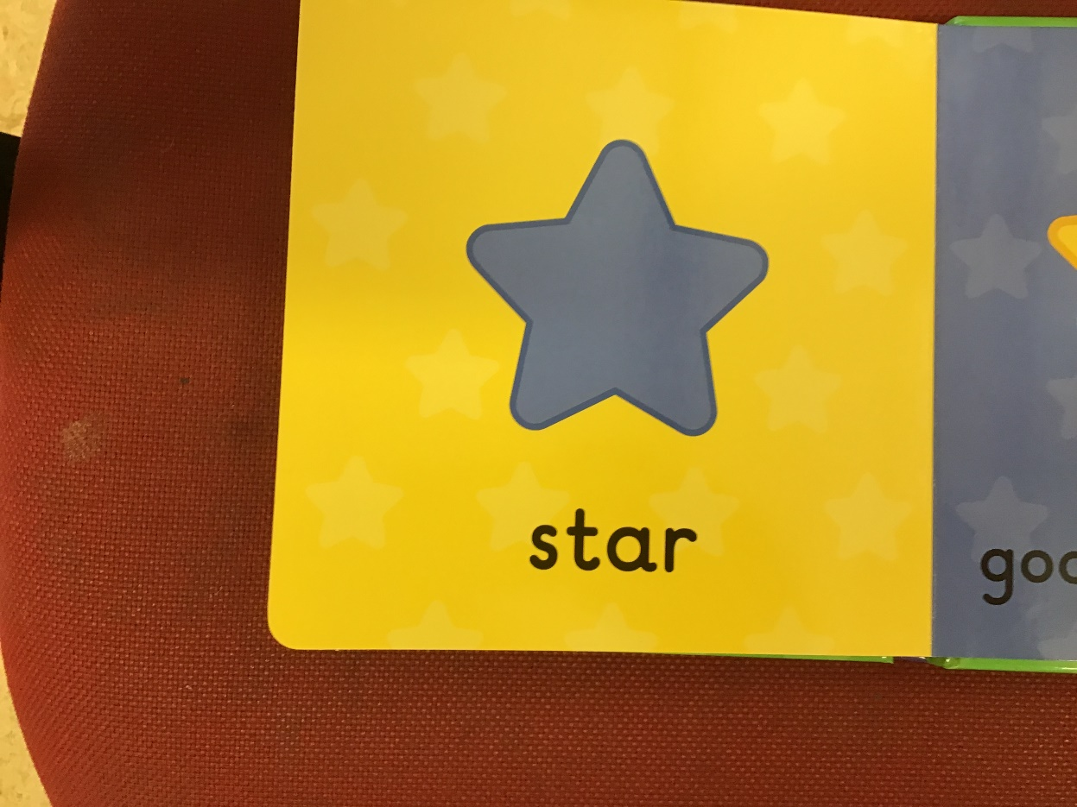
This shape is a star. It can have lots of points but most have 5 or 6. Stars come out at night so Peppa is going to bed now.

This is a star shaped beanbag. To finish our story why not play the children’s favourite version of “Twinkle, Twinkle, Little Star” by the Gigglebellies: https://www.youtube.com/watch?v=gAioeWL1xaU

