**Sand**

Most children enjoy playing in the sand, digging, pouring, and burying objects. Sand play can help children develop their physical, cognitive and social skills.

Try sand play in these different ways.

Make sand moose by adding shaving foam to the sand.

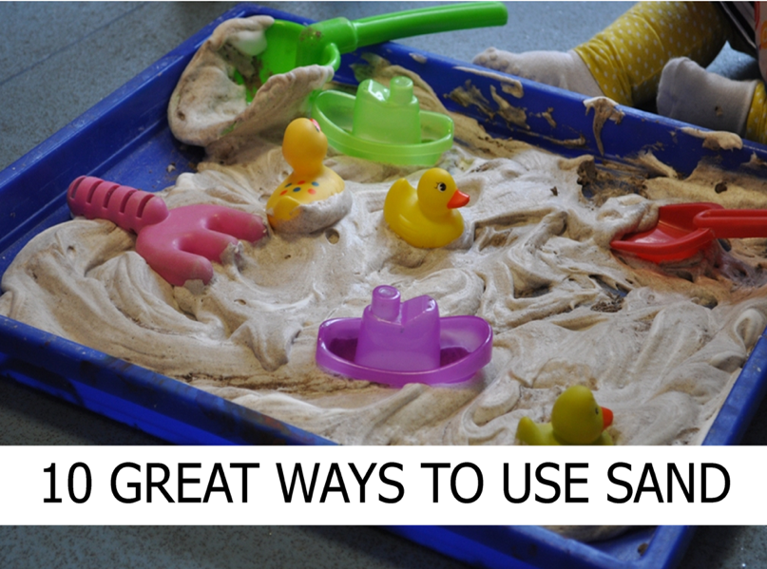

Make moon dough by adding baby oil to the sand.

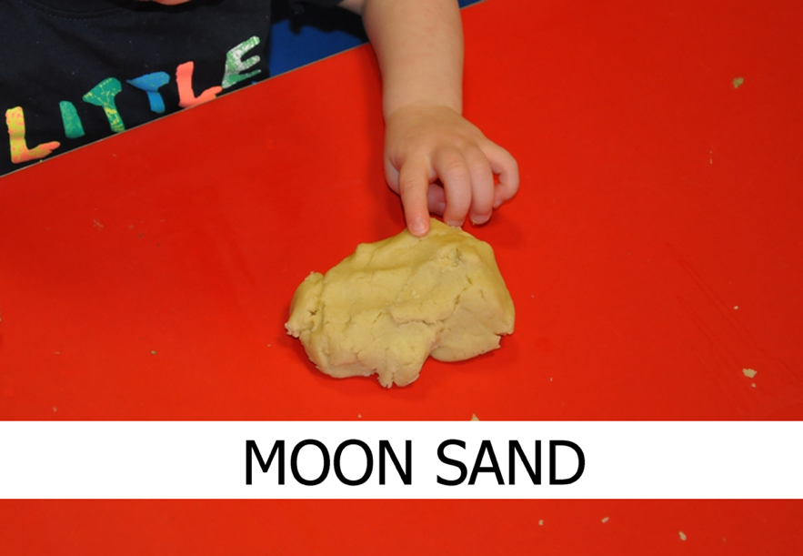

Fill a shallow tray with sand and provide children with different mark making tools eg different size paint brushes. Watch the children make various marks in the sand using the tools as well as their fingers.

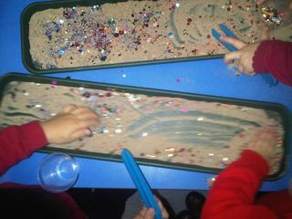

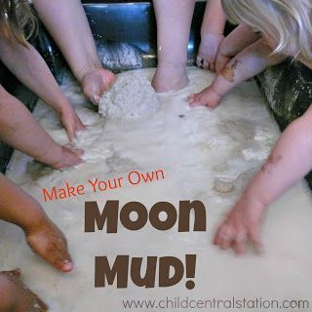Make some moon mud by mixing sand, water and cornflour to create this mud consistency.

**Just have some fun making mess and playing with your child!**