Gerry Germ lay on a handkerchief, next to poorly Gilbert’s bed.

As young Gilbert lay there snivelling, a wet flannel on his head!

*(Feel wetwipe, interact with Gerry Germ or place wet flannel on head)*

Gilbert’s cat jumped on his master’s bed and gave the handkerchief a lick!

Gerry Germ jumped onto Tiddles’ tongue, that germ was super quick!

*(Interact with cat puppet/Sponge tongue)*

‘Ding Dong!’ there’s someone at the door! It’s Glenda, Gilbert’s sister!

Tiddles gave out a loud ‘Meow!’, the little puss had missed her!

*(Ring bell/bells/Meow on BigMack)*

Glenda gave the cat a stroke and Tiddles gave a lick!

Gerry Germ jumped onto Glenda’s hand, now it’s *her* turn to be sick!

*(Interact with cat puppet/stimulate hand (with fingers/vibrating ball etc.)*

Glenda works at the bakery, selling cakes and treats so yummy!

Gerry tasted every scone and cake, and went in people’s tummies!

*(Taste cake/doughnut etc.)*

Mr Chop, the local butcher, bought a juicy current bun,

Now Gerry’s in the butcher’s shop, in the sausages, mince and tongue!

*(Feel ‘water snake’ sausage, chopping motion with plastic cleaver.)*

Mrs Melon, the greengrocer, bought some bones for her chihuahuas,

Now Gerry’s in the grocer’s shop, in the apples and bananas.

*(Peel, taste & smell bananas/apples.)*

Excitement at the grocery, look it’s Mr Knight, the Mayor!

He’s visiting the local school, and has popped in for a pear.

*(Wear top hat and mayor medal, look in mirror.)*

The mayor shakes all the children’s hands, and Gerry shakes them too,

Now the children will be poorly, they’ll all cough and sneeze, “Achoo!”

*(Shake hands/Achoo! on BigMack.)*

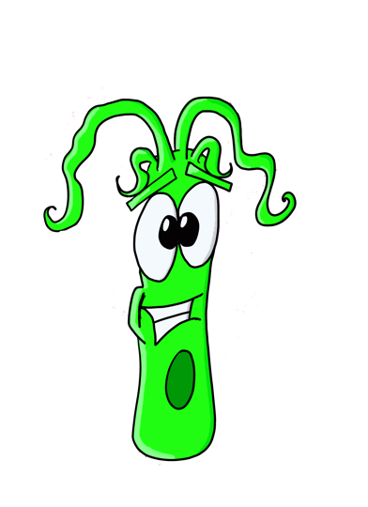But as the bell sounds for lunchtime, the children ruin Gerry’s plans,

Because every clever boy and girl, knows they have to wash their hands!

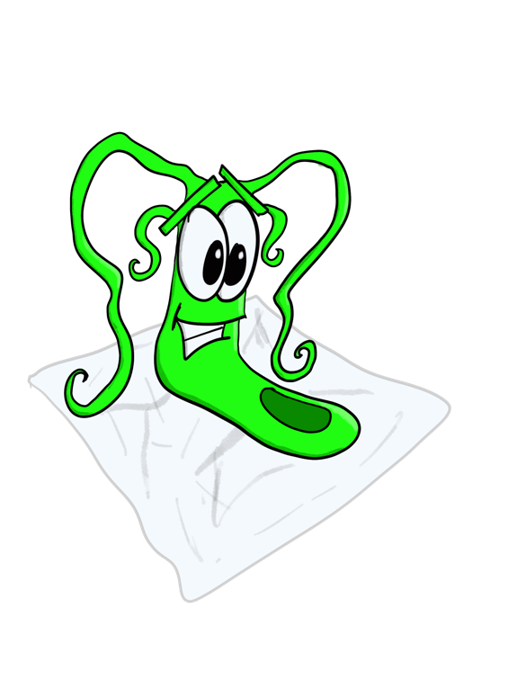*(Wash hands/wetwipe on hands/hand massage.)*

GERY GERM IS DEFEATED!!!

