**OWL BABIES STORY SPOONS**

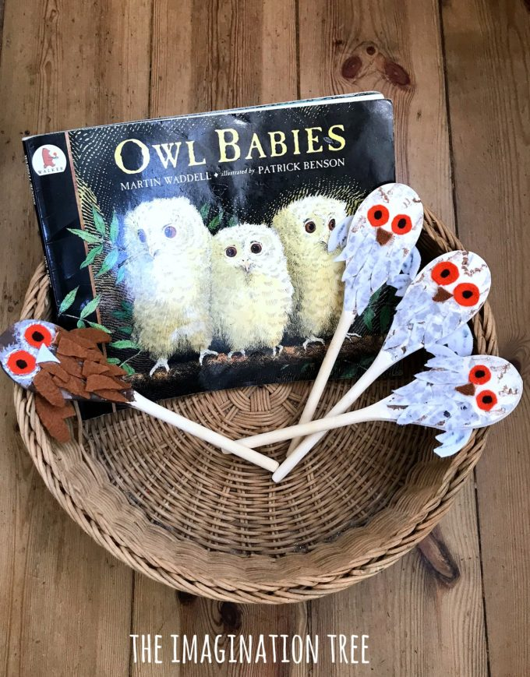

# Make some gorgeous Owl Babies Story Spoons for [**storytelling fun with young children!**](https://theimaginationtree.com/12-creative-storytelling-activities/) Great as a resource to use at home or during a literacy session in the classroom, your kids will love interacting with them as they tell their own version of the story.

# **HOW TO MAKE OWL BABIES STORY SPOONS**

**MATERIALS NEEDED:**

[Wooden Spoons](https://amzn.to/2P1Dyox)

Paint

[Paintbrushes](https://amzn.to/2zMF4FV)

[Coloured felt](https://amzn.to/2QpeDvl)

[Fabric Glue](https://amzn.to/2Rel1H0)

[**Black Sharpie Marker**](https://amzn.to/2RfPrZH)

**Optional:**

[**Round Basket**](https://amzn.to/2RlJKJN)

[**Owl Babies Picture Book**](https://amzn.to/2RiE8Qj)

Start by painting three wooden spoons with white acrylic paint and leave them to dry. Paint a fourth spoon light brown.

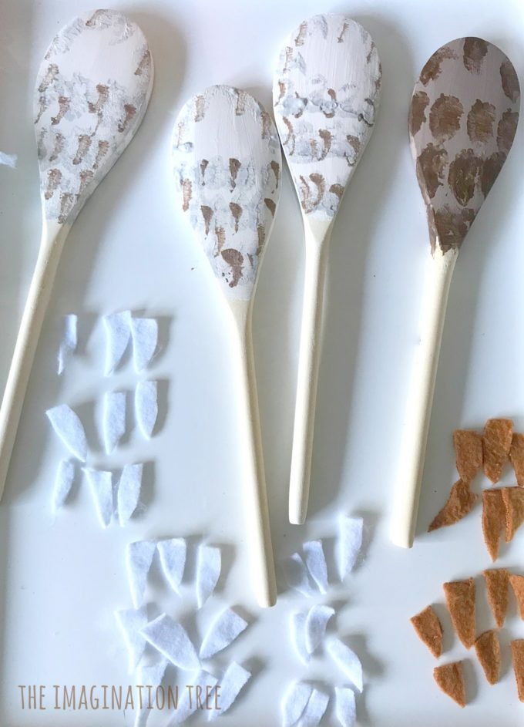When dry, add light grey and brown speckles (using the edge of a paint brush pressed lightly) in slightly overlapping rows, to create the effect of dappled feathers. Do the same for the brown spoon using darker brown shades

Next, cut lots of small feather shapes from the brown and white felt and glue them onto the corresponding owl spoons using fabric glue. Overlap to make them look a little more realistic. After this stick orange circles for eyes and added a pupil in the centre of each with black Sharpie. The beaks and wings were made in the same way, stuck firmly into place with the fabric glue. Add more detailing around the eyes using brown acrylic paint afterwards.

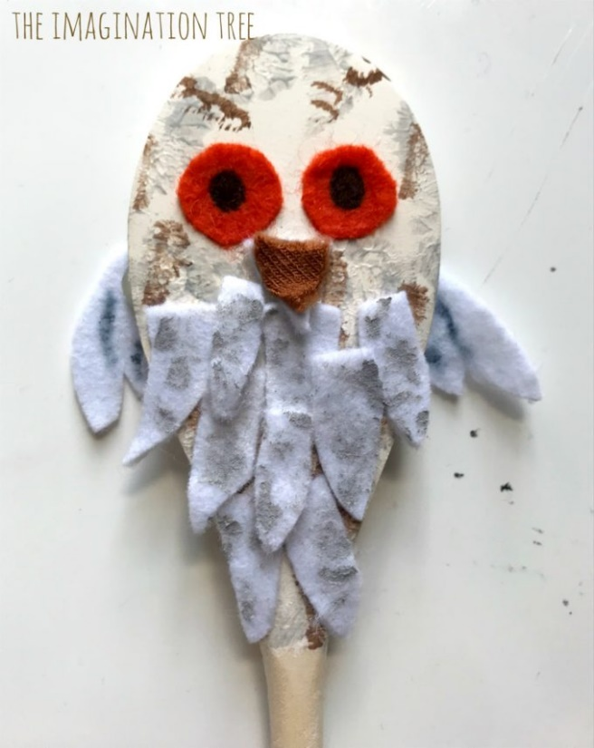

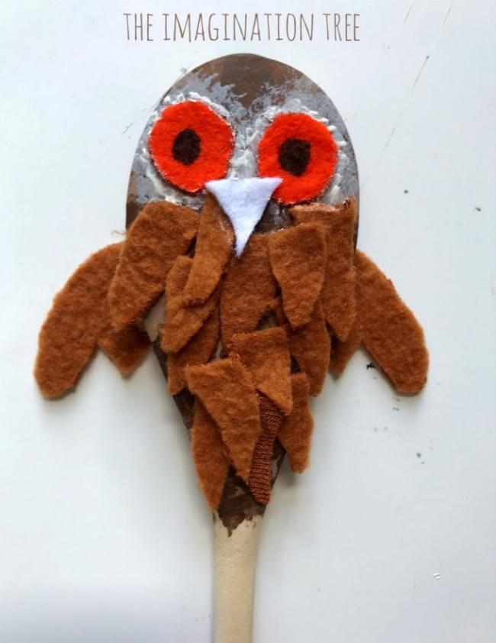

Simply set them out in a basket or story sack, or as part of a visible display, alongside a copy of the Owl Babies story book and possibly some sensory elements e.g. feathers, branches and leaves all ready to tell stories with!

First tell the story, then use these as a prop to tell it with the book, finally using them without the book at all. Encourage children to do the same, using them alongside the book first and then simply to retell in their OWN words, recounting the main elements of the story in the correct order as they do so.

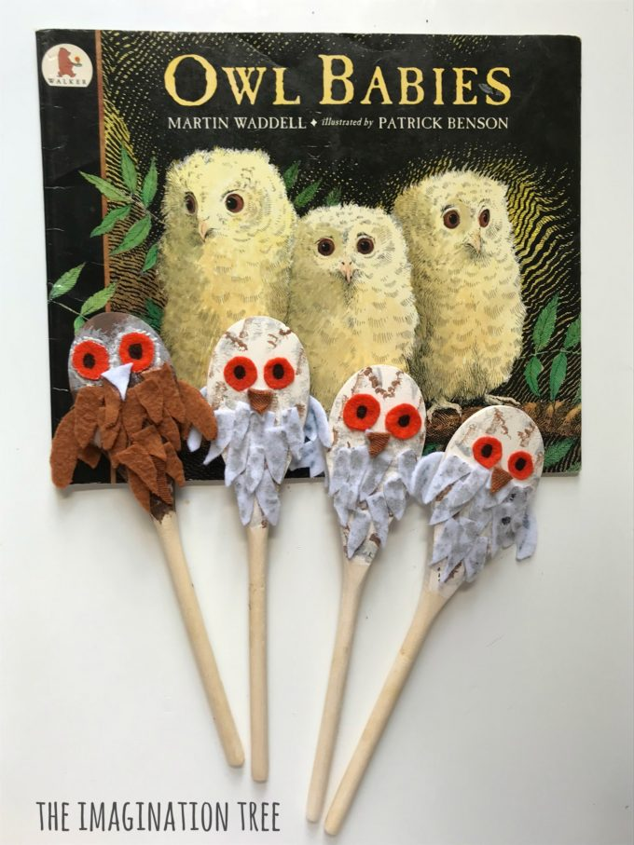

[**Story spoons, puppets, story baskets and other interactive props**](https://theimaginationtree.com/category/sensory-storytelling-basket/) are an amazing way to bring favourite book characters to life and can really help consolidate learning too. Having a prop to hold and use to retell the story in the correct order is a powerful tool for a young child and can be a great enabler for kids with English as an additional language particularly.