**Moulded Feather**

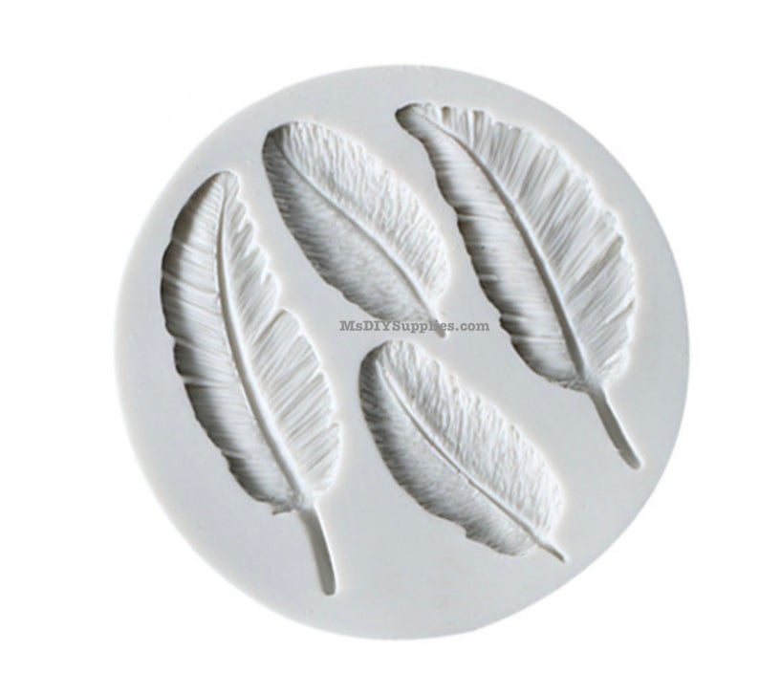

**What you will need:** A small bowl, Plaster of Paris, Spoon

A circle of cardboard or the bottom of a plastic bottle

**Method:**

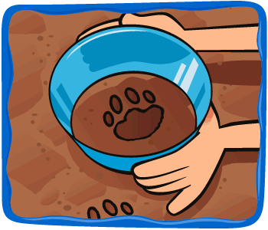Put the circle of card - or your plastic cup/bottle - over the feathers, making sure there are no gaps between the circle and the ground.

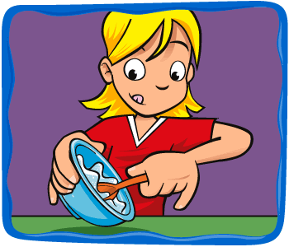Mix up your plaster according to the manufacturer's instructions - you will need a small bowl and some water and a plastic spoon to mix it with.

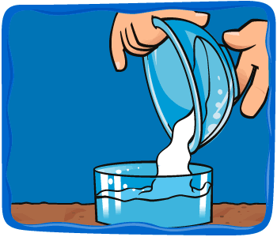Pour the plaster into the circle over your feathers.

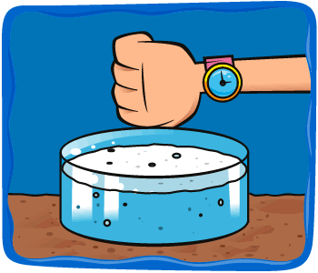

Leave it for 10 - 15 minutes according to the manufacturer's instructions.