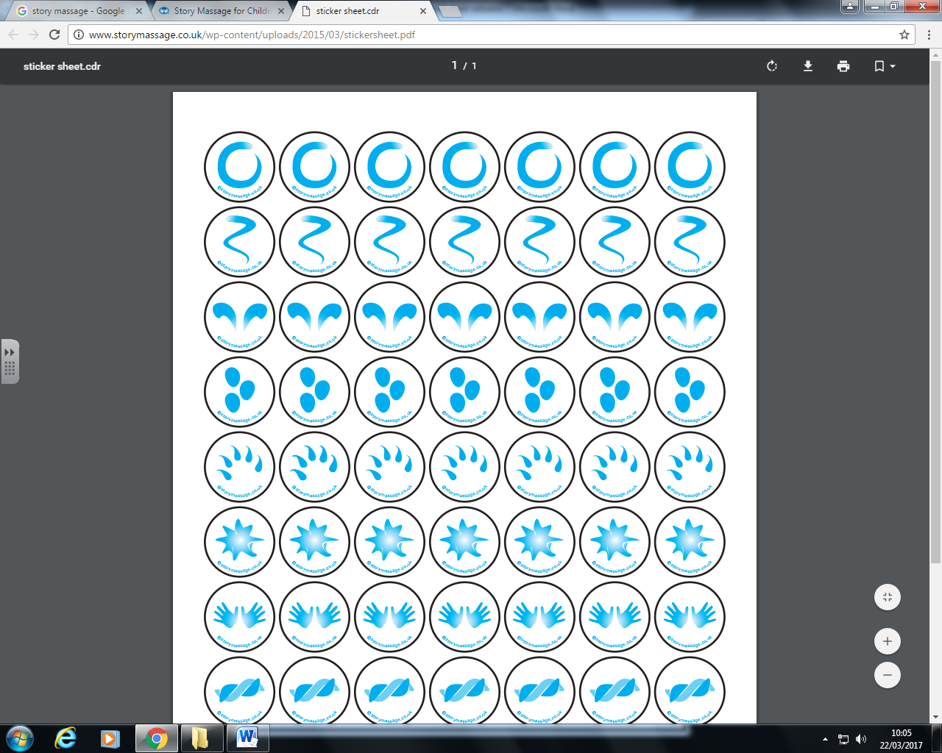

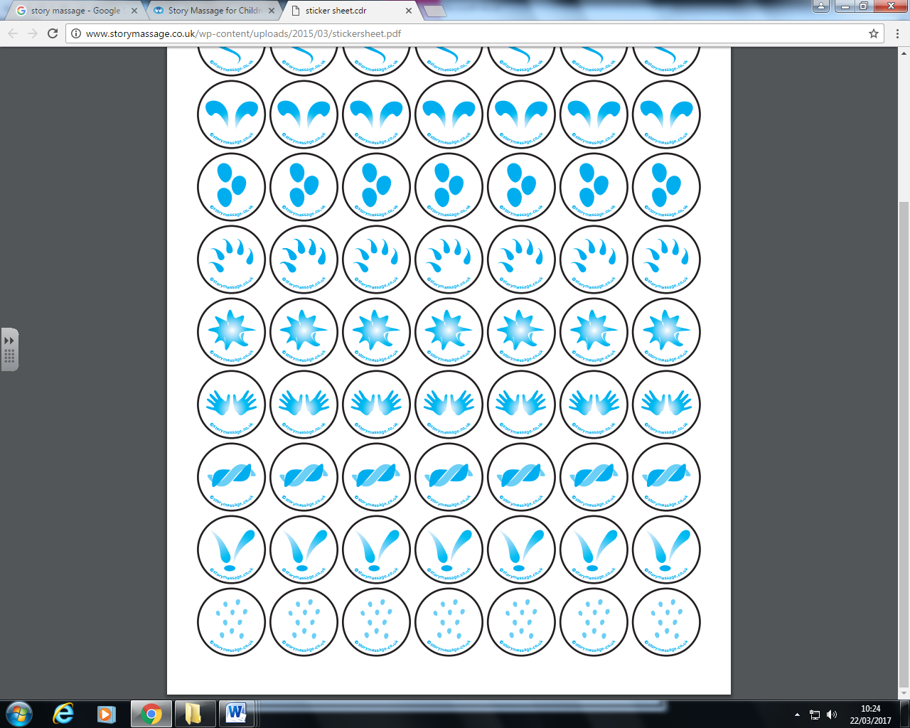









how I wonder what you are.

Twinkle, twinkle, little star,

like a diamond in the sky.

Up above the world so high,

how I wonder what you are.

Twinkle, twinkle, little star

**Twinkle,Twinkle, Little Star**