**Pasta Sunflower**

**Materials Needed:**

* Spiral pasta
* Yellow and brown paint
* Green pipe cleaners
* Glue

**Method:**

Start by pouring some spiral pasta onto a paper plate and paint them yellow.

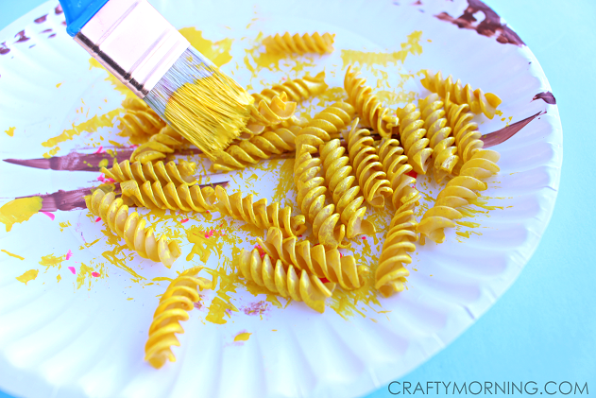

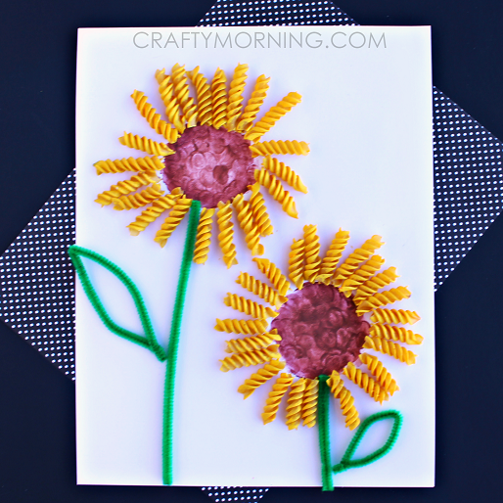While those dry, have the kids dip their finger into brown paint and make a circle for the middle of the sunflower using their fingers. Once all are dry, glue the pasta around the brown paint centre to make a flower. Add some pipe cleaners for the stem/leaf and you’re done!