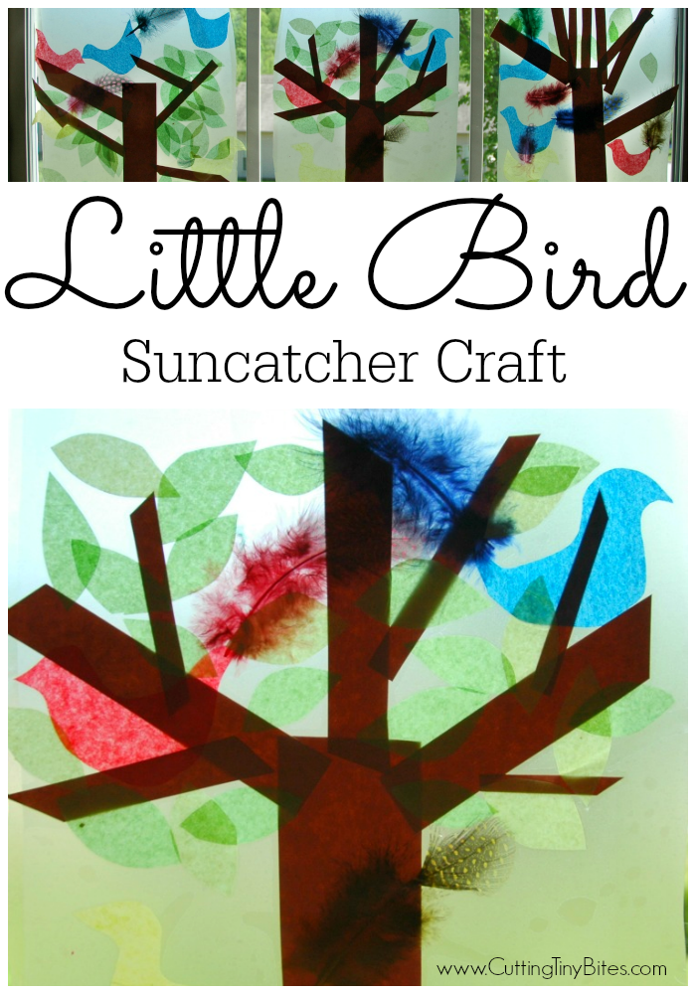Little Birds Sun catcher

**What you need:**

* Feathers of assorted colours
* Different colours of cellophane or tissue paper
* Brown paper
* Clear self-adhesive film
* Scissors

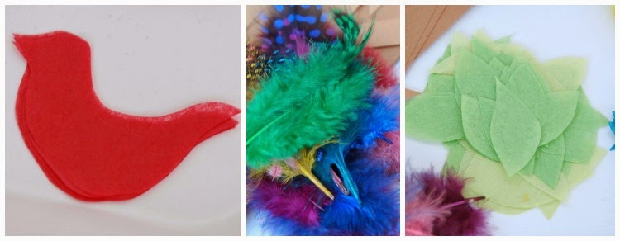

**Method:** with your child, feel and listen to the crunching sound of cellophane and tissue paper. Cut out brown paper for the tree trunk and cut out cellophane and tissue paper to make birds and leaves. Stick them onto clear self-adhesive film and finally decorate with feathers and stick them onto one of your window to let the sun shine through!

