Cardboard Tube Butterfly

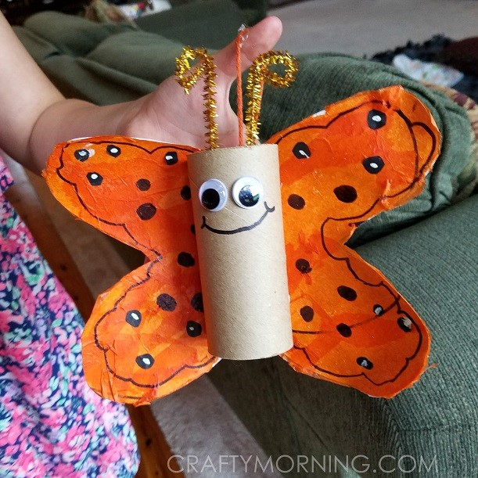

* Cardboard tube and card
* Hot glue gun (if no glue-gun, maybe try PVA glue and leave to dry)
* Pom poms
* Pipe cleaners
* Tissue paper
* Scissors
* Glue
* Googly eyes

Method

1. Start by folding a white piece of card in half and draw half a butterfly wing. Unfold it and cut it out. Glue tissue paper pieces all over it and let dry.
2. Paint your cardboard tube with a sponge. After that’s dry, hot glue the wings on the back as well as the antennas and eyes!

