**Painting with Sponges**

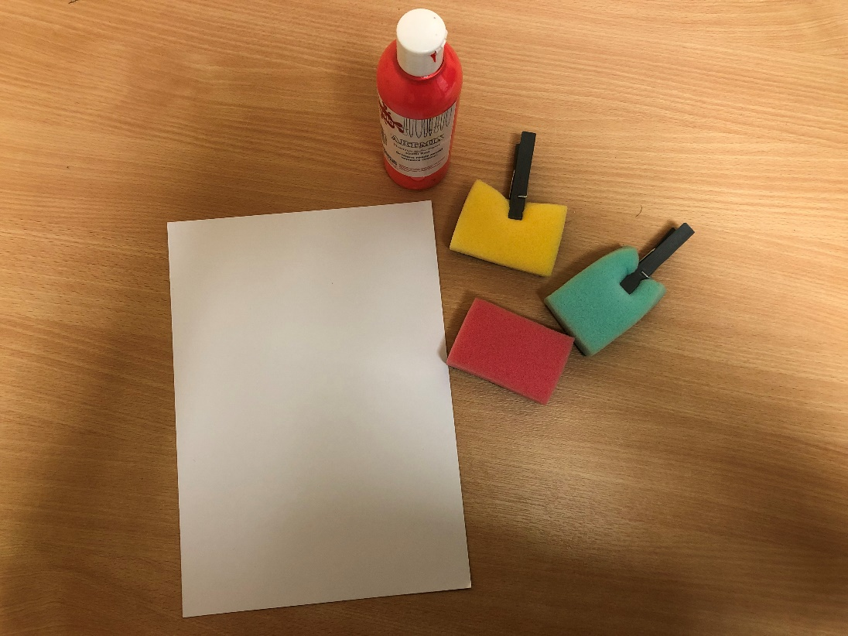

**You will need:**

* Sponges – use whatever sponges you have available (e.g washing up sponges, car washing sponges etc…)
* Clothes peg (optional)
* Pink Paint
* Card
* Paint palette or container

**How to make:**

* If necessary, cut your sponge into smaller pieces – any shape is fine!
* If easier for your child, attach a peg to a piece of sponge to make a handle for your child to hold, or just let them hold the sponge to print!
* Encourage your child to dip their sponge into their paint and to then make marks through either printing or painting over their page.