Objects of Reference

What is an object of reference?
An object of reference can enable the pupil to obtain information from several senses: touch, vision (if they have some useful sight), smell, taste, and sound (eg if they bang it against a surface). This is more reliable for them than relying only on hearing the spoken word, even if that is accompanied by a manual sign.
How can objects of reference help communication?
Objects of reference can play a key part in supporting communication,
- they can help the child to understand what other people say
- provide a means for the child to express needs and wants.

Choosing objects of reference
If it is for an individual pupil it should be an object to which they attach a special meaning. It is therefore essential to view things from their perspective. The object should be something the individual directly experiences and associates with the particular item, place, person, event, activity or experience.

Presenting objects of reference

There are some simple rules for presenting an object of reference, it must be:
- the same object every time
- presented immediately before the item, place, person, event or activity it represents
- used every time it is needed
- presented in the same manner every time
- presented with the same accompanying speech / signing every time.

As more objects of reference are introduced, it is essential to consider the contrasts between them, it is not going to help if the pupil becomes confused by objects that are very similar.

Using objects and signs

The use of Objects of Reference can be readily incorporated into daily routine to give extra information to the child. By consistently linking an object with an activity and a sign the object comes to represent that activity for the child.

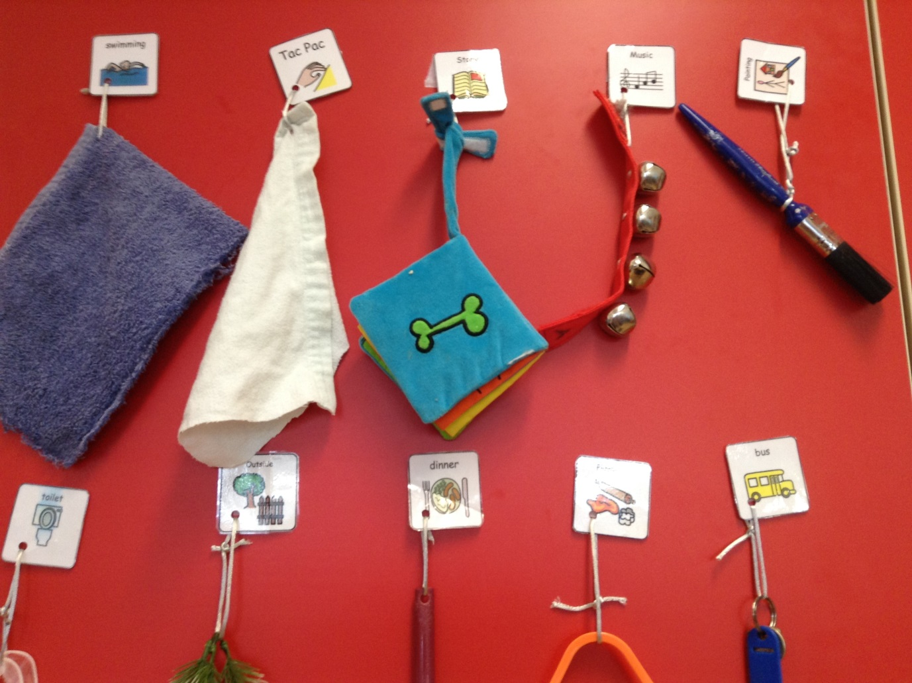

Objects of Reference can also be used alongside symbol or picture and sign to aid recognition.

Examples of Objects of Reference that can be used at home before an activity to help cue the pupil in and prepare them for what is happening next;

- Eat – spoon/plate or syringe if gastrostomy fed
- Wash – flannel/sponge
- Brush teeth – toothbrush to feel first/feel vibrating if electric toothbrush
- Bath time – water spray/favourite bath toy
- Toilet – pad/paper
- Walk – shoes/favourite toy to hold in wheelchair
- Story time – book
- Song time – bells/make your own instrument
- Craft time – paintbrush
- Yoga time – heat bag
- Bed time – favourite teddy/blanket

