**Blossom Tree**

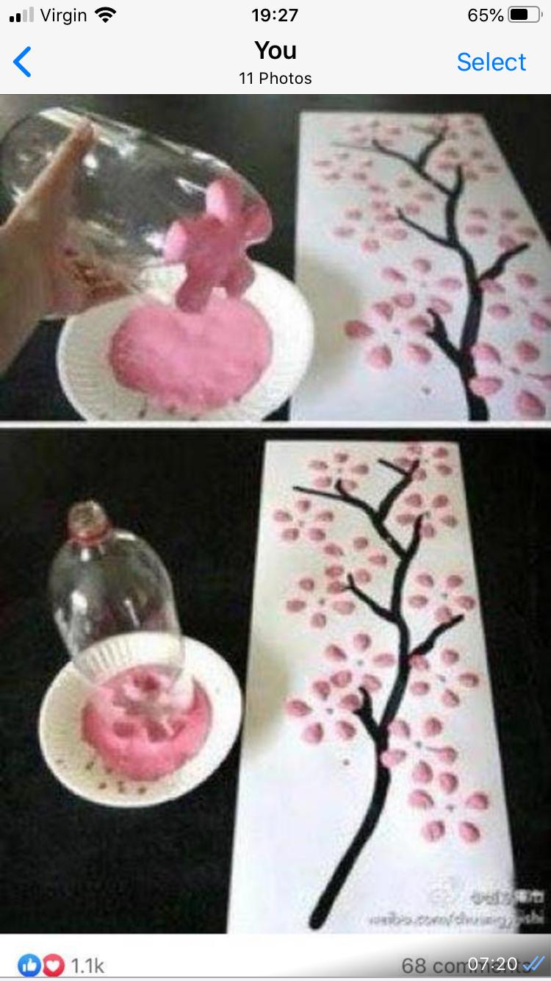**Materials needed**

**White paper**

**Brown paint**

**Pink paint**

**Empty bottle of pop**

1. **Attach A4 paper together as high as the tallest child**
2. **Draw a brown stem with branches as high as the paper**
3. **Pour some pink paint into a paper plate and dip the bottom of the empty pop bottle into the pink paint**
4. **Press bottle onto the white paper as shown to make a blossom tree**
5. **Measure the children against the blossom tree to show each of their heights**

**This will show a comparison of different sized family members, who is the tallest down to th#e smallest.**