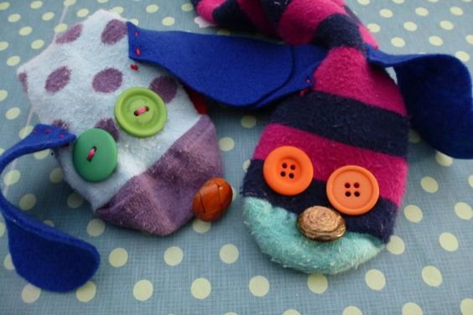
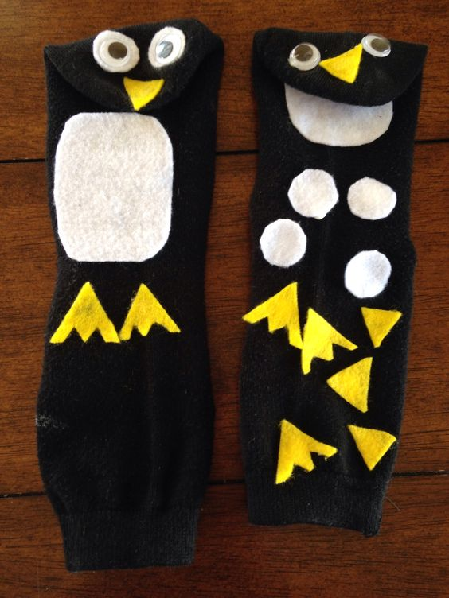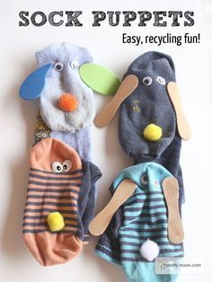

For Sock Puppets you will need:
You can use whatever you like, but some ideas are given below:
- Some old socks.
- Googly eyes or buttons
- Strong glue (suitable for fabric).
- Bits of felt, foam, pompoms or other material for ears and mouth.
- Old lolly pop sticks, wool, ribbon or other materials for hair

How to Make Sock Puppets
Stick down the googly eyes / buttons and the materials of your choice to make the puppets hair, ears and face on your sock.
Make sure you have strong glue, something that will stick to fabric, otherwise the bits will just fall off! If you wanted to, you could stuff your sock with materials such as cotton wool or tissue paper, securing the ends with an elastic band. Or, just leave the sock as it is and place it on your hands to bring it to life!

For more sock puppets ideas, look on the links below:

https://www.handmadecharlotte.com/7-diy-sock-puppets/

http://takingcareofmonkeybusiness.com/blog/2015/07/22/diy-sock-puppets/#_a5y_p=4089024

