### **Cereal Box Puppets:**

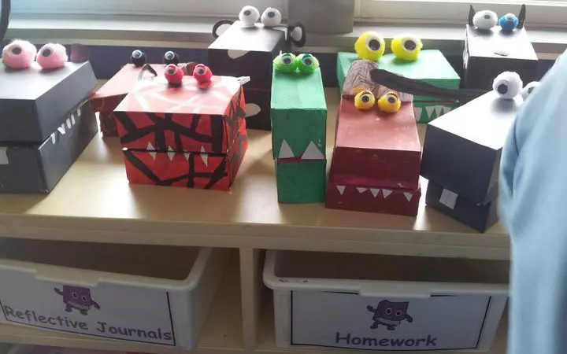

The first thing that you need to do is draw a line across the middle of the empty box and down its sides as well and cut along the lines - this is to make the puppets mouth open and close!

Paint the box with any color of your choice and get googly eyes, buttons, etc. for the eyes. You can paint on the nose, use yarn for hair and create a box puppet just the way you want!