**Tin can music makers**

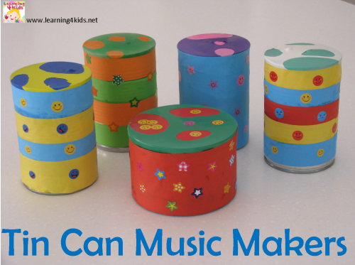

## **You will need:**

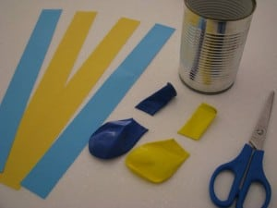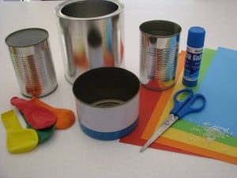

* Coloured paper
* Recycled tin cans
* Balloons
* Scissors
* Glue
* Elastic band
* Materials such as rice, lentils, sand, uncooked pasta, split peas

**How to make:**

* Half fill your tin with the material of your choice - encourage your child to explore the feel of the materials as well as pouring them into the tin.
* Cut the end off the balloon. Use the top of the balloon and stretch it out so that it goes over the top of the tin. Secure the balloon with an elastic band.
* Decorate your tin with coloured paper or stickers.
* Use your tin as a shaker or use it as a drum! (you could use a wooden spoon or a stick as a drum stick).