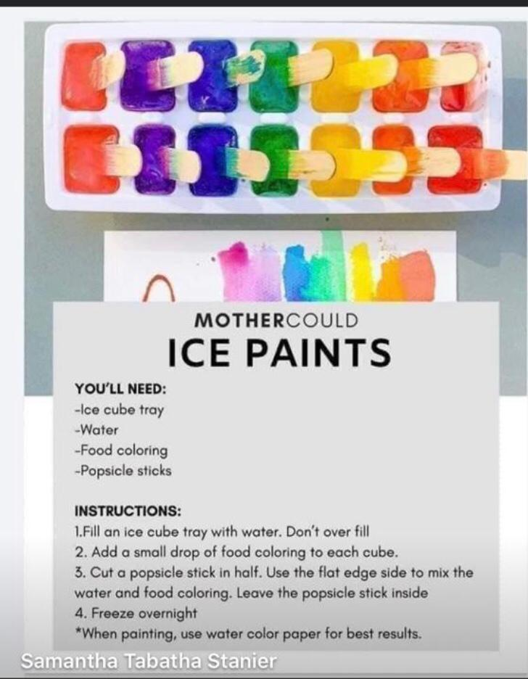Ice Paints

**Materials needed**

* Ice cube tray
* Water
* Food colouring
* Lollipop sticks

**Instructions**

1. Fill in your cube tray with water. Don’t overfill.
2. Add a small drop of food colouring to each cube.
3. Cut a lollipop stick in half. Use the flat edge side to mix the water and food colouring. Leave the lollipop stick inside.
4. Freeze overnight.

** When painting, use water colour paper for best results