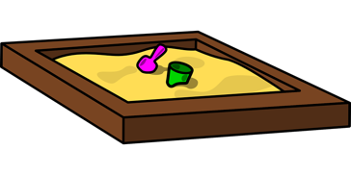**Sand Play with wet and Dry sand** 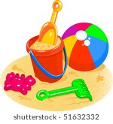

**(Science week 1- Exploring materials)**

## **Dry and Wet Sand Exploration**

Give your child a selection of tools and toys that will let them lift, dig, pour and explore with sand and water. If you do not have a water and play activity table, you can put water and sand on their tray outside for your child to play with. Show them how to use dump trucks in the dry sand. Give them cookie cutters to cut out shapes from the damp sand. Encourage your child to use their imagination to get as creative as possible when playing with the sand and water. Don't worry about them making a mess or mixing the sand with the water - it is all a learning process for your child.

Give your child a small pile of dry sand, one with wet sand and another with damp sand. Let them touch and play with the sand and observe what they notice about the wet, dry and damp sand. See if your child shows a preference to one type and tolerates it, e.g. running their fingers through dry, fine sand and maybe showing a dislike to the texture of wet sand and withdrawing their hand. Have them try, with physical support, to create something out of the dry sand, then have them try it with the wet sand, and finally the damp sand. Encourage all attempts at independent movements and lavishly praise any forms or shapes made.

## **Sand Castles at the Beach**

If you live near a beach, take your child for a day of fun in the sand and water. Show them how much bigger the beach is compared to their sandbox at home. Bring a few small toys such as buckets and spades for them to make sand castles with support. Observe whether they notice any difference from the sand at the beach you are at compared to the sand they play with at home. For example, perhaps you are on a white sand beach, with sand that has a powdery texture. Walk with them to the water's edge to see the waves coming up on onto the sand. Help them make foot prints and hand prints in the damp sand.