**Pink Flamingo Art**

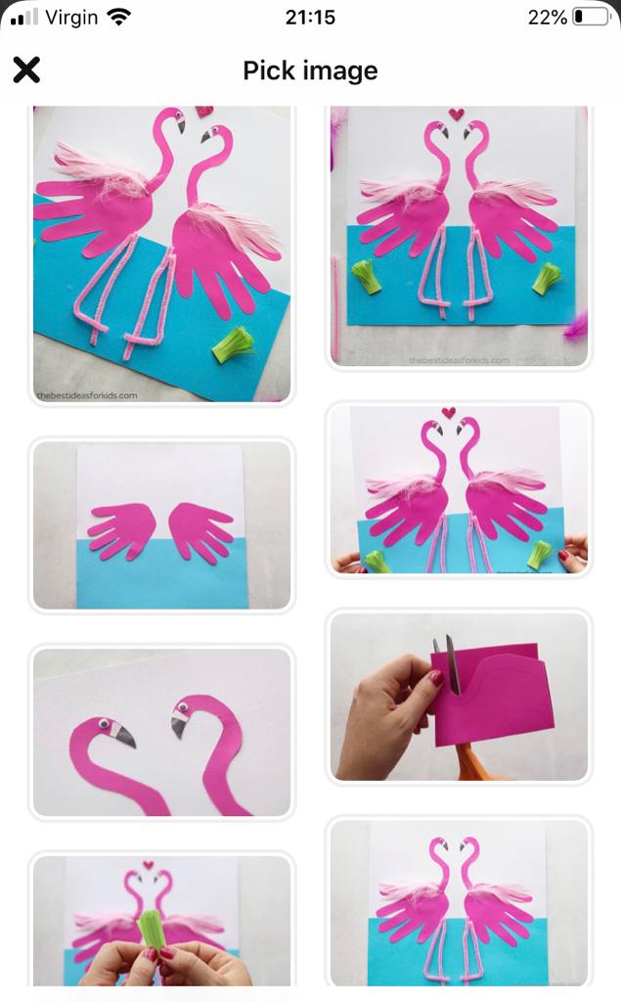

**Materials needed**

* A4 White card/paper
* A4 Blue card/paper
* Pink card/paper
* Black card/paper
* Pink pipe cleaners
* Pink feathers
* Small wobbly eyes

1. Using the blue card/paper, cut a large strip and glue it to cover the bottom of the whitepaper/card to make your water.
2. Using the pink paper trace around your child’s hand. Place the hand cut out onto the half of the white and blue card and glue.
3. Cut out the flamingo neck shape as above and glue down onto the paper.
4. Using some white paper/card cut out a beak and glue onto the head.
5. Cut out a small tip of black paper/card onto the white card and glue.
6. Glue on the Wobbly eye.
7. Add your pink feathers and pipe cleaners using the glue.
8. Finally add some green plants to the water by taking a strip of paper and cutting small slits in it. Once you have the paper cut, roll it up and glue down to your paper.