### **Finger Puppets Made With Paper**

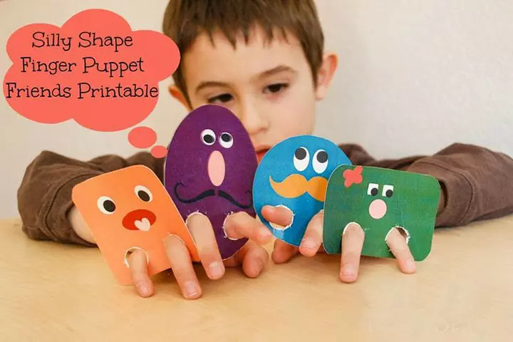

**You will need:**

* Paper / card
* Glue
* Scissors
* Pencils / crayons / paint
* Selection of materials such as felt, wool, tissue paper, buttons, googly eyes (optional)

**How to make:**

* Draw a picture of, or print out a picture, of a person, animal, shape or object of your child’s choice and cut it out. If you are using paper, you might want to back it onto card to make it thicker.
* Encourage your child to decorate their picture using pencils / paints / crayons and any materials that they choose.
* Cut two holes in the middle of their picture so that your child can put their fingers through and use it as a puppet.