Drama: using a basic lamp in the home.

In a theatre there are lots of lights that help create atmosphere. That is slightly difficult at home. We had an idea from Bamboozle theatre which will help with creating your own theatre at home.   
   
Using a table lamp that you can pose:

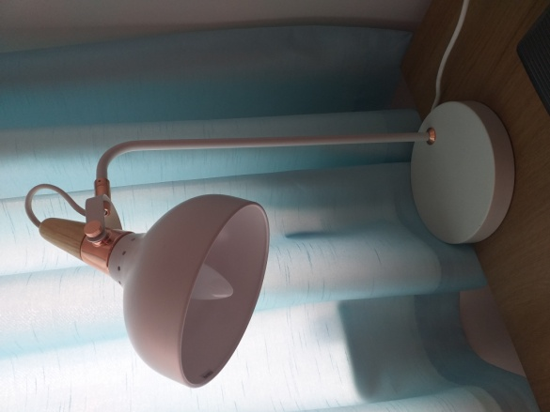

“**Let's imagine, for example, that we want our group to meet a character who is counting some precious stones into a box.  And let's place our character leaning over a table with the box and stones on it.  By putting a light on the table directed to illuminate just the box, the stones and her hands, we create an intimate picture which will have a great focusing effect on the students in the group.**

**This works perfectly well even if we can't achieve black out in the room; just turning the ceiling lights off will change the atmosphere enough to give significance to whatever we are wishing to focus on.”**

Have a great day,

**We had this idea from Christopher Davies Co founder and Artistic Director of BAMBOZLE THEATRE**