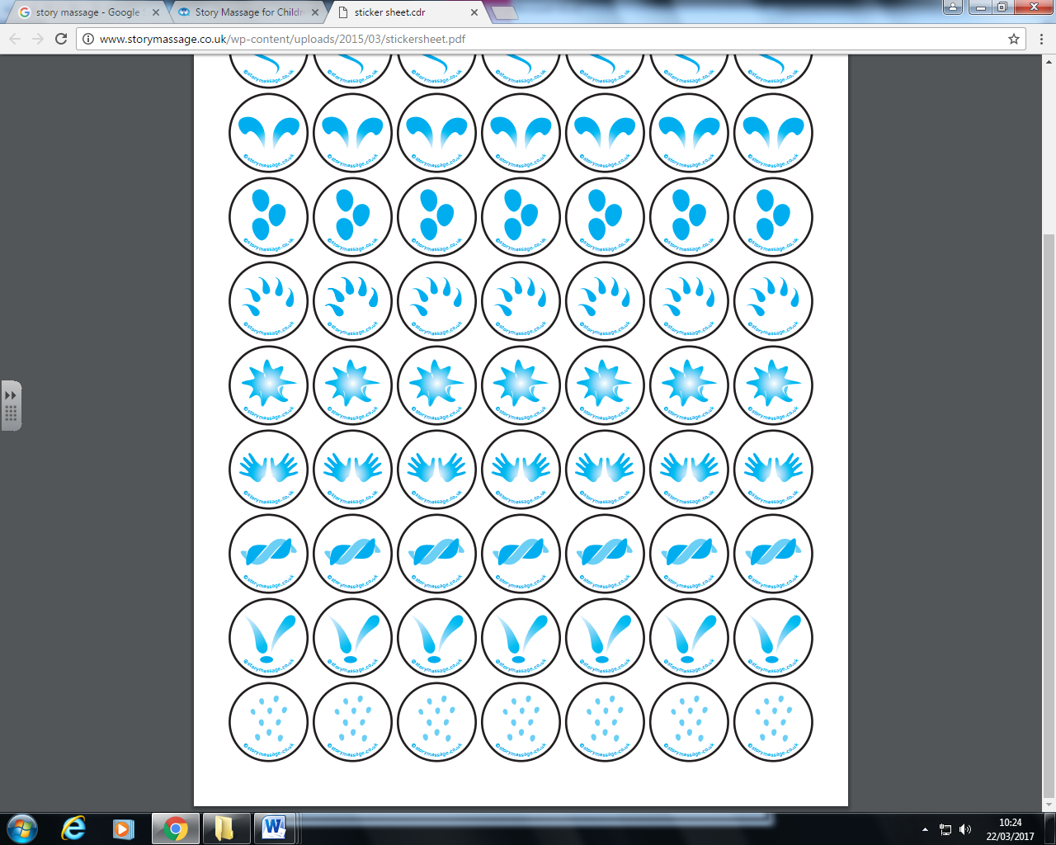

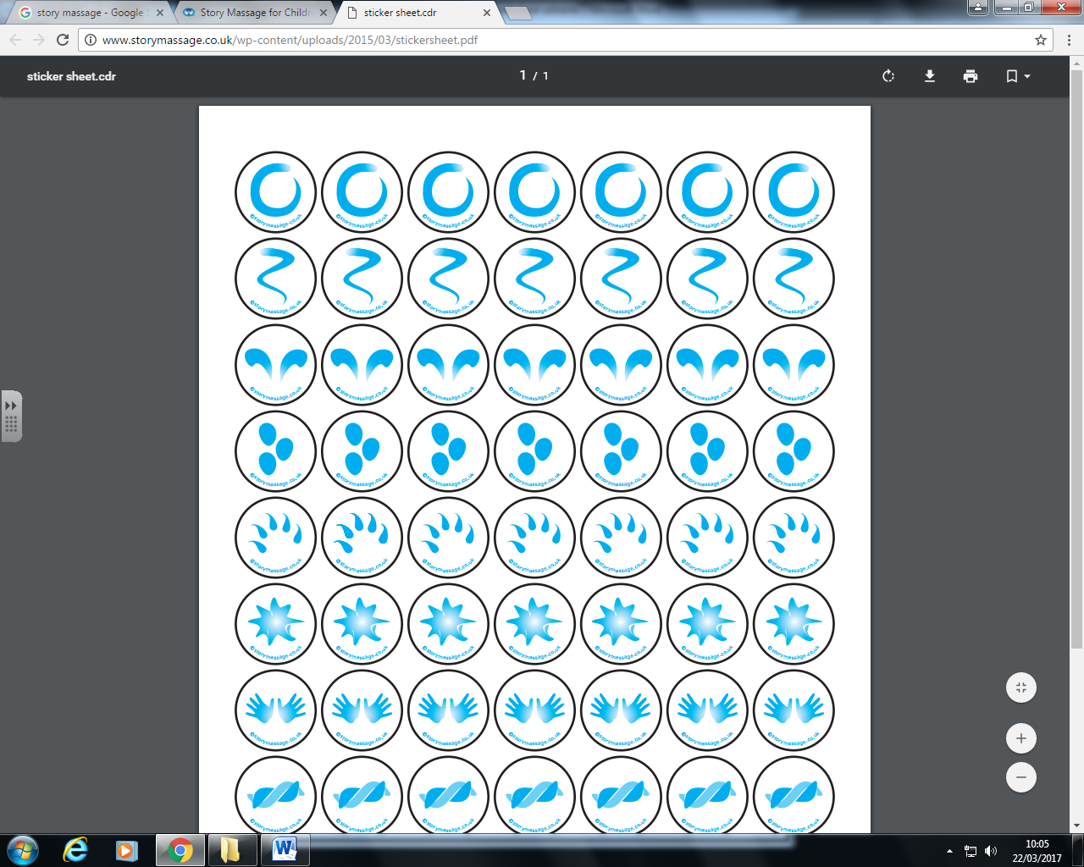











Mother duck said “quack, quack, quack”

Over the hill and far away

Four little ducks went swimming one day

And only four little ducks came back

Mother duck said “quack, quack, quack”

Over the hill and far away

Five little ducks went swimming one day

**Five little ducks**

And only three little ducks came back

**Continue until no little ducks**











Sad mother duck said “quack, quack, quack”

And all five little ducks came swimming back

Over the hill and far away

Sad mother duck went out one day