Story Massage Strokes
The circle  With your palm flat, make a circle | 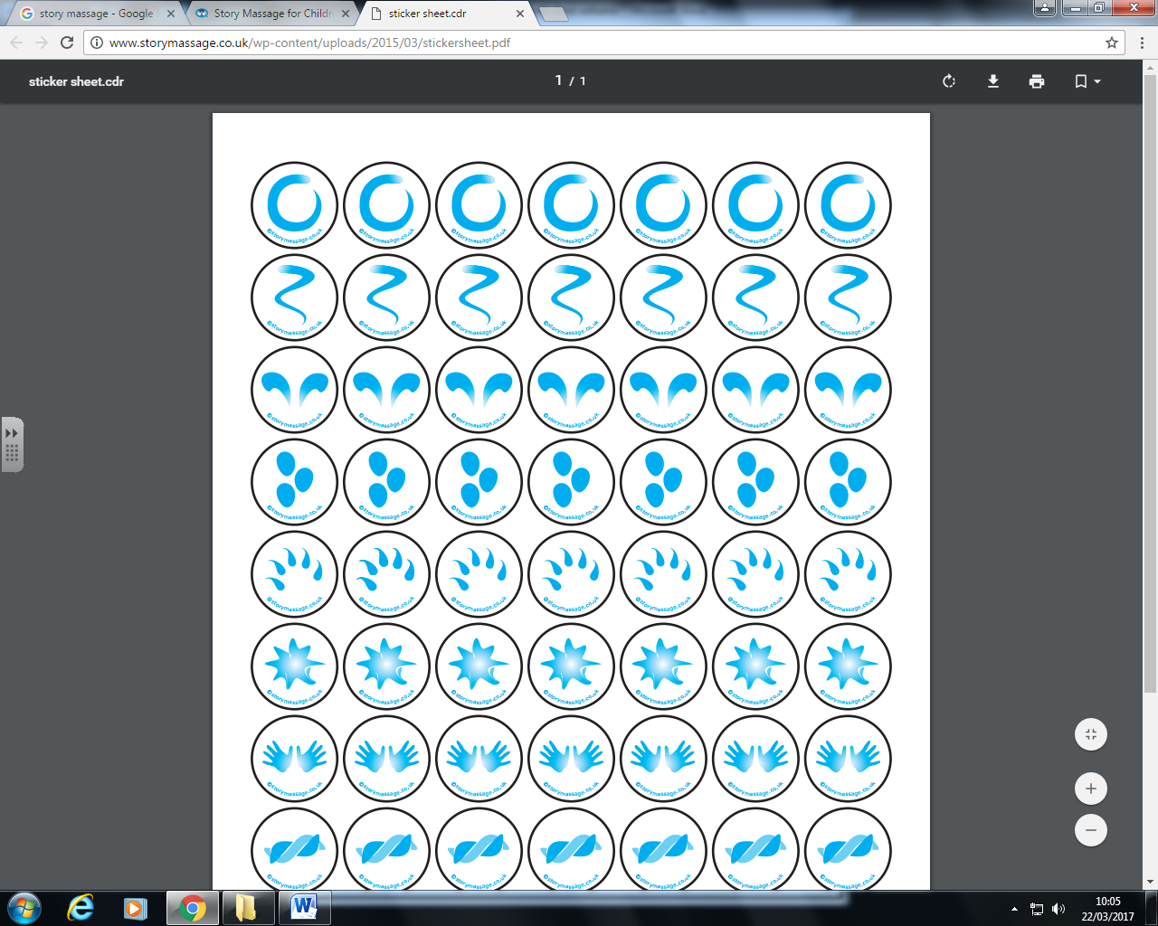
The semi-circle
With your palm flat, make half a circle

The wave
With your palm flat, draw a vertical wavy line
The sideways wave
With your palm flat, draw a horizontal wavy line
The fan
With both palms flat, start with hands at the centre together and move up and out (away from each other) to create a fan shape

The downward fan
With both palms flat, start with hands at the centre together and move down and out (away from each other) to create a fan shape

The calm
Place both palms onto area and just hold. Provide enough pressure to encourage calm.
The walk
Palms flat, place one after each other and ‘walk’ up or down the area.
The drum  Hands make a fist and gently knead area. | 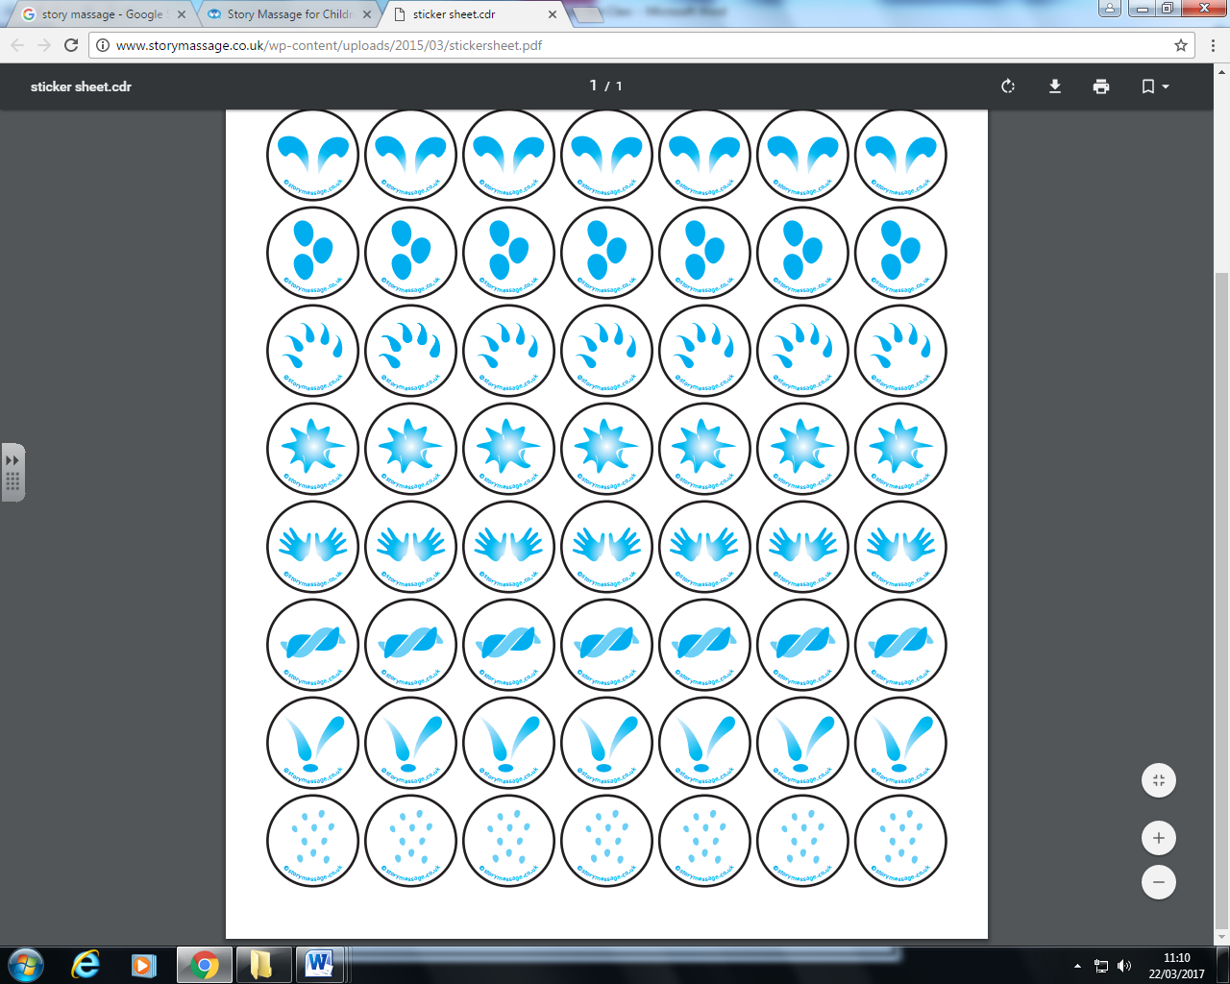
The claw
Fingers make a claw shape and use fingertips to gently move over the area.

The squeeze  Use both hands (between fingers and thumb) to gently ‘squeeze’ the area and hold. | 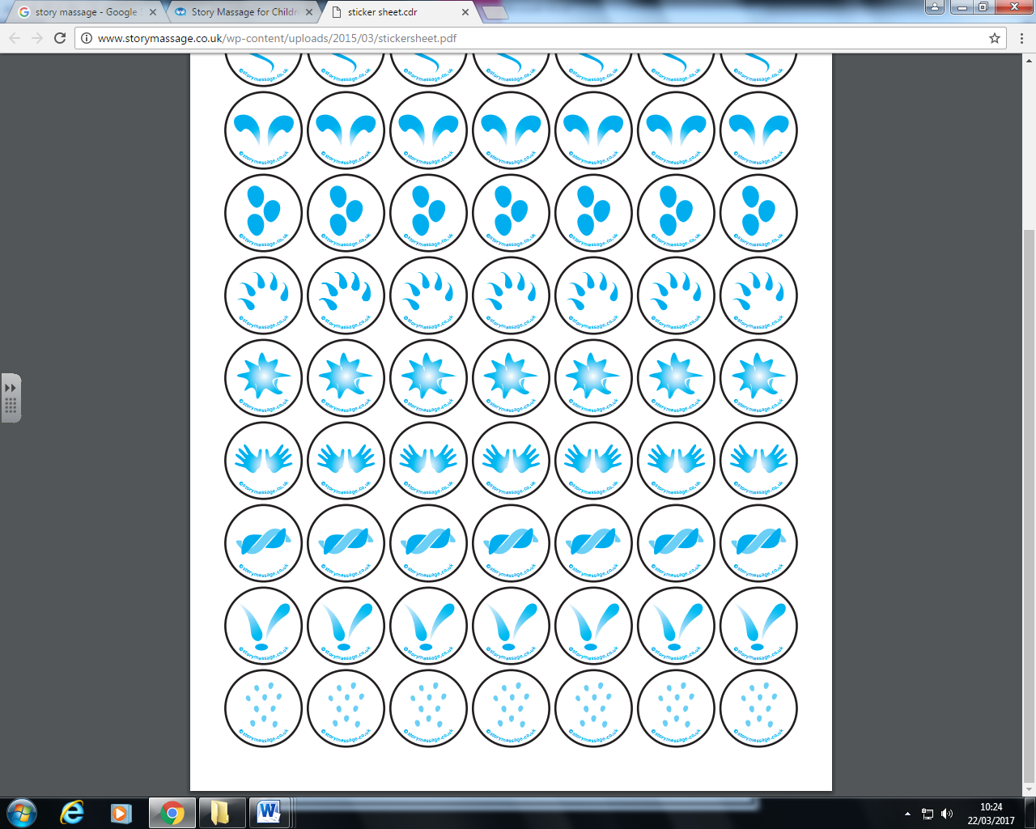
The bounce
Use one hand at a time to gently ‘squeeze’ and pick up the area and then release upwards.
The sprinkle
Use your fingertips alternately to tap over area like rain.

