How I made sad Puppet

* I used two pieces of felt. I drew around my hand for the basic shape and then added a seam allowance - so add and extra half an inch to cut around the shape.
* I sewed a seam around to join the two felt pieces together.
* Turn the hand glove inside out so it hides the seem then I added some outlines of eyes using scrap pieces of felt and added some buttons. I sewed eyes onto the white felt and then glued the eyes down with PVA glue.
* Last of all I added a fuzzy pom pom nose and pipe cleaners for features.

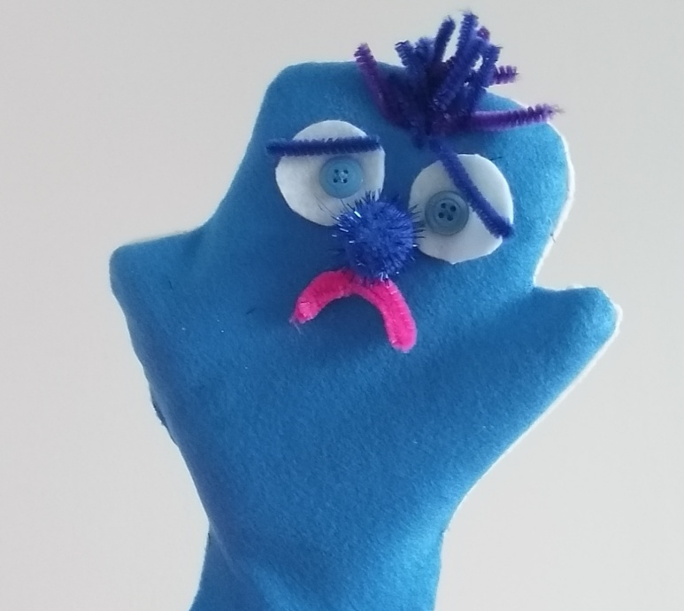

Shops and supplies :

ASDA for pipe cleaners and pom pom nose from kids craft section

Buttons from craft pack from Home Bargains

Felt from Dunhelm- however Ebay is also good and cheap!