**Octopus Puppet**

You will need...

A 1lt clean empty bottle

8 30 cm pipe cleaners

Hole punch

Ribbon

Googly eyes / permanent marker pen

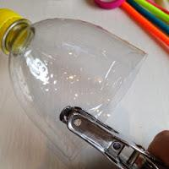

Cut the top off of a bottle - we used 1lr, punch 8 holes around the bottom.

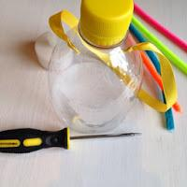

Make a hole either side of the bottle top and thread some ribbon through.

Cut a long pipe cleaner in half and using a pencil, wrap it round to form a spring. Make 8 in total.

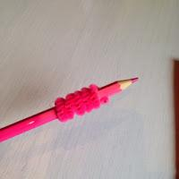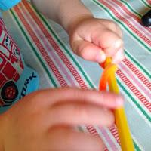

Attach one pipe cleaner spring to each hole and pull to form your octopus's 8 arms. If you do not have pipe cleaners, you could use ribbon instead.

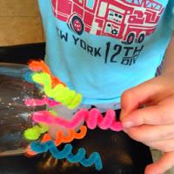

Decorate your octopus face using either googly eyes or draw on eyes using a permanent marker pen.

Your octopus is already to hang up!

