**Makaton Signs for ‘Incy Wincy Spider’**

**Spider**

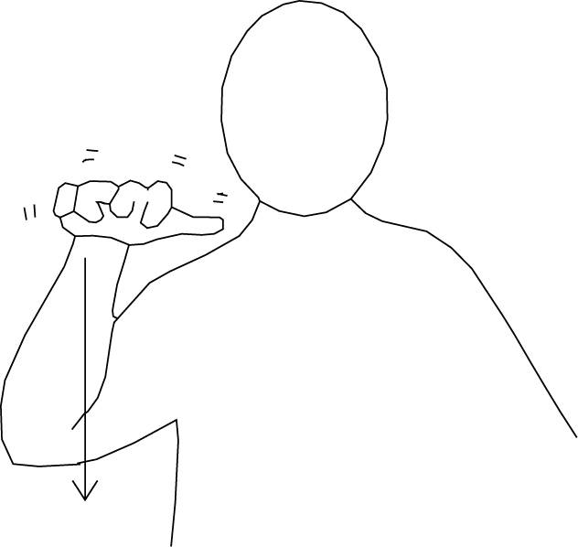

(Use the same sign but travelling upwards for ‘climbed up the water spout’)

**Rain**

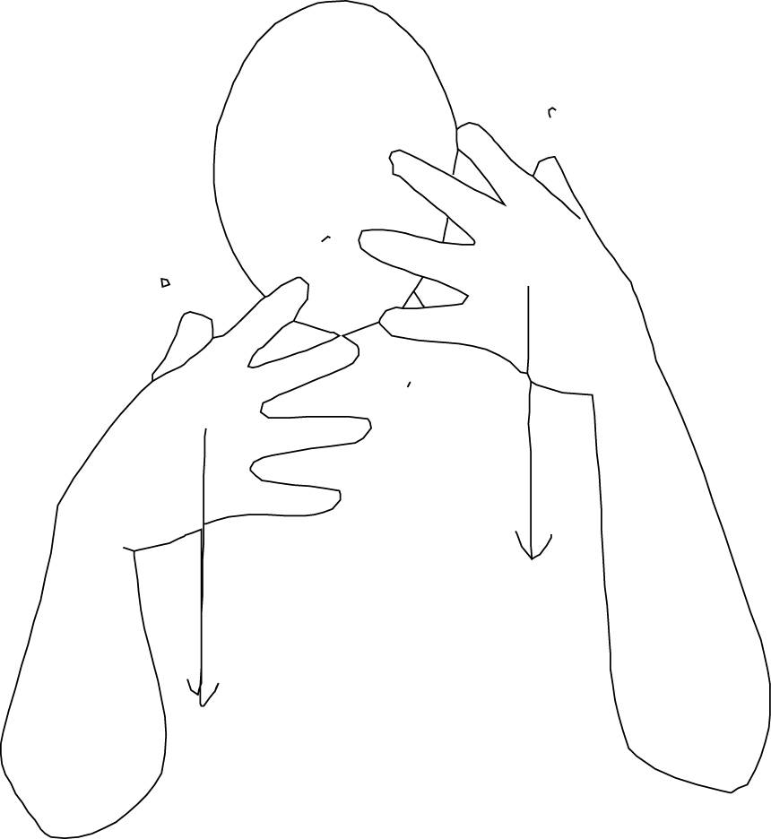

**Washed the spider out**

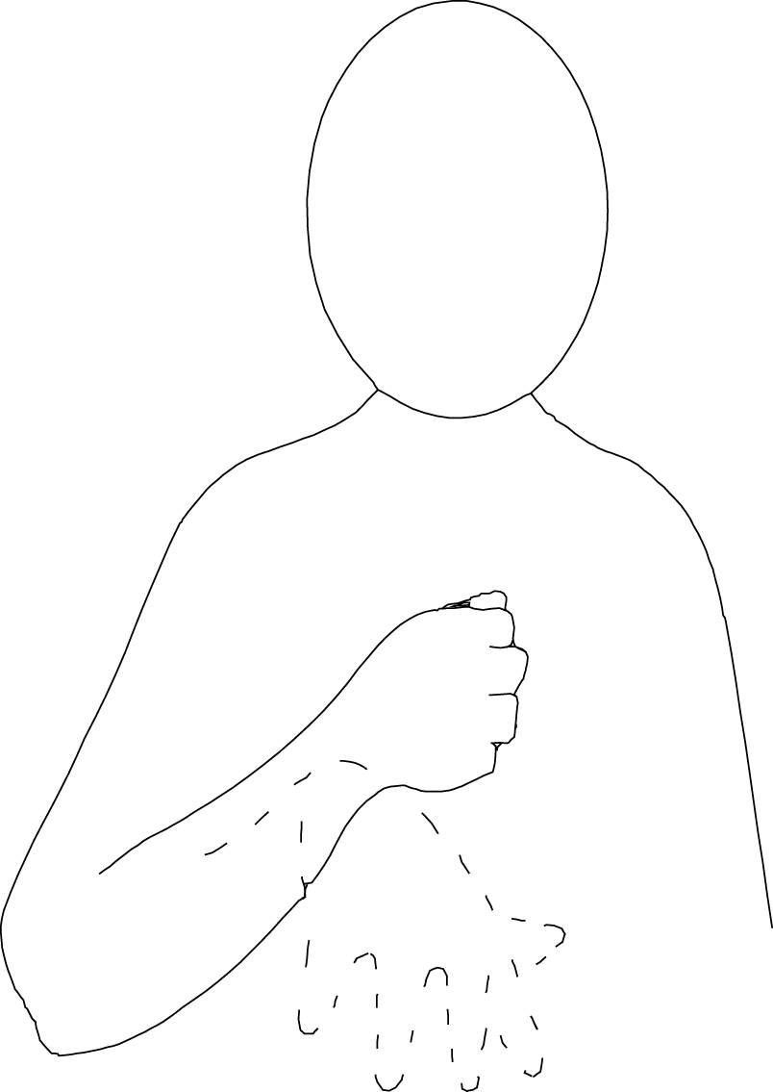

**Sun**



**Dried up**

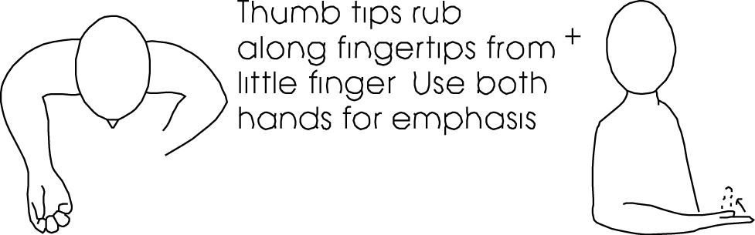

**Again**

