**Summer Art**

Materials needed

* 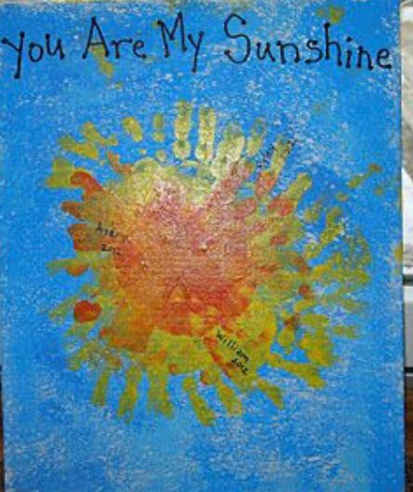A4 Blue card or paper
* Red paint
* Yellow paint
* Orange paint

1. Using the yellow, red, orange paint, paint your child’s hand and place it on the blue paper/card, turning the paper around as you do to make the sunshine