**Painting with clingfilm**

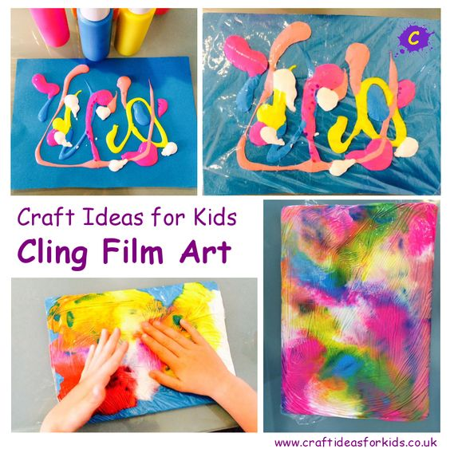

**You will need:**

* Clingfilm
* Pink Paint
* Card
* Paint palette or container

**How to make:**

* Place blobs of pink paint onto the card
* Cover the piece of card with clingfilm, making sure that the clingfilm fully covers the card and is longer than the piece of card. You might want to stick the clingfilm to the table using Sellotape.
* Encourage your child to use their hands to move the paint over the piece of card.
* When finished, remove the clingfilm and leave your card to dry.